About the chart - Grouped bars: compares multiple measures per category, displaying side-by-side bars.

Graphics environment setup.

# installation   
#install.packages("daltoolbox")  
  
# loading DAL  
library(daltoolbox)

library(ggplot2)  
library(RColorBrewer)  
  
# color palette  
colors <- brewer.pal(4, 'Set1')  
  
# setting the font size for all charts  
font <- theme(text = element_text(size=16))

Data aggregated by species for two metrics.

# iris dataset for the example  
head(iris)

## Sepal.Length Sepal.Width Petal.Length Petal.Width Species  
## 1 5.1 3.5 1.4 0.2 setosa  
## 2 4.9 3.0 1.4 0.2 setosa  
## 3 4.7 3.2 1.3 0.2 setosa  
## 4 4.6 3.1 1.5 0.2 setosa  
## 5 5.0 3.6 1.4 0.2 setosa  
## 6 5.4 3.9 1.7 0.4 setosa

library(dplyr)  
  
data <- iris |> group_by(Species) |> summarize(Sepal.Length=mean(Sepal.Length), Sepal.Width=mean(Sepal.Width))  
head(data)

## # A tibble: 3 × 3  
## Species Sepal.Length Sepal.Width  
## <fct> <dbl> <dbl>  
## 1 setosa 5.01 3.43  
## 2 versicolor 5.94 2.77  
## 3 virginica 6.59 2.97

Build a grouped bar chart.

# Grouped bars  
  
# Organizes data into groups per category, showing two or more bars per group, colored by measure.  
  
# More info: https://en.wikipedia.org/wiki/Bar_chart#Grouped_or_stacked  
  
grf <- plot_groupedbar(data, colors=colors[1:2]) + font  
plot(grf)

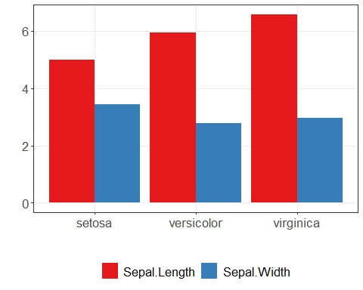

References - Wickham, H. (2016). ggplot2: Elegant Graphics for Data Analysis. Springer. - Cleveland, W. S. (1994). The Elements of Graphing Data (2nd ed.). Hobart Press.