About the chart - Histogram: distributes observations into bins along the x-axis; useful to visualize frequency and skewness.

Graphics environment setup.

# installation   
#install.packages("daltoolbox")  
  
# loading DAL  
library(daltoolbox)

library(ggplot2)  
library(RColorBrewer)  
  
# color palette  
colors <- brewer.pal(4, 'Set1')  
  
# setting the font size for all charts  
font <- theme(text = element_text(size=16))

Generate variables with distinct distributions (exponential, uniform, normal).

# Examples with data distributions  
# We use random variables to facilitate visualization of different distributions.  
  
# example: dataset to be plotted   
example <- data.frame(exponential = rexp(100000, rate = 1),   
 uniform = runif(100000, min = 2.5, max = 3.5),   
 normal = rnorm(100000, mean=5))  
head(example)

## exponential uniform normal  
## 1 0.08071158 2.583249 4.873165  
## 2 1.30459359 3.001843 4.452051  
## 3 0.02286523 2.706203 5.601127  
## 4 3.93338399 3.426023 5.860135  
## 5 0.62192427 3.121745 6.070612  
## 6 0.32600553 2.838081 6.839496

# Histogram

Visualize the distribution of a continuous variable by binning the x-axis and counting observations per bin. geom_histogram() displays counts as bars. More info: ?geom_histogram (R documentation)

Build histograms and arrange multiple charts side by side.

library(dplyr)  
  
grf <- plot_hist(example |> dplyr::select(exponential),   
 label_x = "exponential", color=colors[1]) + font

## Using as id variables

options(repr.plot.width=5, repr.plot.height=4)  
plot(grf)

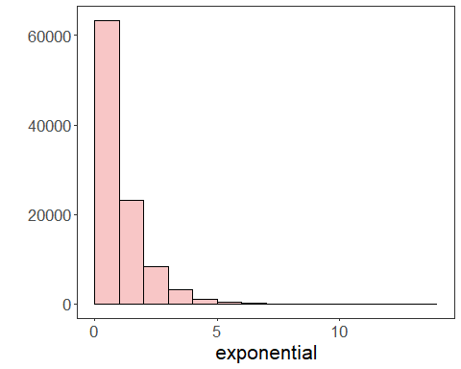

# Chart arrangement

Use grid.arrange to place the generated charts side by side.

grfe <- plot_hist(example |> dplyr::select(exponential),   
 label_x = "exponential", color=colors[1]) + font

## Using as id variables

grfu <- plot_hist(example |> dplyr::select(uniform),   
 label_x = "uniform", color=colors[1]) + font

## Using as id variables

grfn <- plot_hist(example |> dplyr::select(normal),   
 label_x = "normal", color=colors[1]) + font

## Using as id variables

library(gridExtra)   
  
options(repr.plot.width=15, repr.plot.height=4)  
grid.arrange(grfe, grfu, grfn, ncol=3)

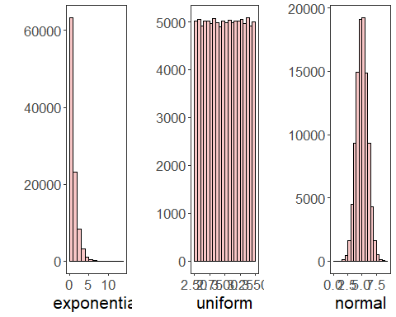

References - Freedman, D., and Diaconis, P. (1981). On the histogram as a density estimator: L2 theory. Zeitschrift für Wahrscheinlichkeitstheorie und verwandte Gebiete. - Wickham, H. (2016). ggplot2: Elegant Graphics for Data Analysis. Springer.