About the chart - Radar: displays multiple numeric variables on radial axes from a common origin; useful for comparative profiles.

Graphics environment setup.

# installation   
#install.packages("daltoolbox")  
  
# loading DAL  
library(daltoolbox)

library(ggplot2)  
library(RColorBrewer)  
  
# color palette  
colors <- brewer.pal(4, 'Set1')  
  
# setting the font size for all charts  
font <- theme(text = element_text(size=16))

Mean per numeric variable and shaping the required format for radar.

# iris dataset for the example  
head(iris)

## Sepal.Length Sepal.Width Petal.Length Petal.Width Species  
## 1 5.1 3.5 1.4 0.2 setosa  
## 2 4.9 3.0 1.4 0.2 setosa  
## 3 4.7 3.2 1.3 0.2 setosa  
## 4 4.6 3.1 1.5 0.2 setosa  
## 5 5.0 3.6 1.4 0.2 setosa  
## 6 5.4 3.9 1.7 0.4 setosa

library(dplyr)  
  
data <- iris |> dplyr::select(-Species)   
data <- sapply(data, mean)  
data <- data.frame(name = names(data), value = data) |> dplyr::arrange(name)  
  
head(data)

## name value  
## Petal.Length Petal.Length 3.758000  
## Petal.Width Petal.Width 1.199333  
## Sepal.Length Sepal.Length 5.843333  
## Sepal.Width Sepal.Width 3.057333

# Radar chart  
  
# Graphical method to display multivariate data with 3+ quantitative variables on axes starting from the same point.  
  
# More info: https://en.wikipedia.org/wiki/Radar_chart  
  
grf <- plot_radar(data, colors=colors[1]) + font  
grf <- grf + ylim(0, NA)  
plot(grf)

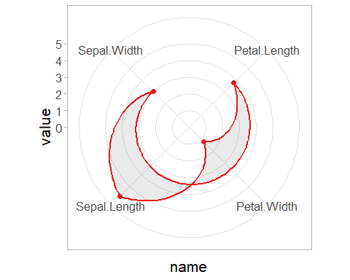

References - Wickham, H. (2016). ggplot2: Elegant Graphics for Data Analysis. Springer. - Wilkinson, L. (2005). The Grammar of Graphics (2nd ed.). Springer.