About the feature - Chart saving: example of exporting with jpeg()/dev.off() and ggsave() to image files.

Graphics environment setup.

# installation   
#install.packages("daltoolbox")  
  
# loading DAL  
library(daltoolbox)

library(ggplot2)  
library(RColorBrewer)  
  
# color palette  
colors <- brewer.pal(4, 'Set1')  
  
# setting the font size for all charts  
font <- theme(text = element_text(size=16))

Synthetic series and chart to export.

# Synthetic time series  
  
x <- seq(0, 10, 0.25)  
serie <- data.frame(x, sin=sin(x), cosine=cos(x)+5)  
head(serie)

## x sin cosine  
## 1 0.00 0.0000000 6.000000  
## 2 0.25 0.2474040 5.968912  
## 3 0.50 0.4794255 5.877583  
## 4 0.75 0.6816388 5.731689  
## 5 1.00 0.8414710 5.540302  
## 6 1.25 0.9489846 5.315322

# Series chart  
  
# Shows points connected by lines, with x-axis ordered by time/index.  
  
# More info: https://en.wikipedia.org/wiki/Line_chart  
  
grf <- plot_series(serie, colors=colors[1:2]) + font  
plot(grf)

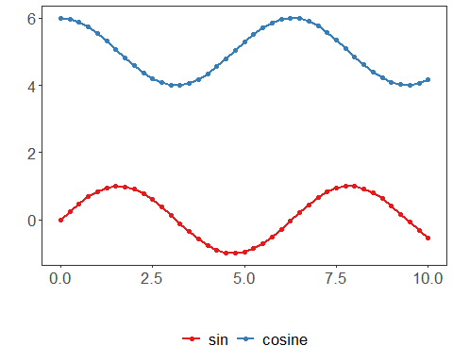

Export using base devices (JPEG) and with ggsave.

jpeg("series.jpg", width = 640, height = 480)  
 plot(grf)  
 dev.off()

## png   
## 2

ggsave("series.png", width = 5, height = 4, units = "cm")

References - Wickham, H. (2016). ggplot2: Elegant Graphics for Data Analysis. Springer. (ggsave)