About the chart - Time series with fit and forecast: shows observed values, model fit, and forecast horizon for visual comparison.

Graphics environment setup.

# installation   
#install.packages("daltoolbox")  
  
# loading DAL  
library(daltoolbox)

library(ggplot2)  
library(RColorBrewer)  
  
# color palette  
colors <- brewer.pal(4, 'Set1')  
  
# setting the font size for all charts  
font <- theme(text = element_text(size=16))

Synthetic series with noise; split windows for fit and forecast.

# Synthetic time series  
  
x <- base::seq(0, 10, 0.25)  
yvalues <- sin(x) + rnorm(41,0,0.1)

# prediction  
adjust <- sin(x[1:35])  
prediction <- sin(x[36:41])

Plot time series with fit and forecast.

# Time series with forecast  
  
# Chart with observed values, model fit, and predicted values.   
  
plot_ts_pred(y=yvalues, yadj=adjust, ypre=prediction)

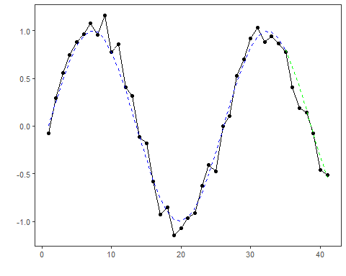

References - Hyndman, R. J., and Athanasopoulos, G. (2021). Forecasting: Principles and Practice (3rd ed.). OTexts.