Denoising Autoencoder (encode)
Denoising autoencoders corrupt inputs with noise and train the network to reconstruct the original clean input. This objective encourages the model to learn robust features that capture underlying structure instead of noise.
This example demonstrates how to use a denoising autoencoder to learn a robust encoding of time-series windows. During training, noise is added to the input.
Prerequisites - Python with PyTorch accessible via reticulate - R packages: daltoolbox, tspredit, daltoolboxdp, ggplot2
Quick notes - Idea: add noise to the input and train the model to recover the clean signal. - Benefit: latent representations that are more robust to perturbations.
# Denoising Autoencoder transformation (encode)
# Considering a dataset with $p$ numerical attributes.
# The goal of the autoencoder is to reduce the dimension of $p$ to $k$, such that these $k$ attributes are enough to recompose the original $p$ attributes.
# Installing packages
#install.packages("tspredit")
#install.packages("daltoolboxdp")
# Loading packages
library(daltoolbox)
library(tspredit)
library(daltoolboxdp)
library(ggplot2)
# Example dataset (series -> windows)
data(tsd)
sw_size <- 5
ts <- ts_data(tsd$y, sw_size)
ts_head(ts)
## t4 t3 t2 t1 t0
## [1,] 0.0000000 0.2474040 0.4794255 0.6816388 0.8414710
## [2,] 0.2474040 0.4794255 0.6816388 0.8414710 0.9489846
## [3,] 0.4794255 0.6816388 0.8414710 0.9489846 0.9974950
## [4,] 0.6816388 0.8414710 0.9489846 0.9974950 0.9839859
## [5,] 0.8414710 0.9489846 0.9974950 0.9839859 0.9092974
## [6,] 0.9489846 0.9974950 0.9839859 0.9092974 0.7780732
# Normalization (min-max by group)
preproc <- ts_norm_gminmax()
preproc <- fit(preproc, ts)
ts <- transform(preproc, ts)
ts_head(ts)
## t4 t3 t2 t1 t0
## [1,] 0.5004502 0.6243512 0.7405486 0.8418178 0.9218625
## [2,] 0.6243512 0.7405486 0.8418178 0.9218625 0.9757058
## [3,] 0.7405486 0.8418178 0.9218625 0.9757058 1.0000000
## [4,] 0.8418178 0.9218625 0.9757058 1.0000000 0.9932346
## [5,] 0.9218625 0.9757058 1.0000000 0.9932346 0.9558303
## [6,] 0.9757058 1.0000000 0.9932346 0.9558303 0.8901126
# Train/test split
samp <- ts_sample(ts, test_size = 10)
train <- as.data.frame(samp$train)
test <- as.data.frame(samp$test)
# Training autoencoder (reduce 5 -> 3)
auto <- autoenc_denoise_e(5, 3)
auto <- fit(auto, train)
Constructor configuration - Fixed-epoch baseline: omit epochs to use the default value and keep validation_strategy = "static" with stopping_rule = "none". - Static early stopping: keep validation_strategy = "static" and choose stopping_rule = "patience", "sma", "ema", or "h". - Dynamic early stopping: switch validation_strategy = "dynamic" and reuse the same stopping rules. - The loss plot below always shows train_loss; it adds val_loss when validation is active.
Architecture variations - noise_factor controls corruption strength during training. - encoder_hidden_sizes and decoder_hidden_sizes define the dense denoising backbone. - Combine a deeper encoder with a moderate noise_factor to learn more robust latent spaces.
fit_loss <- data.frame(x = seq_along(auto$train_loss), train_loss = auto$train_loss)
if (!is.null(auto$val_loss) && length(auto$val_loss) > 0) {
fit_loss$val_loss <- auto$val_loss
}
colors <- if ("val_loss" %in% names(fit_loss)) c("Blue", "Orange") else c("Blue")
grf <- plot_series(fit_loss, colors = colors)
plot(grf)
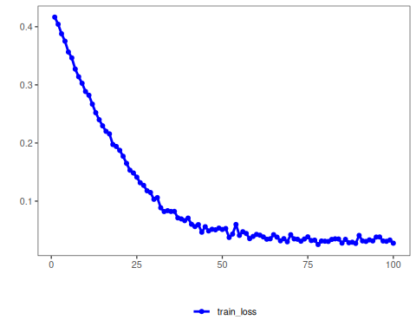
# Convergence should be stable; too much noise can hinder fitting.
# Testing the autoencoder
# Show test samples and display encoding
print(head(test))
## t4 t3 t2 t1 t0
## 1 0.7258342 0.8294719 0.9126527 0.9702046 0.9985496
## 2 0.8294719 0.9126527 0.9702046 0.9985496 0.9959251
## 3 0.9126527 0.9702046 0.9985496 0.9959251 0.9624944
## 4 0.9702046 0.9985496 0.9959251 0.9624944 0.9003360
## 5 0.9985496 0.9959251 0.9624944 0.9003360 0.8133146
## 6 0.9959251 0.9624944 0.9003360 0.8133146 0.7068409
result <- transform(auto, test)
print(head(result))
## [,1] [,2] [,3]
## [1,] 1.144002 1.086805 -1.218257
## [2,] 1.195701 1.141863 -1.316908
## [3,] 1.216952 1.165608 -1.377211
## [4,] 1.206436 1.156563 -1.395417
## [5,] 1.164806 1.115636 -1.369654
## [6,] 1.089796 1.041549 -1.304700
References - Vincent, P., Larochelle, H., Bengio, Y., & Manzagol, P. A. (2008). Extracting and composing robust features with denoising autoencoders. ICML.

