LSTM Autoencoder (encode)
LSTM autoencoders use recurrent units to encode temporal dependencies in a sequence (window) into a fixed-sized latent vector. The memory cell and gating mechanisms help capture long- and short-term patterns before decoding or downstream use of the latent code.
This example demonstrates the use of an LSTM-based Autoencoder to encode windows of a time series. The LSTM encoder learns sequence representations, reducing from p to k dimensions.
Prerequisites - Python with PyTorch accessible via reticulate - R packages: daltoolbox, tspredit, daltoolboxdp, ggplot2
Quick notes - Architecture: LSTM encoder + MLP/decoder to represent time-series windows. - Useful when there is strong temporal dependence within each window.
# Installing example dependencies (if needed)
#install.packages("tspredit")
#install.packages("daltoolboxdp")
# Loading required packages
library(daltoolbox)
library(tspredit)
library(daltoolboxdp)
library(ggplot2)
# Example dataset (series -> windows)
data(tsd)
sw_size <- 5 # sliding window size (p)
ts <- ts_data(tsd$y, sw_size) # convert series into windows with p columns
ts_head(ts)
## t4 t3 t2 t1 t0
## [1,] 0.0000000 0.2474040 0.4794255 0.6816388 0.8414710
## [2,] 0.2474040 0.4794255 0.6816388 0.8414710 0.9489846
## [3,] 0.4794255 0.6816388 0.8414710 0.9489846 0.9974950
## [4,] 0.6816388 0.8414710 0.9489846 0.9974950 0.9839859
## [5,] 0.8414710 0.9489846 0.9974950 0.9839859 0.9092974
## [6,] 0.9489846 0.9974950 0.9839859 0.9092974 0.7780732
# Normalization (min-max by group)
preproc <- ts_norm_gminmax()
preproc <- fit(preproc, ts)
ts <- transform(preproc, ts)
ts_head(ts)
## t4 t3 t2 t1 t0
## [1,] 0.5004502 0.6243512 0.7405486 0.8418178 0.9218625
## [2,] 0.6243512 0.7405486 0.8418178 0.9218625 0.9757058
## [3,] 0.7405486 0.8418178 0.9218625 0.9757058 1.0000000
## [4,] 0.8418178 0.9218625 0.9757058 1.0000000 0.9932346
## [5,] 0.9218625 0.9757058 1.0000000 0.9932346 0.9558303
## [6,] 0.9757058 1.0000000 0.9932346 0.9558303 0.8901126
# Train/test split
samp <- ts_sample(ts, test_size = 10)
train <- as.data.frame(samp$train)
test <- as.data.frame(samp$test)
# Creating the LSTM autoencoder: reduce from 5 -> 3 dimensions (p -> k)
# - this example intentionally increases the number of epochs above the library default
# - use the full window as a sequence and a larger recurrent hidden state
auto <- autoenc_lstm_e(
5, 3,
sequence_length = 5L,
lstm_hidden_size = 16L,
epochs = 200L
)
# Training the model
auto <- fit(auto, train)
Constructor configuration - Fixed-epoch baseline: omit epochs to use the default value of 100L and keep validation_strategy = "static" with stopping_rule = "none". - Static early stopping: keep validation_strategy = "static" and choose stopping_rule = "patience", "sma", "ema", or "h". - Dynamic early stopping: switch validation_strategy = "dynamic" and reuse the same stopping rules. - The loss plot below always shows train_loss; it adds val_loss when validation is active.
Architecture variations - sequence_length reshapes each row into a longer temporal sequence before the recurrent encoder. - lstm_hidden_size decouples recurrent capacity from the latent bottleneck encoding_size. - num_layers and dropout enable deeper recurrent autoencoders. - For this example, sequence_length = 5L makes each window a true 5-step sequence, which is usually more informative than the degenerate sequence_length = 1L.
# Learning curves
fit_loss <- data.frame(
x = seq_along(auto$train_loss),
train_loss = auto$train_loss
)
if (!is.null(auto$val_loss) && length(auto$val_loss) > 0) {
fit_loss$val_loss <- auto$val_loss
}
colors <- if ("val_loss" %in% names(fit_loss)) c("Blue", "Orange") else c("Blue")
grf <- plot_series(fit_loss, colors = colors)
plot(grf)
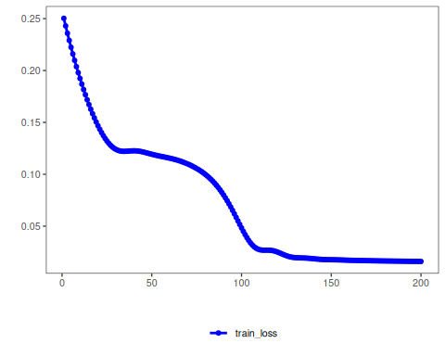
# Testing the autoencoder (encoding)
# Show samples from the test set and the encoding (k columns)
print(head(test))
## t4 t3 t2 t1 t0
## 1 0.7258342 0.8294719 0.9126527 0.9702046 0.9985496
## 2 0.8294719 0.9126527 0.9702046 0.9985496 0.9959251
## 3 0.9126527 0.9702046 0.9985496 0.9959251 0.9624944
## 4 0.9702046 0.9985496 0.9959251 0.9624944 0.9003360
## 5 0.9985496 0.9959251 0.9624944 0.9003360 0.8133146
## 6 0.9959251 0.9624944 0.9003360 0.8133146 0.7068409
result <- transform(auto, test)
print(head(result))
## [,1] [,2] [,3]
## [1,] 1.362024 0.7970662 0.6722835
## [2,] 1.444962 0.8730902 0.7173678
## [3,] 1.486477 0.9091334 0.7370238
## [4,] 1.489795 0.9081959 0.7319571
## [5,] 1.455718 0.8711807 0.7024149
## [6,] 1.382273 0.7966385 0.6480446
References - Hochreiter, S., & Schmidhuber, J. (1997). Long short-term memory. Neural Computation, 9(8), 1735–1780.

