Stacked Autoencoder (encode)
Stacked autoencoders compose multiple nonlinear layers to gradually compress inputs into a low-dimensional code. Depth allows the model to learn hierarchical features before exposing the compact representation for downstream use.
This example demonstrates a Stacked Autoencoder for encoding time-series windows, reducing from p to k dimensions with successive dense layers.
Prerequisites - Python with PyTorch accessible via reticulate - R packages: daltoolbox, tspredit, daltoolboxdp, ggplot2
# Installing example dependencies (if needed)
#install.packages("tspredit")
#install.packages("daltoolboxdp")
# Loading required packages
library(daltoolbox)
library(tspredit)
library(daltoolboxdp)
library(ggplot2)
# Example dataset (series -> windows)
data(tsd)
sw_size <- 5 # sliding window size (p)
ts <- ts_data(tsd$y, sw_size) # convert series into windows with p columns
ts_head(ts)
## t4 t3 t2 t1 t0
## [1,] 0.0000000 0.2474040 0.4794255 0.6816388 0.8414710
## [2,] 0.2474040 0.4794255 0.6816388 0.8414710 0.9489846
## [3,] 0.4794255 0.6816388 0.8414710 0.9489846 0.9974950
## [4,] 0.6816388 0.8414710 0.9489846 0.9974950 0.9839859
## [5,] 0.8414710 0.9489846 0.9974950 0.9839859 0.9092974
## [6,] 0.9489846 0.9974950 0.9839859 0.9092974 0.7780732
# Normalization (min-max by group)
preproc <- ts_norm_gminmax()
preproc <- fit(preproc, ts)
ts <- transform(preproc, ts)
ts_head(ts)
## t4 t3 t2 t1 t0
## [1,] 0.5004502 0.6243512 0.7405486 0.8418178 0.9218625
## [2,] 0.6243512 0.7405486 0.8418178 0.9218625 0.9757058
## [3,] 0.7405486 0.8418178 0.9218625 0.9757058 1.0000000
## [4,] 0.8418178 0.9218625 0.9757058 1.0000000 0.9932346
## [5,] 0.9218625 0.9757058 1.0000000 0.9932346 0.9558303
## [6,] 0.9757058 1.0000000 0.9932346 0.9558303 0.8901126
# Train/test split
samp <- ts_sample(ts, test_size = 10)
train <- as.data.frame(samp$train)
test <- as.data.frame(samp$test)
# Creating the stacked autoencoder: reduce from 5 -> 3 dimensions (p -> k)
auto <- autoenc_stacked_e(5, 3)
# Training the model
auto <- fit(auto, train)
Constructor configuration - Fixed-epoch baseline: omit epochs to use the default value and keep validation_strategy = "static" with stopping_rule = "none". - Static early stopping: keep validation_strategy = "static" and choose stopping_rule = "patience", "sma", "ema", or "h". - Dynamic early stopping: switch validation_strategy = "dynamic" and reuse the same stopping rules. - The loss plot below always shows train_loss; it adds val_loss when validation is active.
Architecture variations - encoding_sizes = c(16L, 8L, 4L) creates progressively smaller latent stages. - encoder_hidden_sizes can be a single vector shared by all stages or a list with one layout per stage.
# Learning curves
fit_loss <- data.frame(
x = seq_along(auto$train_loss),
train_loss = auto$train_loss
)
if (!is.null(auto$val_loss) && length(auto$val_loss) > 0) {
fit_loss$val_loss <- auto$val_loss
}
colors <- if ("val_loss" %in% names(fit_loss)) c("Blue", "Orange") else c("Blue")
grf <- plot_series(fit_loss, colors = colors)
plot(grf)
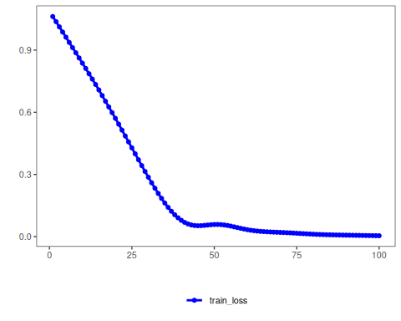
# Testing the autoencoder (encoding)
# Show samples from the test set and the encoding (k columns)
print(head(test))
## t4 t3 t2 t1 t0
## 1 0.7258342 0.8294719 0.9126527 0.9702046 0.9985496
## 2 0.8294719 0.9126527 0.9702046 0.9985496 0.9959251
## 3 0.9126527 0.9702046 0.9985496 0.9959251 0.9624944
## 4 0.9702046 0.9985496 0.9959251 0.9624944 0.9003360
## 5 0.9985496 0.9959251 0.9624944 0.9003360 0.8133146
## 6 0.9959251 0.9624944 0.9003360 0.8133146 0.7068409
result <- transform(auto, test)
print(head(result))
## [,1] [,2] [,3]
## [1,] 1.063763 -1.286977 -1.789592
## [2,] 1.112706 -1.370241 -1.901208
## [3,] 1.139156 -1.415405 -1.963008
## [4,] 1.142125 -1.420023 -1.970339
## [5,] 1.121404 -1.383690 -1.922564
## [6,] 1.077206 -1.307398 -1.820995
References - Bengio, Y., Lamblin, P., Popovici, D., & Larochelle, H. (2007). Greedy layer-wise training of deep networks. NIPS.

