Time Series Encoding and Reconstruction (encode-decode)
Time series windows of size p are encoded into k-dimensional latent vectors and then decoded back to p dimensions. Training minimizes reconstruction loss so that latent codes capture the essential structure of windows, enabling quality assessment via reconstruction error.
This example shows how to transform a time series into windows (p) and train an autoencoder to encode (p -> k) and reconstruct (k -> p) these windows, allowing evaluation of reconstruction quality.
Prerequisites - R packages: daltoolbox, ggplot2 - Python with PyTorch accessible via reticulate (backend called internally)
# Loading required packages
library(daltoolbox)
Series for study
data(tsd)
tsd$y[39] <- tsd$y[39] * 6 # inject a synthetic outlier for illustration
sw_size <- 5 # sliding window size (p)
ts <- ts_data(tsd$y, sw_size) # series -> windows with p columns
ts_head(ts, 3)
## t4 t3 t2 t1 t0
## [1,] 0.0000000 0.2474040 0.4794255 0.6816388 0.8414710
## [2,] 0.2474040 0.4794255 0.6816388 0.8414710 0.9489846
## [3,] 0.4794255 0.6816388 0.8414710 0.9489846 0.9974950
library(ggplot2)
plot_ts(x = tsd$x, y = tsd$y) +
theme(text = element_text(size = 16))
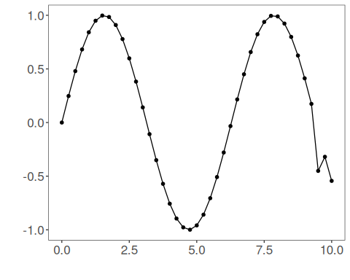
Data sampling
samp <- ts_sample(ts, test_size = 5)
train <- as.data.frame(samp$train)
test <- as.data.frame(samp$test)
Train the model (encode-decode)
auto <- autoenc_ed(5, 3) # 5 -> 3 -> 5 dimensions
auto <- fit(auto, train)
Reconstruction evaluation (train)
print(head(train)) # original windows (p columns)
## t4 t3 t2 t1 t0
## 1 0.0000000 0.2474040 0.4794255 0.6816388 0.8414710
## 2 0.2474040 0.4794255 0.6816388 0.8414710 0.9489846
## 3 0.4794255 0.6816388 0.8414710 0.9489846 0.9974950
## 4 0.6816388 0.8414710 0.9489846 0.9974950 0.9839859
## 5 0.8414710 0.9489846 0.9974950 0.9839859 0.9092974
## 6 0.9489846 0.9974950 0.9839859 0.9092974 0.7780732
result <- transform(auto, train) # reconstructed windows (p columns)
print(head(result))
## [,1] [,2] [,3] [,4] [,5]
## [1,] -0.00675039 0.3144473 0.5369650 0.6467962 0.8037730
## [2,] 0.24005219 0.5332720 0.7222347 0.8097209 0.9351729
## [3,] 0.45920840 0.7013658 0.8450642 0.8884892 0.9963930
## [4,] 0.67386049 0.8554488 0.9303247 0.9299266 0.9692301
## [5,] 0.86409807 0.9575740 0.9607112 0.9432069 0.8992014
## [6,] 0.98816168 0.9942968 0.9299460 0.9085716 0.7825539
Reconstruction of the test set
print(head(test))
## t4 t3 t2 t1 t0
## 1 0.9893582 0.9226042 0.7984871 0.6247240 0.4121185
## 2 0.9226042 0.7984871 0.6247240 0.4121185 0.1738895
## 3 0.7984871 0.6247240 0.4121185 0.1738895 -0.4509067
## 4 0.6247240 0.4121185 0.1738895 -0.4509067 -0.3195192
## 5 0.4121185 0.1738895 -0.4509067 -0.3195192 -0.5440211
result <- transform(auto, test)
print(head(result))
## [,1] [,2] [,3] [,4] [,5]
## [1,] 1.0229124 0.8798418 0.7362882 0.73188686 0.4574116
## [2,] 0.9220788 0.7197322 0.5729905 0.58139384 0.2561637
## [3,] 0.8403827 0.4674396 0.2239445 0.24409267 -0.1848854
## [4,] 0.5306146 0.1906195 0.0217180 -0.05321822 -0.3908328
## [5,] 0.1433797 -0.1271850 -0.2227965 -0.37598518 -0.5834533
References - Goodfellow, I., Bengio, Y., & Courville, A. (2016). Deep Learning. MIT Press. (Chapter on Autoencoders)

