Time-Series MLP Regression
About the method - torch_ts_mlp uses a feedforward multilayer perceptron over lagged windows. - It is the direct PyTorch MLP counterpart to the recurrent and convolutional forecasters already available in this package.
Didactic goal: compare a plain feedforward forecaster with ts_lstm and ts_conv1d, while preserving the same Experiment Line used in tspredit.
# Time Series Regression - PyTorch MLP
# Installing packages (if needed)
#install.packages("daltoolboxdp")
We start by loading the packages used throughout this example.
# Loading the packages
library(daltoolbox)
library(daltoolboxdp)
library(tspredit)
library(ggplot2)
We load the example series that will be used throughout the demonstration.
# Series for study and sliding windows
data(tsd)
ts <- ts_data(tsd$y, 10)
ts_head(ts, 3)
## t9 t8 t7 t6 t5 t4 t3 t2 t1 t0
## [1,] 0.0000000 0.2474040 0.4794255 0.6816388 0.8414710 0.9489846 0.9974950 0.9839859 0.9092974 0.7780732
## [2,] 0.2474040 0.4794255 0.6816388 0.8414710 0.9489846 0.9974950 0.9839859 0.9092974 0.7780732 0.5984721
## [3,] 0.4794255 0.6816388 0.8414710 0.9489846 0.9974950 0.9839859 0.9092974 0.7780732 0.5984721 0.3816610
Before moving on, we visualize the series so the effect of the next transformation can be compared against the original signal.
# Series visualization
plot_ts(x = tsd$x, y = tsd$y) + theme(text = element_text(size = 16))
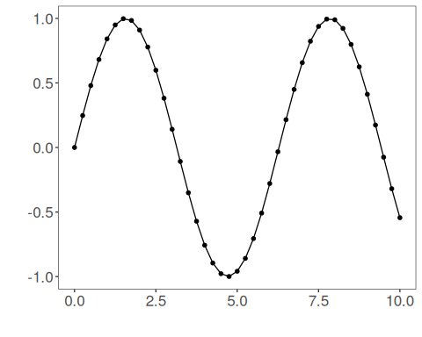
We now preserve the time order, split the data into train and test partitions, and project the windows into inputs and targets.
# Train-test split and projection (X, y)
samp <- ts_sample(ts, test_size = 5)
io_train <- ts_projection(samp$train)
io_test <- ts_projection(samp$test)
We now train the MLP forecaster on the prepared training data.
# Training the PyTorch MLP model
model <- torch_ts_mlp(
ts_norm_gminmax(),
input_size = 4,
hidden_sizes = c(64L, 32L, 16L),
epochs = 1000L,
batch_size = 16L
)
model <- fit(model, x = io_train$input, y = io_train$output)
Constructor configuration - Fixed-epoch baseline: omit epochs to use the default value, keep validation_strategy = "static", and stopping_rule = "none". - Static early stopping: keep validation_strategy = "static" and choose stopping_rule = "patience", "sma", "ema", or "h". - Dynamic early stopping: switch validation_strategy = "dynamic" and reuse the same stopping rules. - The final curve plot always shows train_loss_hist; it adds val_loss_hist when validation is active.
Architecture variations - activation changes the hidden nonlinearity. - normalization = "batch" or "layer" adds normalization after each hidden layer. - init_method controls how linear weights are initialized. - output_activation can constrain the forecast range when needed.
We first evaluate the in-sample fit so the model adjustment can be compared with the later forecast.
# Fit evaluation (train)
adjust <- predict(model, io_train$input)
adjust <- as.vector(adjust)
output <- as.vector(io_train$output)
ev_adjust <- evaluate(model, output, adjust)
ev_adjust$mse
## [1] 4.621556e-07
We now forecast the test set and compare the predicted values with the observed ones.
# Forecast on test set
steps_ahead <- 1
prediction <- predict(model, x = io_test$input, steps_ahead = steps_ahead)
prediction <- as.vector(prediction)
output <- as.vector(io_test$output)
if (steps_ahead > 1)
output <- output[1:steps_ahead]
print(sprintf("%.2f, %.2f", output, prediction))
## [1] "0.41, 0.41" "0.17, 0.17" "-0.08, -0.07" "-0.32, -0.32" "-0.54, -0.54"
This chunk evaluates the custom component on the held-out test segment.
# Test evaluation
ev_test <- evaluate(model, output, prediction)
print(head(ev_test$metrics))
## mse smape R2
## 1 1.479336e-07 0.00143209 0.9999987
print(sprintf("smape: %.2f", 100 * ev_test$metrics$smape))
## [1] "smape: 0.14"
This final plot summarizes the result of the transformation so the effect can be interpreted visually.
# Plot results
yvalues <- c(io_train$output, io_test$output)
plot_ts_pred(y = yvalues, yadj = adjust, ypre = prediction) + theme(text = element_text(size = 16))
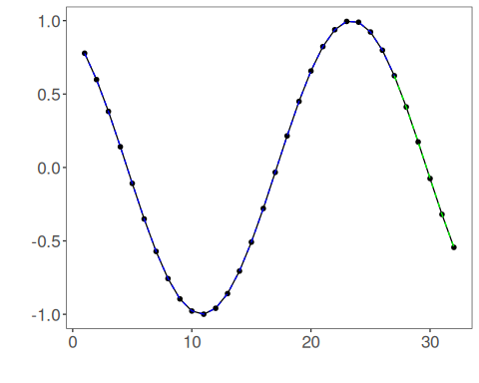
The additional plot below shows the training curve and, when enabled, the validation curve used by the unified early-stopping strategies.
# Training and validation curves
fit_loss <- data.frame(
x = seq_along(model$train_loss_hist),
train_loss = model$train_loss_hist
)
if (!is.null(model$val_loss_hist) && length(model$val_loss_hist) > 0) {
fit_loss$val_loss <- model$val_loss_hist
}
colors <- if ("val_loss" %in% names(fit_loss)) c("Blue", "Orange") else c("Blue")
grf <- plot_series(fit_loss, colors = colors)
plot(grf)
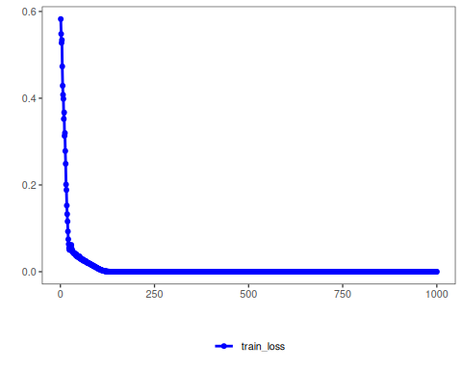
Notes - The default configuration is validation_strategy = "static" and stopping_rule = "none", so only the training curve is shown. - This example uses epochs = 1000L explicitly so the feedforward MLP reaches a competitive fit on this series. - To display validation loss as well, use an early-stopping rule such as "patience", "sma", "ema", or "h". - To combine dynamic validation with those criteria, set validation_strategy = "dynamic".
References - Bishop, C. M. (1995). Neural Networks for Pattern Recognition. - Paszke, A., et al. (2019). PyTorch: An Imperative Style, High-Performance Deep Learning Library.

