Conv1D Regression
About the method - A 1D convolutional network applies learnable filters across the lag window to detect local temporal motifs. - It is useful when short repeated patterns matter more than long global recurrence alone.
Didactic goal: understand how convolution changes the representation learned from sliding windows, while keeping the same Experiment Line used in tspredit.
# Time Series Regression - 1D CNN (Conv1D)
# Installing packages (if needed)
#install.packages("daltoolboxdp")
We start by loading the packages used throughout this example.
# Loading the packages
library(daltoolbox)
library(daltoolboxdp)
library(tspredit)
library(ggplot2)
We load the example series that will be used throughout the demonstration.
# Series for study and sliding windows
data(tsd)
ts <- ts_data(tsd$y, 10)
ts_head(ts, 3)
## t9 t8 t7 t6 t5 t4 t3 t2 t1 t0
## [1,] 0.0000000 0.2474040 0.4794255 0.6816388 0.8414710 0.9489846 0.9974950 0.9839859 0.9092974 0.7780732
## [2,] 0.2474040 0.4794255 0.6816388 0.8414710 0.9489846 0.9974950 0.9839859 0.9092974 0.7780732 0.5984721
## [3,] 0.4794255 0.6816388 0.8414710 0.9489846 0.9974950 0.9839859 0.9092974 0.7780732 0.5984721 0.3816610
Before moving on, we visualize the series so the effect of the next transformation can be compared against the original signal.
# Series visualization
plot_ts(x = tsd$x, y = tsd$y) + theme(text = element_text(size = 16))
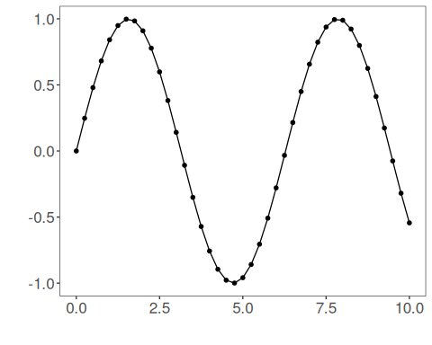
We now preserve the time order, split the data into train and test partitions, and project the windows into inputs and targets.
# Train-test split and projection (X, y)
samp <- ts_sample(ts, test_size = 5)
io_train <- ts_projection(samp$train)
io_test <- ts_projection(samp$test)
This step trains the Conv1D model.
# Training the Conv1D model
model <- ts_conv1d(ts_norm_gminmax(), input_size = 4)
model <- fit(model, x = io_train$input, y = io_train$output)
Constructor configuration - Fixed-epoch baseline: omit epochs to use the default value, keep validation_strategy = "static", and stopping_rule = "none". - Static early stopping: keep validation_strategy = "static" and choose stopping_rule = "patience", "sma", "ema", or "h". - Dynamic early stopping: switch validation_strategy = "dynamic" and reuse the same stopping rules. - The final curve plot always shows train_loss_hist; it adds val_loss_hist when validation is active.
Architecture variations - in_channels and sequence_length control how each row is reshaped before the convolution. - conv_channels, kernel_sizes, and strides define the convolutional stack. - pooling and dense_hidden_sizes control feature aggregation and the regression head.
We first evaluate the in-sample fit so the model adjustment can be compared with the later forecast.
# Fit evaluation (train)
adjust <- predict(model, io_train$input)
adjust <- as.vector(adjust)
output <- as.vector(io_train$output)
ev_adjust <- evaluate(model, output, adjust)
ev_adjust$mse
## [1] 0.000140831
We now forecast the test set and compare the predicted values with the observed ones.
# Forecast on test set
prediction <- predict(model, x = io_test$input[1, ], steps_ahead = 5)
prediction <- as.vector(prediction)
output <- as.vector(io_test$output)
ev_test <- evaluate(model, output, prediction)
ev_test
## $values
## [1] 0.41211849 0.17388949 -0.07515112 -0.31951919 -0.54402111
##
## $prediction
## [1] 0.42680154 0.19821316 -0.05069287 -0.30709041 -0.54469819
##
## $smape
## [1] 0.1190725
##
## $mse
## [1] 0.0003120745
##
## $R2
## [1] 0.9973046
##
## $metrics
## mse smape R2
## 1 0.0003120745 0.1190725 0.9973046
This final plot summarizes the result of the transformation so the effect can be interpreted visually.
# Plot results
yvalues <- c(io_train$output, io_test$output)
plot_ts_pred(y = yvalues, yadj = adjust, ypre = prediction) + theme(text = element_text(size = 16))
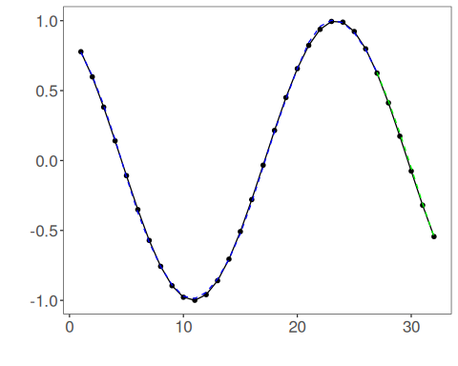
The additional plot below shows the training curve and, when enabled, the validation curve used by the unified early-stopping strategies.
# Training and validation curves
fit_loss <- data.frame(
x = seq_along(model$train_loss_hist),
train_loss = model$train_loss_hist
)
if (!is.null(model$val_loss_hist) && length(model$val_loss_hist) > 0) {
fit_loss$val_loss <- model$val_loss_hist
}
colors <- if ("val_loss" %in% names(fit_loss)) c("Blue", "Orange") else c("Blue")
grf <- plot_series(fit_loss, colors = colors)
plot(grf)
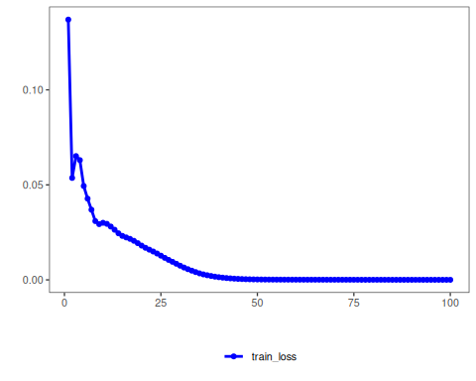
Notes - The default configuration is validation_strategy = "static" and stopping_rule = "none", so only the training curve is shown. - To display validation loss as well, use an early-stopping rule such as "patience", "sma", "ema", or "h". - To combine dynamic validation with those criteria, set validation_strategy = "dynamic".
References - Y. LeCun, L. Bottou, Y. Bengio, and P. Haffner (1998). Gradient-based learning applied to document recognition. Proceedings of the IEEE, 86(11), 2278–2324.

