21. LSTM Regression with Static Validation and Patience
About the method - LSTM networks are recurrent models designed to retain and update information across ordered inputs. - They are useful when forecasting depends on sequential dependencies that may span more than a few immediate lags.
Didactic goal: compare a recurrent sequence model with the feedforward and convolutional alternatives, while preserving the same Experiment Line used in tspredit.
# Time Series Regression - LSTM
# Installing packages (if needed)
#install.packages("daltoolboxdp")
We start by loading the packages used throughout this example.
# Loading the packages
library(daltoolbox)
library(daltoolboxdp)
library(tspredit)
library(ggplot2)
We load the example series that will be used throughout the demonstration.
# Series for study and sliding windows
data(tsd)
ts <- ts_data(tsd$y, 10)
ts_head(ts, 3)
## t9 t8 t7 t6 t5 t4 t3 t2 t1 t0
## [1,] 0.0000000 0.2474040 0.4794255 0.6816388 0.8414710 0.9489846 0.9974950 0.9839859 0.9092974 0.7780732
## [2,] 0.2474040 0.4794255 0.6816388 0.8414710 0.9489846 0.9974950 0.9839859 0.9092974 0.7780732 0.5984721
## [3,] 0.4794255 0.6816388 0.8414710 0.9489846 0.9974950 0.9839859 0.9092974 0.7780732 0.5984721 0.3816610
Before moving on, we visualize the series so the effect of the next transformation can be compared against the original signal.
# Series visualization
plot_ts(x = tsd$x, y = tsd$y) + theme(text = element_text(size = 16))
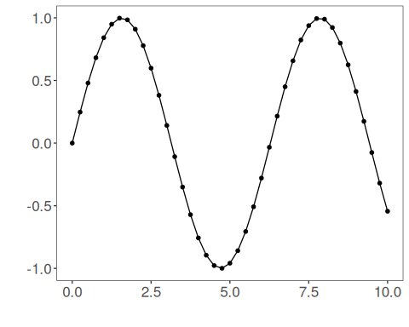
We now preserve the time order, split the data into train and test partitions, and project the windows into inputs and targets.
# Train-test split and projection (X, y)
samp <- ts_sample(ts, test_size = 5)
io_train <- ts_projection(samp$train)
io_test <- ts_projection(samp$test)
We now train the LSTM model with a fixed validation partition and patience-based early stopping.
# Training the LSTM model
model <- ts_lstm(
ts_norm_gminmax(),
input_size = 9,
sequence_length = 3L,
hidden_size = 16L,
epochs = 300L,
validation_strategy = "static",
stopping_rule = "patience",
patience = 20L
)
model <- fit(model, x = io_train$input, y = io_train$output)
Constructor configuration - validation_strategy = "static" keeps the validation subset fixed across the whole run. - stopping_rule = "patience" stops training when validation loss stops improving for the configured number of epochs. - epochs = 300L is only an upper bound here; the effective training length is controlled by early stopping. - The final curve plot shows both train_loss_hist and val_loss_hist.
Architecture variations - sequence_length converts each row into a true multistep sequence instead of a single recurrent step. - hidden_size, num_layers, dropout, and bidirectional change the recurrent backbone. - mlp_hidden_sizes adds a dense head after the final recurrent state. - In this example, input_size = 9 matches the nine lagged predictors produced by ts_projection(), and sequence_length = 3L turns them into three temporal steps with three features each. - This example emphasizes interpretability of the validation curve, because all epochs are judged against the same holdout partition.
We first evaluate the in-sample fit so the model adjustment can be compared with the later forecast.
# Fit evaluation (train)
adjust <- predict(model, io_train$input)
adjust <- as.vector(adjust)
output <- as.vector(io_train$output)
ev_adjust <- evaluate(model, output, adjust)
ev_adjust$mse
## [1] 0.001658215
We now forecast the test set and compare the predicted values with the observed ones.
# Forecast on test set
steps_ahead <- 1
prediction <- predict(model, x = io_test$input, steps_ahead = steps_ahead)
prediction <- as.vector(prediction)
output <- as.vector(io_test$output)
if (steps_ahead > 1)
output <- output[1:steps_ahead]
print(sprintf("%.2f, %.2f", output, prediction))
## [1] "0.41, 0.40" "0.17, 0.17" "-0.08, -0.08" "-0.32, -0.33" "-0.54, -0.55"
This chunk evaluates the custom component on the held-out test segment.
# Test evaluation
ev_test <- evaluate(model, output, prediction)
print(head(ev_test$metrics))
## mse smape R2
## 1 6.048172e-05 0.03659147 0.9994776
print(sprintf("smape: %.2f", 100 * ev_test$metrics$smape))
## [1] "smape: 3.66"
This final plot summarizes the result of the transformation so the effect can be interpreted visually.
# Plot results
yvalues <- c(io_train$output, io_test$output)
plot_ts_pred(y = yvalues, yadj = adjust, ypre = prediction) + theme(text = element_text(size = 16))
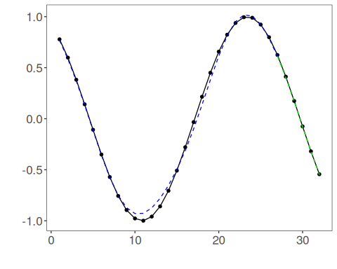
The additional plot below shows the training curve and, when enabled, the validation curve used by the unified early-stopping strategies.
# Training and validation curves
fit_loss <- data.frame(
x = seq_along(model$train_loss_hist),
train_loss = model$train_loss_hist
)
if (!is.null(model$val_loss_hist) && length(model$val_loss_hist) > 0) {
fit_loss$val_loss <- model$val_loss_hist
}
colors <- if ("val_loss" %in% names(fit_loss)) c("Blue", "Orange") else c("Blue")
grf <- plot_series(fit_loss, colors = colors)
plot(grf)
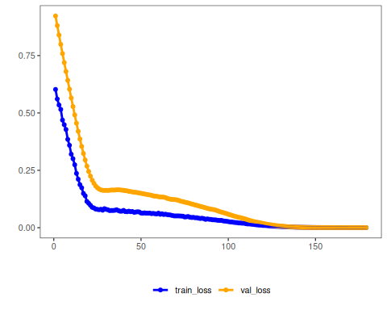
# Effective training duration
print(model$epochs_done)
## [1] 179
Notes - This configuration is useful when you want a stable validation reference across epochs. - To compare with redrawn validation splits, see 22_ts_lstm_dynamic_patience.
References - S. Hochreiter and J. Schmidhuber (1997). Long short-term memory. Neural Computation, 9(8), 1735–1780.

