Time Series Forecasting with Conv1D
This example shows how to use the PyTorch-backed ts_conv1d forecaster with sliding windows from tspredit. The model uses 1D convolutions over the lag window to learn local temporal patterns before the final prediction.
Prerequisites - R packages: daltoolbox, tspredit, daltoolboxdp, ggplot2 - Python with PyTorch accessible via reticulate
library(daltoolbox)
library(tspredit)
library(daltoolboxdp)
library(ggplot2)
data(tsd)
sw_size <- 5
ts <- data.frame(unclass(ts_data(tsd$y, sw_size)))
split_at <- nrow(ts) - 5
train <- ts[1:split_at, ]
test <- ts[(split_at + 1):nrow(ts), ]
model <- ts_conv1d(
preprocess = ts_norm_gminmax(),
input_size = 4L,
epochs = 100L
)
model <- fit(model, train[, 1:4], train[, 5])
# Training curves
fit_loss <- data.frame(
x = seq_along(model$train_loss_hist),
train_loss = model$train_loss_hist
)
if (!is.null(model$val_loss_hist) && length(model$val_loss_hist) > 0) {
fit_loss$val_loss <- model$val_loss_hist
}
colors <- if ("val_loss" %in% names(fit_loss)) c("Blue", "Orange") else c("Blue")
grf <- plot_series(fit_loss, colors = colors)
plot(grf)
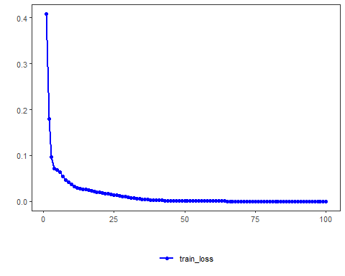
# One-step-ahead prediction on the test windows
prediction <- predict(model, test[, 1:4])
print(prediction)
## [1] 0.41001562 0.16947048 -0.07644035 -0.31325250 -0.55243968
Notes - The default configuration is validation_strategy = "static" and stopping_rule = "none", so only the training curve is shown. - To include validation loss, choose an early-stopping rule such as "patience", "sma", "ema", or "h".
References - LeCun, Y., Bengio, Y., & Hinton, G. (2015). Deep learning.

