Time Series Forecasting with LSTM
This example shows how to use the PyTorch-backed ts_lstm forecaster. The workflow follows the tspredit sliding-window approach: transform a univariate series into lagged windows, fit the model, inspect training curves, and generate one-step-ahead predictions on the hold-out windows.
Prerequisites - R packages: daltoolbox, tspredit, daltoolboxdp, ggplot2 - Python with PyTorch accessible via reticulate
library(daltoolbox)
library(tspredit)
library(daltoolboxdp)
library(ggplot2)
data(tsd)
sw_size <- 5
ts <- data.frame(unclass(ts_data(tsd$y, sw_size)))
split_at <- nrow(ts) - 5
train <- ts[1:split_at, ]
test <- ts[(split_at + 1):nrow(ts), ]
model <- ts_lstm(
preprocess = ts_norm_gminmax(),
input_size = 4L,
epochs = 100L
)
model <- fit(model, train[, 1:4], train[, 5])
# Training curves
fit_loss <- data.frame(
x = seq_along(model$train_loss_hist),
train_loss = model$train_loss_hist
)
if (!is.null(model$val_loss_hist) && length(model$val_loss_hist) > 0) {
fit_loss$val_loss <- model$val_loss_hist
}
colors <- if ("val_loss" %in% names(fit_loss)) c("Blue", "Orange") else c("Blue")
grf <- plot_series(fit_loss, colors = colors)
plot(grf)
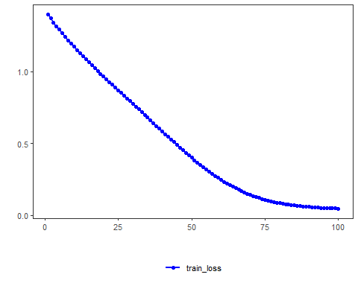
# One-step-ahead prediction on the test windows
prediction <- predict(model, test[, 1:4])
print(prediction)
## [1] 0.51126825 0.45296308 0.36484097 0.24459286 0.09328788
Notes - The default configuration is validation_strategy = "static" and stopping_rule = "none", so only the training curve is shown. - To display validation loss as well, use an early-stopping rule such as "patience", "sma", "ema", or "h".
References - Hochreiter, S., & Schmidhuber, J. (1997). Long short-term memory.

