Convolutional Autoencoder (encode)
Convolutional autoencoders apply 1D convolutions to capture local patterns within windows. The encoder compresses the input via learned filters and pooling (if used), while the decoder reconstructs from the compact code. This inductive bias suits structured temporal neighborhoods.
This example demonstrates how to use a 1D convolutional autoencoder to encode windows from a time series, reducing from p to k dimensions while preserving relevant information.
Prerequisites - Python with PyTorch accessible via reticulate - R packages: daltoolbox, tspredit, daltoolboxdp, ggplot2
Quick notes - Architecture: Conv1D layers in encoder/decoder to capture local patterns in each window. - Useful when there are local structures (short trends, repeating patterns) within the window.
# Convolutional Autoencoder transformation (encode)
# Considering a dataset with $p$ numerical attributes.
# The goal of the autoencoder is to reduce the dimension of $p$ to $k$, such that these $k$ attributes are enough to recompose the original $p$ attributes.
# Installing packages
#install.packages("tspredit")
#install.packages("daltoolboxdp")
# Loading packages
library(daltoolbox)
library(tspredit)
library(daltoolboxdp)
library(ggplot2)
# Example dataset (series -> windows)
data(tsd)
sw_size <- 5
ts <- ts_data(tsd$y, sw_size)
ts_head(ts)
## t4 t3 t2 t1 t0
## [1,] 0.0000000 0.2474040 0.4794255 0.6816388 0.8414710
## [2,] 0.2474040 0.4794255 0.6816388 0.8414710 0.9489846
## [3,] 0.4794255 0.6816388 0.8414710 0.9489846 0.9974950
## [4,] 0.6816388 0.8414710 0.9489846 0.9974950 0.9839859
## [5,] 0.8414710 0.9489846 0.9974950 0.9839859 0.9092974
## [6,] 0.9489846 0.9974950 0.9839859 0.9092974 0.7780732
# Normalization (min-max by group)
preproc <- ts_norm_gminmax()
preproc <- fit(preproc, ts)
ts <- transform(preproc, ts)
ts_head(ts)
## t4 t3 t2 t1 t0
## [1,] 0.5004502 0.6243512 0.7405486 0.8418178 0.9218625
## [2,] 0.6243512 0.7405486 0.8418178 0.9218625 0.9757058
## [3,] 0.7405486 0.8418178 0.9218625 0.9757058 1.0000000
## [4,] 0.8418178 0.9218625 0.9757058 1.0000000 0.9932346
## [5,] 0.9218625 0.9757058 1.0000000 0.9932346 0.9558303
## [6,] 0.9757058 1.0000000 0.9932346 0.9558303 0.8901126
# Train/test split
samp <- ts_sample(ts, test_size = 10)
train <- as.data.frame(samp$train)
test <- as.data.frame(samp$test)
# Training autoencoder (reduce 5 -> 3)
auto <- autoenc_conv_e(5, 3)
auto <- fit(auto, train)
Constructor configuration - Fixed-epoch baseline: omit epochs to use the default value and keep validation_strategy = "static" with stopping_rule = "none". - Static early stopping: keep validation_strategy = "static" and choose stopping_rule = "patience", "sma", "ema", or "h". - Dynamic early stopping: switch validation_strategy = "dynamic" and reuse the same stopping rules. - The loss plot below always shows train_loss; it adds val_loss when validation is active.
fit_loss <- data.frame(x = seq_along(auto$train_loss), train_loss = auto$train_loss)
if (!is.null(auto$val_loss) && length(auto$val_loss) > 0) {
fit_loss$val_loss <- auto$val_loss
}
colors <- if ("val_loss" %in% names(fit_loss)) c("Blue", "Orange") else c("Blue")
grf <- plot_series(fit_loss, colors = colors)
plot(grf)
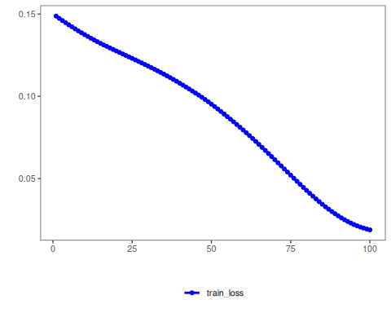
# The curves show the loss evolution; stable decreases indicate good learning
# Testing the autoencoder
# Show test samples and display encoding
print(head(test))
## t4 t3 t2 t1 t0
## 1 0.7258342 0.8294719 0.9126527 0.9702046 0.9985496
## 2 0.8294719 0.9126527 0.9702046 0.9985496 0.9959251
## 3 0.9126527 0.9702046 0.9985496 0.9959251 0.9624944
## 4 0.9702046 0.9985496 0.9959251 0.9624944 0.9003360
## 5 0.9985496 0.9959251 0.9624944 0.9003360 0.8133146
## 6 0.9959251 0.9624944 0.9003360 0.8133146 0.7068409
result <- transform(auto, test)
print(head(result))
## [,1] [,2] [,3]
## [1,] -1.173076 -0.5960507 -1.1396550
## [2,] -1.279619 -0.6703183 -1.2609624
## [3,] -1.326293 -0.6788120 -1.3074102
## [4,] -1.304490 -0.6172864 -1.2724645
## [5,] -1.216148 -0.4984950 -1.1649903
## [6,] -1.061418 -0.3276087 -0.9852813
References - Masci, J., Meier, U., Ciresan, D., & Schmidhuber, J. (2011). Stacked Convolutional Auto-Encoders for Hierarchical Feature Extraction. ICANN.

