Time-Series MLP Regression
About the method - torch_ts_mlp uses a feedforward multilayer perceptron over lagged windows. - It is the direct PyTorch MLP counterpart to the recurrent and convolutional forecasters already available in this package.
Didactic goal: compare a plain feedforward forecaster with ts_lstm and ts_conv1d, while preserving the same Experiment Line used in tspredit.
# Time Series Regression - PyTorch MLP
# Installing packages (if needed)
#install.packages("daltoolboxdp")
We start by loading the packages used throughout this example.
# Loading the packages
library(daltoolbox)
library(daltoolboxdp)
library(tspredit)
library(ggplot2)
We load the example series that will be used throughout the demonstration.
# Series for study and sliding windows
data(tsd)
ts <- ts_data(tsd$y, 10)
ts_head(ts, 3)
## t9 t8 t7 t6 t5 t4 t3
## [1,] 0.0000000 0.2474040 0.4794255 0.6816388 0.8414710 0.9489846 0.9974950
## [2,] 0.2474040 0.4794255 0.6816388 0.8414710 0.9489846 0.9974950 0.9839859
## [3,] 0.4794255 0.6816388 0.8414710 0.9489846 0.9974950 0.9839859 0.9092974
## t2 t1 t0
## [1,] 0.9839859 0.9092974 0.7780732
## [2,] 0.9092974 0.7780732 0.5984721
## [3,] 0.7780732 0.5984721 0.3816610
Before moving on, we visualize the series so the effect of the next transformation can be compared against the original signal.
# Series visualization
plot_ts(x = tsd$x, y = tsd$y) + theme(text = element_text(size = 16))
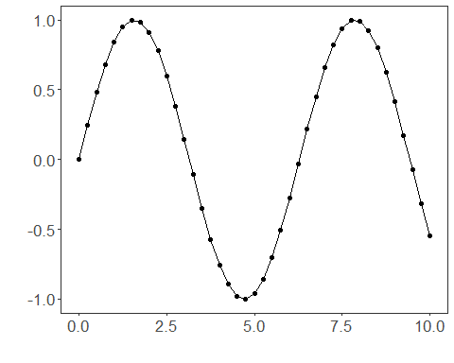
We now preserve the time order, split the data into train and test partitions, and project the windows into inputs and targets.
# Train-test split and projection (X, y)
samp <- ts_sample(ts, test_size = 5)
io_train <- ts_projection(samp$train)
io_test <- ts_projection(samp$test)
We now train the MLP forecaster on the prepared training data.
# Training the PyTorch MLP model
model <- torch_ts_mlp(ts_norm_gminmax(), input_size = 4, hidden_sizes = c(16L, 8L))
model <- fit(model, x = io_train$input, y = io_train$output)
Constructor configuration - Fixed-epoch baseline: omit epochs to use the default value, keep validation_strategy = "static", and stopping_rule = "none". - Static early stopping: keep validation_strategy = "static" and choose stopping_rule = "patience", "sma", "ema", or "h". - Dynamic early stopping: switch validation_strategy = "dynamic" and reuse the same stopping rules. - The final curve plot always shows train_loss_hist; it adds val_loss_hist when validation is active.
We first evaluate the in-sample fit so the model adjustment can be compared with the later forecast.
# Fit evaluation (train)
adjust <- predict(model, io_train$input)
adjust <- as.vector(adjust)
output <- as.vector(io_train$output)
ev_adjust <- evaluate(model, output, adjust)
ev_adjust$mse
## [1] 1.383876
We now forecast the test set and compare the predicted values with the observed ones.
# Forecast on test set
steps_ahead <- 1
prediction <- predict(model, x = io_test$input, steps_ahead = steps_ahead)
prediction <- as.vector(prediction)
output <- as.vector(io_test$output)
if (steps_ahead > 1)
output <- output[1:steps_ahead]
print(sprintf("%.2f, %.2f", output, prediction))
## [1] "0.41, -0.86" "0.17, -0.87" "-0.08, -0.89" "-0.32, -0.91" "-0.54, -0.93"
This chunk evaluates the custom component on the held-out test segment.
# Test evaluation
ev_test <- evaluate(model, output, prediction)
print(head(ev_test$metrics))
## mse smape R2
## 1 0.7720111 1.432987 -5.667899
print(sprintf("smape: %.2f", 100 * ev_test$metrics$smape))
## [1] "smape: 143.30"
This final plot summarizes the result of the transformation so the effect can be interpreted visually.
# Plot results
yvalues <- c(io_train$output, io_test$output)
plot_ts_pred(y = yvalues, yadj = adjust, ypre = prediction) + theme(text = element_text(size = 16))
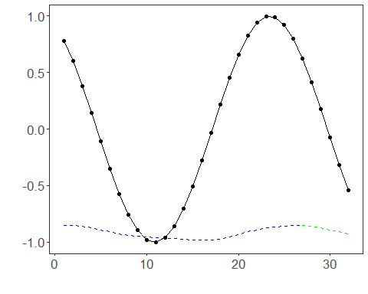
The additional plot below shows the training curve and, when enabled, the validation curve used by the unified early-stopping strategies.
# Training and validation curves
fit_loss <- data.frame(
x = seq_along(model$train_loss_hist),
train_loss = model$train_loss_hist
)
if (!is.null(model$val_loss_hist) && length(model$val_loss_hist) > 0) {
fit_loss$val_loss <- model$val_loss_hist
}
colors <- if ("val_loss" %in% names(fit_loss)) c("Blue", "Orange") else c("Blue")
grf <- plot_series(fit_loss, colors = colors)
plot(grf)
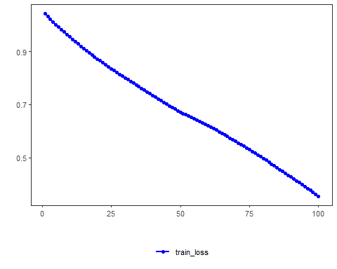
Notes - The default configuration is validation_strategy = "static" and stopping_rule = "none", so only the training curve is shown. - To display validation loss as well, use an early-stopping rule such as "patience", "sma", "ema", or "h". - To combine dynamic validation with those criteria, set validation_strategy = "dynamic".
References - Bishop, C. M. (1995). Neural Networks for Pattern Recognition. - Paszke, A., et al. (2019). PyTorch: An Imperative Style, High-Performance Deep Learning Library.

