Time Series Encoding (encode)
We use a sliding-window embedding to convert a univariate series into fixed-length vectors of length p. A feed-forward autoencoder is trained to minimize reconstruction error, and its bottleneck (k < p) provides a compact encoding that preserves salient information for downstream tasks.
This example shows how to transform a time series into fixed-size windows and train an autoencoder to learn a compact latent representation (p -> k) of these windows.
Prerequisites - R packages: daltoolbox, ggplot2 - Python with PyTorch accessible via reticulate (the backend is loaded by internal functions)
# Loading required packages
library(daltoolbox)
Series for study
data(tsd)
tsd$y[39] <- tsd$y[39] * 6 # inject a synthetic outlier for illustration in the plot
sw_size <- 5 # sliding window size (p)
ts <- ts_data(tsd$y, sw_size) # convert the series into windows with p columns
ts_head(ts, 3) # view the first 3 windows
## t4 t3 t2 t1 t0
## [1,] 0.0000000 0.2474040 0.4794255 0.6816388 0.8414710
## [2,] 0.2474040 0.4794255 0.6816388 0.8414710 0.9489846
## [3,] 0.4794255 0.6816388 0.8414710 0.9489846 0.9974950
library(ggplot2)
plot_ts(x = tsd$x, y = tsd$y) + # series plot with the outlier peak
theme(text = element_text(size = 16))
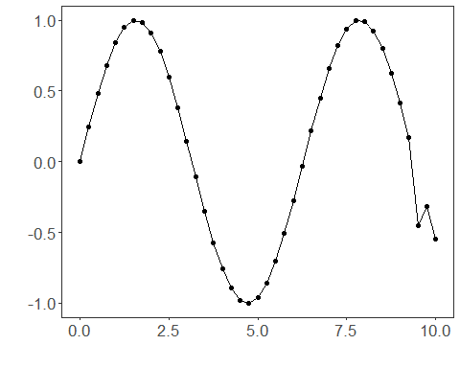
Data sampling
samp <- ts_sample(ts, test_size = 5) # hold out the last 5 windows for test
train <- as.data.frame(samp$train)
test <- as.data.frame(samp$test)
Train the model
auto <- autoenc_e(5, 3) # reduce from 5 -> 3 dimensions (p -> k)
auto <- fit(auto, train)
Encoding evaluation (train)
print(head(train)) # original windows (p columns)
## t4 t3 t2 t1 t0
## 1 0.0000000 0.2474040 0.4794255 0.6816388 0.8414710
## 2 0.2474040 0.4794255 0.6816388 0.8414710 0.9489846
## 3 0.4794255 0.6816388 0.8414710 0.9489846 0.9974950
## 4 0.6816388 0.8414710 0.9489846 0.9974950 0.9839859
## 5 0.8414710 0.9489846 0.9974950 0.9839859 0.9092974
## 6 0.9489846 0.9974950 0.9839859 0.9092974 0.7780732
result <- transform(auto, train) # encodings (k columns)
print(head(result))
## [,1] [,2] [,3]
## [1,] -0.58791876 -0.6623528 0.4329058
## [2,] -0.46181139 -0.8707486 0.5909081
## [3,] -0.29848197 -1.0075243 0.7167485
## [4,] -0.09607549 -1.0844626 0.7987470
## [5,] 0.09359595 -1.1052122 0.8367527
## [6,] 0.25734141 -1.0621089 0.8263159
Encoding of the test set
print(head(test))
## t4 t3 t2 t1 t0
## 1 0.9893582 0.9226042 0.7984871 0.6247240 0.4121185
## 2 0.9226042 0.7984871 0.6247240 0.4121185 0.1738895
## 3 0.7984871 0.6247240 0.4121185 0.1738895 -0.4509067
## 4 0.6247240 0.4121185 0.1738895 -0.4509067 -0.3195192
## 5 0.4121185 0.1738895 -0.4509067 -0.3195192 -0.5440211
result <- transform(auto, test)
print(head(result))
## [,1] [,2] [,3]
## [1,] 0.4616863 -0.8077081 0.6694039
## [2,] 0.4942211 -0.5852442 0.5281265
## [3,] 0.6992936 -0.1135772 0.3044598
## [4,] 0.5753309 0.2230003 0.1322699
## [5,] 0.3480665 0.6163263 -0.1515697
References - Goodfellow, I., Bengio, Y., & Courville, A. (2016). Deep Learning. MIT Press. (Chapter on Autoencoders)

