22. Autoencoder (Encode-Decode) with Dynamic Validation and Patience
This example keeps the same simple dense autoencoder architecture, but redraws the validation split at each epoch. It is useful when a single fixed holdout seems too brittle for the available data.
Prerequisites - Reticulate configured and Python with PyTorch installed - R packages: daltoolbox, tspredit, daltoolboxdp, ggplot2
# Installing packages
#install.packages("tspredit")
#install.packages("daltoolboxdp")
# Loading packages
library(daltoolbox)
library(tspredit)
library(daltoolboxdp)
library(ggplot2)
# Example dataset (series -> windows)
data(tsd)
sw_size <- 5
ts <- ts_data(tsd$y, sw_size)
preproc <- ts_norm_gminmax()
preproc <- fit(preproc, ts)
ts <- transform(preproc, ts)
samp <- ts_sample(ts, test_size = 10)
train <- as.data.frame(samp$train)
test <- as.data.frame(samp$test)
# Dynamic validation with patience-based early stopping
auto <- autoenc_ed(
5, 3,
epochs = 300L,
validation_strategy = "dynamic",
stopping_rule = "patience",
patience = 20L,
val_ratio = 0.2
)
auto <- fit(auto, train)
Training configuration - validation_strategy = "dynamic" redraws the validation split at each epoch. - stopping_rule = "patience" stops training when recent validation values stop improving enough. - epochs = 300L is only a ceiling; the realized duration depends on early stopping.
# Effective training duration
print(length(auto$train_loss))
## [1] 198
# Training and validation curves
fit_loss <- data.frame(x = seq_along(auto$train_loss), train_loss = auto$train_loss)
if (!is.null(auto$val_loss) && length(auto$val_loss) > 0) {
fit_loss$val_loss <- auto$val_loss
}
colors <- if ("val_loss" %in% names(fit_loss)) c("Blue", "Orange") else c("Blue")
grf <- plot_series(fit_loss, colors = colors)
plot(grf)
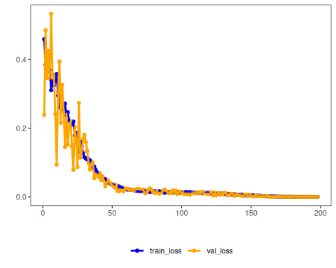
# Testing: reconstruction of the test set
result <- transform(auto, test)
result <- as.data.frame(result)
names(result) <- names(test)
print(head(result))
## t4 t3 t2 t1 t0
## 1 0.7341992 0.8316329 0.9144543 0.9783357 0.9959475
## 2 0.8392407 0.9183757 0.9663505 0.9922336 0.9854301
## 3 0.9220429 0.9817311 0.9886963 0.9766881 0.9470644
## 4 0.9825926 1.0155282 0.9854522 0.9344487 0.8853105
## 5 1.0114759 1.0120234 0.9533769 0.8667711 0.8000152
## 6 1.0051498 0.9787415 0.8955949 0.7792678 0.6946990
Notes - Dynamic validation typically produces a noisier validation curve than the static case. - To compare with a fixed validation split, see 21_autoenc_ed_static_patience.
References - Goodfellow, I., Bengio, Y., & Courville, A. (2016). Deep Learning. MIT Press. (Chapter on Autoencoders)

