PyTorch Multi-Layer Perceptron (MLP) Classifier
This example uses the PyTorch-backed MLP classifier exposed by daltoolboxdp to classify the Iris dataset. The workflow mirrors the scikit-learn MLP example: split train/test, train, predict, and evaluate.
Prerequisites - R packages: daltoolbox, daltoolboxdp - Python with PyTorch accessible via reticulate
# Installation (if needed)
#install.packages("daltoolboxdp")
library(daltoolbox)
library(daltoolboxdp)
# Loading Iris dataset
iris <- datasets::iris
# Training and evaluation with PyTorch MLP
slevels <- levels(iris$Species)
set.seed(1)
sr <- sample_random()
sr <- train_test(sr, iris)
iris_train <- sr$train
iris_test <- sr$test
model <- torch_cla_mlp(
attribute = "Species",
slevels = slevels,
input_size = 4L,
hidden_sizes = c(16L, 8L),
num_classes = 3L,
epochs = 1000L
)
model <- fit(model, iris_train)
train_prediction <- predict(model, iris_train)
iris_train_predictand <- adjust_class_label(iris_train[, "Species"])
train_eval <- evaluate(model, iris_train_predictand, train_prediction)
print(train_eval$metrics)
## accuracy TP TN FP FN precision recall sensitivity specificity f1
## 1 0.975 39 81 0 0 1 1 1 1 1
Constructor configuration - Fixed-epoch baseline: omit epochs to use the default value of 100L, keep validation_strategy = "static", and stopping_rule = "none". - Static early stopping: keep validation_strategy = "static" and switch stopping_rule to "patience", "sma", "ema", or "h". - Dynamic early stopping: switch validation_strategy = "dynamic" and use the same stopping rules. - The curve plot below always shows train_loss_hist; it adds val_loss_hist when validation is active.
Architecture variations - Use normalization = "batch" or "layer" to stabilize deeper classifiers. - init_method lets you switch from PyTorch defaults to Xavier or Kaiming initialization. - activation changes the hidden nonlinearity without changing the public workflow.
# Test prediction and evaluation
test_prediction <- predict(model, iris_test)
iris_test_predictand <- adjust_class_label(iris_test[, "Species"])
test_eval <- evaluate(model, iris_test_predictand, test_prediction)
print(test_eval$metrics)
## accuracy TP TN FP FN precision recall sensitivity specificity f1
## 1 1 11 19 0 0 1 1 1 1 1
# Training and validation curves
fit_loss <- data.frame(
x = seq_along(model$train_loss_hist),
train_loss = model$train_loss_hist
)
if (!is.null(model$val_loss_hist) && length(model$val_loss_hist) > 0) {
fit_loss$val_loss <- model$val_loss_hist
}
colors <- if ("val_loss" %in% names(fit_loss)) c("Blue", "Orange") else c("Blue")
grf <- plot_series(fit_loss, colors = colors)
plot(grf)
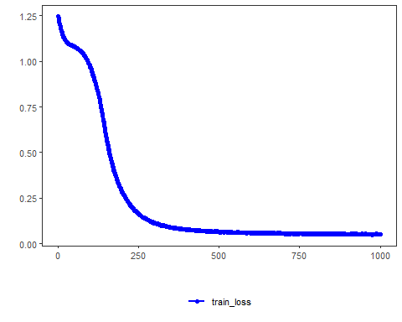
Notes - By default, this example uses validation_strategy = "static" and stopping_rule = "none", so only the training curve is shown. - To enable early stopping, change stopping_rule to "patience", "sma", "ema", or "h". - To switch to the dynamic split, use validation_strategy = "dynamic".
References - Rumelhart, D. E., Hinton, G. E., & Williams, R. J. (1986). Learning representations by back-propagating errors. - Paszke, A., et al. (2019). PyTorch: An Imperative Style, High-Performance Deep Learning Library.

