08. PyTorch MLP Classifier with Dynamic Validation and Patience
This example focuses on the training regime rather than only the network architecture. It shows how to train the PyTorch-backed MLP classifier with a dynamic validation split and patience-based early stopping.
Prerequisites - R packages: daltoolbox, daltoolboxdp - Python with PyTorch accessible via reticulate
# Installation (if needed)
#install.packages("daltoolboxdp")
library(daltoolbox)
library(daltoolboxdp)
# Loading Iris dataset
iris <- datasets::iris
# Train/test split
slevels <- levels(iris$Species)
set.seed(1)
sr <- sample_random()
sr <- train_test(sr, iris)
iris_train <- sr$train
iris_test <- sr$test
# Dynamic validation with patience-based early stopping
model <- torch_cla_mlp(
attribute = "Species",
slevels = slevels,
input_size = 4L,
hidden_sizes = c(16L, 8L),
num_classes = 3L,
epochs = 300L,
validation_strategy = "dynamic",
stopping_rule = "patience",
patience = 20L,
val_ratio = 0.2
)
model <- fit(model, iris_train)
Training configuration - validation_strategy = "dynamic" redraws the train/validation split at each epoch. - stopping_rule = "patience" stops training after a chosen number of epochs without meaningful validation improvement. - epochs = 300L is an upper bound here; the effective number of epochs is controlled by early stopping.
# Training evaluation
train_prediction <- predict(model, iris_train)
iris_train_predictand <- adjust_class_label(iris_train[, "Species"])
train_eval <- evaluate(model, iris_train_predictand, train_prediction)
print(train_eval$metrics)
## accuracy TP TN FP FN precision recall sensitivity specificity f1
## 1 0.6916667 39 81 0 0 1 1 1 1 1
# Test evaluation
test_prediction <- predict(model, iris_test)
iris_test_predictand <- adjust_class_label(iris_test[, "Species"])
test_eval <- evaluate(model, iris_test_predictand, test_prediction)
print(test_eval$metrics)
## accuracy TP TN FP FN precision recall sensitivity specificity f1
## 1 0.6333333 11 19 0 0 1 1 1 1 1
# Effective training duration
print(model$epochs_done)
## [1] 151
# Training and validation curves
fit_loss <- data.frame(
x = seq_along(model$train_loss_hist),
train_loss = model$train_loss_hist
)
if (!is.null(model$val_loss_hist) && length(model$val_loss_hist) > 0) {
fit_loss$val_loss <- model$val_loss_hist
}
colors <- if ("val_loss" %in% names(fit_loss)) c("Blue", "Orange") else c("Blue")
grf <- plot_series(fit_loss, colors = colors)
plot(grf)
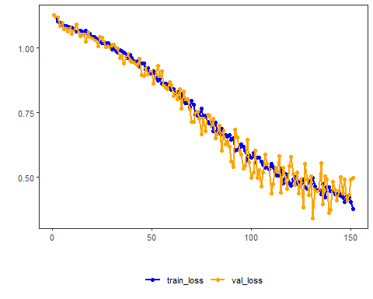
Notes - This example is useful when a fixed validation partition feels too brittle on smaller datasets. - To compare behaviors, keep the same architecture and swap only stopping_rule among "patience", "sma", "ema", and "h". - To return to the default baseline, set validation_strategy = "static" and stopping_rule = "none".
References - Rumelhart, D. E., Hinton, G. E., & Williams, R. J. (1986). Learning representations by back-propagating errors. - Paszke, A., et al. (2019). PyTorch: An Imperative Style, High-Performance Deep Learning Library.

