About the method - torch_reg_mlp: PyTorch-backed multilayer perceptron for regression. - Hyperparameters: hidden_sizes (hidden-layer width/depth), dropout, epochs, lr, and the unified validation/early-stopping controls.
Didactic goal: read this example as the same numeric-prediction workflow used by reg_mlp. The Experiment Line stays the same; the practical change is the constructor.
Environment setup.
# Regression MLP with PyTorch
# installation
#install.packages("daltoolboxdp")
# loading DAL
library(daltoolbox)
library(daltoolboxdp)
Load Boston dataset (MASS) and inspect types.
# Dataset for regression analysis
library(MASS)
data(Boston)
print(t(sapply(Boston, class)))
## crim zn indus chas nox rm age
## [1,] "numeric" "numeric" "numeric" "integer" "numeric" "numeric" "numeric"
## dis rad tax ptratio black lstat medv
## [1,] "numeric" "integer" "numeric" "numeric" "numeric" "numeric" "numeric"
head(Boston)
## crim zn indus chas nox rm age dis rad tax ptratio black lstat
## 1 0.00632 18 2.31 0 0.538 6.575 65.2 4.0900 1 296 15.3 396.90 4.98
## 2 0.02731 0 7.07 0 0.469 6.421 78.9 4.9671 2 242 17.8 396.90 9.14
## 3 0.02729 0 7.07 0 0.469 7.185 61.1 4.9671 2 242 17.8 392.83 4.03
## 4 0.03237 0 2.18 0 0.458 6.998 45.8 6.0622 3 222 18.7 394.63 2.94
## 5 0.06905 0 2.18 0 0.458 7.147 54.2 6.0622 3 222 18.7 396.90 5.33
## 6 0.02985 0 2.18 0 0.458 6.430 58.7 6.0622 3 222 18.7 394.12 5.21
## medv
## 1 24.0
## 2 21.6
## 3 34.7
## 4 33.4
## 5 36.2
## 6 28.7
Optional conversion to matrix.
# for performance, you can convert to matrix
Boston <- as.matrix(Boston)
Random and reproducible train/test split.
# preparing dataset for random sampling
set.seed(1)
sr <- sample_random()
sr <- train_test(sr, Boston)
boston_train <- sr$train
boston_test <- sr$test
Train MLP: define the hidden architecture and training controls.
# Training
model <- torch_reg_mlp(
attribute = "medv",
input_size = ncol(Boston) - 1L,
hidden_sizes = c(16L, 8L),
epochs = 1000L
)
model <- fit(model, boston_train)
Constructor configuration - Fixed-epoch baseline: omit epochs to use the default value of 100L, keep validation_strategy = "static", and stopping_rule = "none". - Static early stopping: keep validation_strategy = "static" and choose stopping_rule = "patience", "sma", "ema", or "h". - Dynamic early stopping: switch validation_strategy = "dynamic" and reuse the same stopping rules. - The curve plot below always shows train_loss_hist; it adds val_loss_hist when validation is active.
Architecture variations - activation and normalization control the hidden blocks. - output_activation can restrict the prediction range when required by the domain. - init_method exposes the initialization strategy for deeper or more sensitive regressors.
Training evaluation.
# Model adjustment
train_prediction <- predict(model, boston_train)
boston_train_predictand <- boston_train[, "medv"]
train_eval <- evaluate(model, boston_train_predictand, train_prediction)
print(train_eval$metrics)
## mse smape R2
## 1 11.74771 0.1285341 0.8694819
Test evaluation.
# Test
test_prediction <- predict(model, boston_test)
boston_test_predictand <- boston_test[, "medv"]
test_eval <- evaluate(model, boston_test_predictand, test_prediction)
print(test_eval$metrics)
## mse smape R2
## 1 20.74642 0.1489793 0.6552343
Training curves.
# Training and validation curves
fit_loss <- data.frame(
x = seq_along(model$train_loss_hist),
train_loss = model$train_loss_hist
)
if (!is.null(model$val_loss_hist) && length(model$val_loss_hist) > 0) {
fit_loss$val_loss <- model$val_loss_hist
}
colors <- if ("val_loss" %in% names(fit_loss)) c("Blue", "Orange") else c("Blue")
grf <- plot_series(fit_loss, colors = colors)
plot(grf)
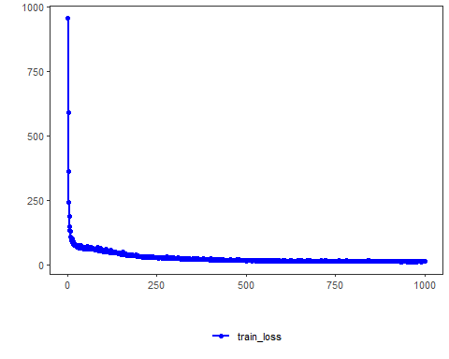
Notes - Default configuration uses validation_strategy = "static" and stopping_rule = "none", so only the training curve is shown. - To activate early stopping, set stopping_rule to "patience", "sma", "ema", or "h". - To activate dynamic validation splits, use validation_strategy = "dynamic".
References - Bishop, C. M. (1995). Neural Networks for Pattern Recognition. Oxford University Press. - Paszke, A., et al. (2019). PyTorch: An Imperative Style, High-Performance Deep Learning Library.

