02. PyTorch MLP Regressor with Static Validation and Patience
This example emphasizes the training regime of the PyTorch-backed MLP regressor. The architecture is kept simple while validation is held fixed across epochs and early stopping is controlled by patience.
Prerequisites - R packages: daltoolbox, daltoolboxdp - Python with PyTorch accessible via reticulate
# installation
#install.packages("daltoolboxdp")
library(daltoolbox)
library(daltoolboxdp)
library(MASS)
# Dataset for regression analysis
data(Boston)
Boston <- as.matrix(Boston)
# Train/test split
set.seed(1)
sr <- sample_random()
sr <- train_test(sr, Boston)
boston_train <- sr$train
boston_test <- sr$test
# Static validation with patience-based early stopping
model <- torch_reg_mlp(
attribute = "medv",
input_size = ncol(Boston) - 1L,
hidden_sizes = c(16L, 8L),
epochs = 300L,
validation_strategy = "static",
stopping_rule = "patience",
patience = 20L,
val_ratio = 0.2
)
model <- fit(model, boston_train)
Training configuration - validation_strategy = "static" keeps the same validation partition during the whole training run. - stopping_rule = "patience" stops training when the validation loss stops improving for a chosen number of epochs. - epochs = 300L acts as an upper bound; the effective number of epochs is determined by early stopping.
# Training evaluation
train_prediction <- predict(model, boston_train)
boston_train_predictand <- boston_train[, "medv"]
train_eval <- evaluate(model, boston_train_predictand, train_prediction)
print(train_eval$metrics)
## mse smape R2
## 1 36.63777 0.2028756 0.5929509
# Test evaluation
test_prediction <- predict(model, boston_test)
boston_test_predictand <- boston_test[, "medv"]
test_eval <- evaluate(model, boston_test_predictand, test_prediction)
print(test_eval$metrics)
## mse smape R2
## 1 26.71252 0.2032066 0.5560893
# Effective training duration
print(model$epochs_done)
## [1] 300
# Training and validation curves
fit_loss <- data.frame(
x = seq_along(model$train_loss_hist),
train_loss = model$train_loss_hist
)
if (!is.null(model$val_loss_hist) && length(model$val_loss_hist) > 0) {
fit_loss$val_loss <- model$val_loss_hist
}
colors <- if ("val_loss" %in% names(fit_loss)) c("Blue", "Orange") else c("Blue")
grf <- plot_series(fit_loss, colors = colors)
plot(grf)
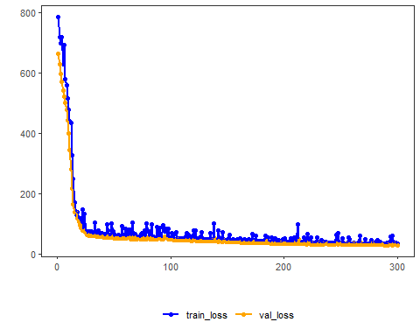
Notes - This setup is easier to interpret because all epochs are judged against the same validation subset. - To compare stopping mechanisms, keep the same architecture and change only stopping_rule.
References - Bishop, C. M. (1995). Neural Networks for Pattern Recognition. Oxford University Press. - Paszke, A., et al. (2019). PyTorch: An Imperative Style, High-Performance Deep Learning Library.

