Time Series Encoding and Reconstruction (encode-decode)
Time series windows of size p are encoded into k-dimensional latent vectors and then decoded back to p dimensions. Training minimizes reconstruction loss so that latent codes capture the essential structure of windows, enabling quality assessment via reconstruction error.
This example shows how to transform a time series into windows (p) and train an autoencoder to encode (p -> k) and reconstruct (k -> p) these windows, allowing evaluation of reconstruction quality.
Prerequisites - R packages: daltoolbox, ggplot2 - Python with PyTorch accessible via reticulate (backend called internally)
# Loading required packages
library(daltoolbox)
Series for study
data(tsd)
tsd$y[39] <- tsd$y[39] * 6 # inject a synthetic outlier for illustration
sw_size <- 5 # sliding window size (p)
ts <- ts_data(tsd$y, sw_size) # series -> windows with p columns
ts_head(ts, 3)
## t4 t3 t2 t1 t0
## [1,] 0.0000000 0.2474040 0.4794255 0.6816388 0.8414710
## [2,] 0.2474040 0.4794255 0.6816388 0.8414710 0.9489846
## [3,] 0.4794255 0.6816388 0.8414710 0.9489846 0.9974950
library(ggplot2)
plot_ts(x = tsd$x, y = tsd$y) +
theme(text = element_text(size = 16))
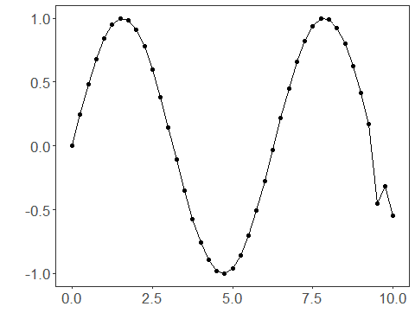
Data sampling
samp <- ts_sample(ts, test_size = 5)
train <- as.data.frame(samp$train)
test <- as.data.frame(samp$test)
Train the model (encode-decode)
auto <- autoenc_ed(5, 3) # 5 -> 3 -> 5 dimensions
auto <- fit(auto, train)
Reconstruction evaluation (train)
print(head(train)) # original windows (p columns)
## t4 t3 t2 t1 t0
## 1 0.0000000 0.2474040 0.4794255 0.6816388 0.8414710
## 2 0.2474040 0.4794255 0.6816388 0.8414710 0.9489846
## 3 0.4794255 0.6816388 0.8414710 0.9489846 0.9974950
## 4 0.6816388 0.8414710 0.9489846 0.9974950 0.9839859
## 5 0.8414710 0.9489846 0.9974950 0.9839859 0.9092974
## 6 0.9489846 0.9974950 0.9839859 0.9092974 0.7780732
result <- transform(auto, train) # reconstructed windows (p columns)
print(head(result))
## [,1] [,2] [,3] [,4] [,5]
## [1,] 0.1384313 0.3237551 0.4794721 0.6801789 0.7484931
## [2,] 0.3034692 0.4771605 0.6257209 0.7744519 0.8076903
## [3,] 0.5118471 0.6820119 0.7969884 0.8779535 0.8496023
## [4,] 0.7327246 0.8457048 0.9112816 0.9331555 0.8571754
## [5,] 0.8900059 0.9518926 0.9748541 0.9433414 0.8289360
## [6,] 0.9615482 0.9855673 0.9794773 0.9074199 0.7692553
Reconstruction of the test set
print(head(test))
## t4 t3 t2 t1 t0
## 1 0.9893582 0.9226042 0.7984871 0.6247240 0.4121185
## 2 0.9226042 0.7984871 0.6247240 0.4121185 0.1738895
## 3 0.7984871 0.6247240 0.4121185 0.1738895 -0.4509067
## 4 0.6247240 0.4121185 0.1738895 -0.4509067 -0.3195192
## 5 0.4121185 0.1738895 -0.4509067 -0.3195192 -0.5440211
result <- transform(auto, test)
print(head(result))
## [,1] [,2] [,3] [,4] [,5]
## [1,] 0.8761966 0.8741961 0.8401079 0.731237173 0.58056289
## [2,] 0.7279449 0.7153549 0.7020346 0.582779765 0.46690461
## [3,] 0.4548819 0.3829153 0.4258522 0.242995963 0.18158679
## [4,] 0.1482204 0.1077424 0.1499725 -0.009470092 0.04106381
## [5,] -0.1902543 -0.1459606 -0.2178537 -0.382163733 -0.23149623
References - Goodfellow, I., Bengio, Y., & Courville, A. (2016). Deep Learning. MIT Press. (Chapter on Autoencoders)

