## Denoising Autoencoder (encode)

Denoising autoencoders corrupt inputs with noise and train the network to reconstruct the original clean input. This objective encourages the model to learn robust features that capture underlying structure instead of noise.

This example demonstrates how to use a denoising autoencoder to learn a robust encoding of time-series windows. During training, noise is added to the input.

Prerequisites - Python with PyTorch accessible via reticulate - R packages: daltoolbox, tspredit, daltoolboxdp, ggplot2

Quick notes - Idea: add noise to the input and train the model to recover the clean signal. - Benefit: latent representations that are more robust to perturbations.

# Denoising Autoencoder transformation (encode)  
  
# Considering a dataset with $p$ numerical attributes.   
  
# The goal of the autoencoder is to reduce the dimension of $p$ to $k$, such that these $k$ attributes are enough to recompose the original $p$ attributes.   
  
# Installing packages  
#install.packages("tspredit")  
#install.packages("daltoolboxdp")

# Loading packages  
library(daltoolbox)  
library(tspredit)  
library(daltoolboxdp)  
library(ggplot2)

# Example dataset (series -> windows)   
data(tsd)  
  
sw_size <- 5  
ts <- ts_data(tsd$y, sw_size)  
  
ts_head(ts)

## t4 t3 t2 t1 t0  
## [1,] 0.0000000 0.2474040 0.4794255 0.6816388 0.8414710  
## [2,] 0.2474040 0.4794255 0.6816388 0.8414710 0.9489846  
## [3,] 0.4794255 0.6816388 0.8414710 0.9489846 0.9974950  
## [4,] 0.6816388 0.8414710 0.9489846 0.9974950 0.9839859  
## [5,] 0.8414710 0.9489846 0.9974950 0.9839859 0.9092974  
## [6,] 0.9489846 0.9974950 0.9839859 0.9092974 0.7780732

# Normalization (min-max by group)  
preproc <- ts_norm_gminmax()  
preproc <- fit(preproc, ts)  
ts <- transform(preproc, ts)  
  
ts_head(ts)

## t4 t3 t2 t1 t0  
## [1,] 0.5004502 0.6243512 0.7405486 0.8418178 0.9218625  
## [2,] 0.6243512 0.7405486 0.8418178 0.9218625 0.9757058  
## [3,] 0.7405486 0.8418178 0.9218625 0.9757058 1.0000000  
## [4,] 0.8418178 0.9218625 0.9757058 1.0000000 0.9932346  
## [5,] 0.9218625 0.9757058 1.0000000 0.9932346 0.9558303  
## [6,] 0.9757058 1.0000000 0.9932346 0.9558303 0.8901126

# Train/test split  
samp <- ts_sample(ts, test_size = 10)  
train <- as.data.frame(samp$train)  
test <- as.data.frame(samp$test)

# Training autoencoder (reduce 5 -> 3)  
auto <- autoenc_denoise_e(5, 3, num_epochs=1500)  
auto <- fit(auto, train)

fit_loss <- data.frame(x=1:length(auto$train_loss), train_loss=auto$train_loss,val_loss=auto$val_loss)  
  
grf <- plot_series(fit_loss, colors=c('Blue','Orange'))  
plot(grf)

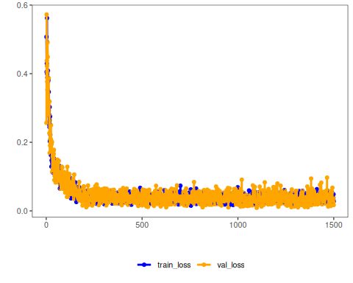

# Convergence should be stable; too much noise can hinder fitting.

# Testing the autoencoder  
# Show test samples and display encoding  
print(head(test))

## t4 t3 t2 t1 t0  
## 1 0.7258342 0.8294719 0.9126527 0.9702046 0.9985496  
## 2 0.8294719 0.9126527 0.9702046 0.9985496 0.9959251  
## 3 0.9126527 0.9702046 0.9985496 0.9959251 0.9624944  
## 4 0.9702046 0.9985496 0.9959251 0.9624944 0.9003360  
## 5 0.9985496 0.9959251 0.9624944 0.9003360 0.8133146  
## 6 0.9959251 0.9624944 0.9003360 0.8133146 0.7068409

result <- transform(auto, test)  
print(head(result))

## [,1] [,2] [,3]  
## [1,] 0.6138985 -1.472368 0.1688247  
## [2,] 0.6819679 -1.522876 0.2663558  
## [3,] 0.7242357 -1.527592 0.3609856  
## [4,] 0.7380739 -1.486221 0.4468301  
## [5,] 0.7226220 -1.401336 0.5185524  
## [6,] 0.6788408 -1.278216 0.5716927

References - Vincent, P., Larochelle, H., Bengio, Y., & Manzagol, P. A. (2008). Extracting and composing robust features with denoising autoencoders. ICML.