## LSTM Autoencoder (encode)

This example demonstrates the use of an LSTM-based Autoencoder to encode windows of a time series. The LSTM encoder learns sequence representations, reducing from p to k dimensions.

Prerequisites - Python with PyTorch accessible via reticulate - R packages: daltoolbox, tspredit, daltoolboxdp, ggplot2

Quick notes - Architecture: LSTM encoder + MLP/decoder to represent time-series windows. - Useful when there is strong temporal dependence within each window.

# Installing example dependencies (if needed)  
#install.packages("tspredit")  
#install.packages("daltoolboxdp")

# Loading required packages  
library(daltoolbox)  
library(tspredit)  
library(daltoolboxdp)  
library(ggplot2)

# Example dataset (series -> windows)  
data(tsd)  
  
sw_size <- 5 # sliding window size (p)  
ts <- ts_data(tsd$y, sw_size) # convert series into windows with p columns  
  
ts_head(ts)

## t4 t3 t2 t1 t0  
## [1,] 0.0000000 0.2474040 0.4794255 0.6816388 0.8414710  
## [2,] 0.2474040 0.4794255 0.6816388 0.8414710 0.9489846  
## [3,] 0.4794255 0.6816388 0.8414710 0.9489846 0.9974950  
## [4,] 0.6816388 0.8414710 0.9489846 0.9974950 0.9839859  
## [5,] 0.8414710 0.9489846 0.9974950 0.9839859 0.9092974  
## [6,] 0.9489846 0.9974950 0.9839859 0.9092974 0.7780732

# Normalization (min-max by group)  
preproc <- ts_norm_gminmax()  
preproc <- fit(preproc, ts)  
ts <- transform(preproc, ts)  
  
ts_head(ts)

## t4 t3 t2 t1 t0  
## [1,] 0.5004502 0.6243512 0.7405486 0.8418178 0.9218625  
## [2,] 0.6243512 0.7405486 0.8418178 0.9218625 0.9757058  
## [3,] 0.7405486 0.8418178 0.9218625 0.9757058 1.0000000  
## [4,] 0.8418178 0.9218625 0.9757058 1.0000000 0.9932346  
## [5,] 0.9218625 0.9757058 1.0000000 0.9932346 0.9558303  
## [6,] 0.9757058 1.0000000 0.9932346 0.9558303 0.8901126

# Train/test split  
samp <- ts_sample(ts, test_size = 10)  
train <- as.data.frame(samp$train)  
test <- as.data.frame(samp$test)

# Creating the LSTM autoencoder: reduce from 5 -> 3 dimensions (p -> k)  
# - num_epochs: number of epochs (LSTM may require more epochs to converge)  
auto <- autoenc_lstm_e(5, 3, num_epochs = 1500)  
  
# Training the model  
auto <- fit(auto, train)

# Learning curves (train and validation loss per epoch)  
fit_loss <- data.frame(  
 x = 1:length(auto$train_loss),  
 train_loss = auto$train_loss,  
 val_loss = auto$val_loss  
)  
grf <- plot_series(fit_loss, colors = c('Blue', 'Orange'))  
plot(grf)

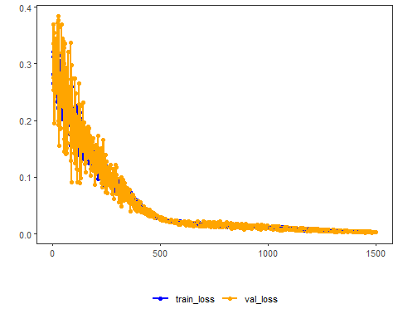

# Testing the autoencoder (encoding)  
# Show samples from the test set and the encoding (k columns)  
print(head(test))

## t4 t3 t2 t1 t0  
## 1 0.7258342 0.8294719 0.9126527 0.9702046 0.9985496  
## 2 0.8294719 0.9126527 0.9702046 0.9985496 0.9959251  
## 3 0.9126527 0.9702046 0.9985496 0.9959251 0.9624944  
## 4 0.9702046 0.9985496 0.9959251 0.9624944 0.9003360  
## 5 0.9985496 0.9959251 0.9624944 0.9003360 0.8133146  
## 6 0.9959251 0.9624944 0.9003360 0.8133146 0.7068409

result <- transform(auto, test)  
print(head(result))

## [,1] [,2] [,3]  
## [1,] -0.1641252 -0.6517871 0.6061522  
## [2,] -0.3061997 -0.6653859 0.5900856  
## [3,] -0.4069033 -0.6717903 0.5485110  
## [4,] -0.4694059 -0.6718291 0.4680848  
## [5,] -0.5014372 -0.6654832 0.3302852  
## [6,] -0.5086973 -0.6518764 0.1277761