## Stacked Autoencoder (encode-decode)

This example demonstrates a Stacked Autoencoder to encode time-series windows (p -> k) and reconstruct them (k -> p), enabling evaluation of reconstruction quality.

Prerequisites - Python with PyTorch accessible via reticulate - R packages: daltoolbox, tspredit, daltoolboxdp, ggplot2

# Installing example dependencies (if needed)  
#install.packages("tspredit")  
#install.packages("daltoolboxdp")

# Loading required packages  
library(daltoolbox)  
library(tspredit)  
library(daltoolboxdp)  
library(ggplot2)

# Example dataset (series -> windows)  
data(tsd)  
  
sw_size <- 5 # sliding window size (p)  
ts <- ts_data(tsd$y, sw_size) # convert series into windows with p columns  
  
ts_head(ts)

## t4 t3 t2 t1 t0  
## [1,] 0.0000000 0.2474040 0.4794255 0.6816388 0.8414710  
## [2,] 0.2474040 0.4794255 0.6816388 0.8414710 0.9489846  
## [3,] 0.4794255 0.6816388 0.8414710 0.9489846 0.9974950  
## [4,] 0.6816388 0.8414710 0.9489846 0.9974950 0.9839859  
## [5,] 0.8414710 0.9489846 0.9974950 0.9839859 0.9092974  
## [6,] 0.9489846 0.9974950 0.9839859 0.9092974 0.7780732

# Normalization (min-max by group)  
preproc <- ts_norm_gminmax()  
preproc <- fit(preproc, ts)  
ts <- transform(preproc, ts)  
  
ts_head(ts)

## t4 t3 t2 t1 t0  
## [1,] 0.5004502 0.6243512 0.7405486 0.8418178 0.9218625  
## [2,] 0.6243512 0.7405486 0.8418178 0.9218625 0.9757058  
## [3,] 0.7405486 0.8418178 0.9218625 0.9757058 1.0000000  
## [4,] 0.8418178 0.9218625 0.9757058 1.0000000 0.9932346  
## [5,] 0.9218625 0.9757058 1.0000000 0.9932346 0.9558303  
## [6,] 0.9757058 1.0000000 0.9932346 0.9558303 0.8901126

# Train/test split  
samp <- ts_sample(ts, test_size = 10)  
train <- as.data.frame(samp$train)  
test <- as.data.frame(samp$test)

# Creating the stacked autoencoder (encode-decode): 5 -> 3 -> 5 dimensions  
auto <- autoenc_stacked_ed(5, 3)  
  
# Training the model  
auto <- fit(auto, train)

# Learning curves (train and validation loss per epoch)  
fit_loss <- data.frame(  
 x = 1:length(auto$train_loss),  
 train_loss = auto$train_loss,  
 val_loss = auto$val_loss  
)  
grf <- plot_series(fit_loss, colors = c('Blue', 'Orange'))  
plot(grf)

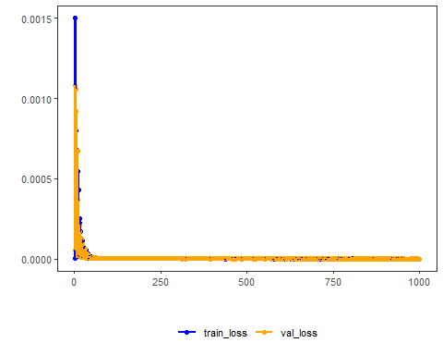

# Testing the autoencoder (reconstruction)  
# Show samples from the test set and the reconstruction (p columns)  
print(head(test))

## t4 t3 t2 t1 t0  
## 1 0.7258342 0.8294719 0.9126527 0.9702046 0.9985496  
## 2 0.8294719 0.9126527 0.9702046 0.9985496 0.9959251  
## 3 0.9126527 0.9702046 0.9985496 0.9959251 0.9624944  
## 4 0.9702046 0.9985496 0.9959251 0.9624944 0.9003360  
## 5 0.9985496 0.9959251 0.9624944 0.9003360 0.8133146  
## 6 0.9959251 0.9624944 0.9003360 0.8133146 0.7068409

result <- transform(auto, test)  
print(head(result))

## [,1] [,2] [,3] [,4] [,5]  
## [1,] 0.7263157 0.8304793 0.9136825 0.9707337 0.9978378  
## [2,] 0.8301944 0.9139377 0.9699187 0.9973598 0.9947565  
## [3,] 0.9130094 0.9712008 0.9986390 0.9955447 0.9627025  
## [4,] 0.9708271 0.9994614 0.9961067 0.9621595 0.9006577  
## [5,] 0.9994978 0.9965859 0.9622326 0.8991832 0.8126339  
## [6,] 0.9959853 0.9626608 0.9001266 0.8125797 0.7071432

# Reconstruction metrics per column: R2 and MAPE  
result <- as.data.frame(result)  
names(result) <- names(test)  
r2 <- c()  
mape <- c()  
for (col in names(test)){  
 r2_col <- cor(test[col], result[col])^2  
 r2 <- append(r2, r2_col)  
 mape_col <- mean((abs((result[col] - test[col]))/test[col])[[col]])  
 mape <- append(mape, mape_col)  
 print(paste(col, 'R2 test:', r2_col, 'MAPE:', mape_col))  
}

## [1] "t4 R2 test: 0.999982875181059 MAPE: 0.000674159145974009"  
## [1] "t3 R2 test: 0.999990421055869 MAPE: 0.000837831927207218"  
## [1] "t2 R2 test: 0.999995591290343 MAPE: 0.000574277481376518"  
## [1] "t1 R2 test: 0.999992893130402 MAPE: 0.000907004634109462"  
## [1] "t0 R2 test: 0.999996408391074 MAPE: 0.00107117882116635"

print(paste('Means R2 test:', mean(r2), 'MAPE:', mean(mape)))

## [1] "Means R2 test: 0.99999163780975 MAPE: 0.000812890401966712"