## Variational Autoencoder (encode)

Variational Autoencoders learn a probabilistic encoder that outputs parameters of a latent distribution (e.g., mean and variance) and a decoder that reconstructs from latent samples. The loss combines reconstruction error and a KL divergence that regularizes the latent distribution toward a prior.

This example uses a Variational Autoencoder (VAE) to learn latent representations of time-series windows. The VAE reduces from p to k dimensions and regularizes the latent space to approximate a target distribution (e.g., standard normal) via a KL term.

Prerequisites - Python with PyTorch accessible via reticulate - R packages: daltoolbox, tspredit, daltoolboxdp, ggplot2

Quick notes - Loss: reconstruction + KL divergence between the latent distribution and the prior. - Useful for generating continuous, well-behaved representations in latent space.

# Installing example dependencies (if needed)  
#install.packages("tspredit")  
#install.packages("daltoolboxdp")

# Loading required packages  
library(daltoolbox)  
library(tspredit)  
library(daltoolboxdp)  
library(ggplot2)

# Example dataset (series -> windows)  
data(tsd)  
  
sw_size <- 5 # sliding window size (p)  
ts <- ts_data(tsd$y, sw_size) # convert series into windows with p columns  
  
ts_head(ts)

## t4 t3 t2 t1 t0  
## [1,] 0.0000000 0.2474040 0.4794255 0.6816388 0.8414710  
## [2,] 0.2474040 0.4794255 0.6816388 0.8414710 0.9489846  
## [3,] 0.4794255 0.6816388 0.8414710 0.9489846 0.9974950  
## [4,] 0.6816388 0.8414710 0.9489846 0.9974950 0.9839859  
## [5,] 0.8414710 0.9489846 0.9974950 0.9839859 0.9092974  
## [6,] 0.9489846 0.9974950 0.9839859 0.9092974 0.7780732

# Normalization (min-max by group)  
preproc <- ts_norm_gminmax()  
preproc <- fit(preproc, ts)  
ts <- transform(preproc, ts)  
  
ts_head(ts)

## t4 t3 t2 t1 t0  
## [1,] 0.5004502 0.6243512 0.7405486 0.8418178 0.9218625  
## [2,] 0.6243512 0.7405486 0.8418178 0.9218625 0.9757058  
## [3,] 0.7405486 0.8418178 0.9218625 0.9757058 1.0000000  
## [4,] 0.8418178 0.9218625 0.9757058 1.0000000 0.9932346  
## [5,] 0.9218625 0.9757058 1.0000000 0.9932346 0.9558303  
## [6,] 0.9757058 1.0000000 0.9932346 0.9558303 0.8901126

# Train/test split  
samp <- ts_sample(ts, test_size = 10)  
train <- as.data.frame(samp$train)  
test <- as.data.frame(samp$test)

# Creating the VAE: reduce from 5 -> 3 dimensions (p -> k)  
# - num_epochs: fewer epochs may suffice given the additional KL term  
auto <- autoenc_variational_e(5, 3, num_epochs = 350)  
  
# Training the model  
auto <- fit(auto, train)

# Learning curves (total loss per epoch)  
fit_loss <- data.frame(  
 x = 1:length(auto$train_loss),  
 train_loss = auto$train_loss,  
 val_loss = auto$val_loss  
)  
grf <- plot_series(fit_loss, colors = c('Blue', 'Orange'))  
plot(grf)

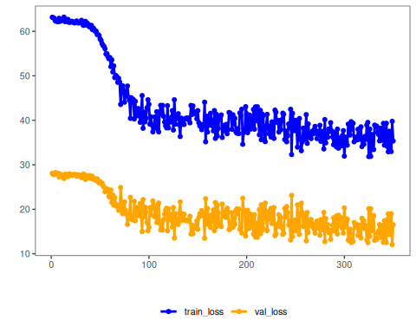

# Testing the VAE (encoding)  
# Show samples from the test set and the encoding (k columns)  
print(head(test))

## t4 t3 t2 t1 t0  
## 1 0.7258342 0.8294719 0.9126527 0.9702046 0.9985496  
## 2 0.8294719 0.9126527 0.9702046 0.9985496 0.9959251  
## 3 0.9126527 0.9702046 0.9985496 0.9959251 0.9624944  
## 4 0.9702046 0.9985496 0.9959251 0.9624944 0.9003360  
## 5 0.9985496 0.9959251 0.9624944 0.9003360 0.8133146  
## 6 0.9959251 0.9624944 0.9003360 0.8133146 0.7068409

result <- transform(auto, test)  
print(head(result))

## [,1] [,2] [,3] [,4] [,5] [,6]  
## [1,] -0.029332668 0.2367538 -0.06540994 0.0001824498 -0.006236266 0.01435075  
## [2,] 0.009082831 0.2600152 -0.01620427 -0.0019754656 -0.010239262 0.01572724  
## [3,] 0.053593442 0.2532565 0.04174804 -0.0021032058 -0.012234828 0.01615443  
## [4,] 0.094553009 0.2197868 0.09447352 -0.0009527281 -0.013612058 0.01701297  
## [5,] 0.127344146 0.1660533 0.13658243 0.0004750863 -0.013502374 0.01696155  
## [6,] 0.145732522 0.1018441 0.15691586 -0.0002584867 -0.009815825 0.01160238

References - Kingma, D. P., & Welling, M. (2014). Auto-Encoding Variational Bayes. ICLR.