I have prepared an hourly-based time series dataset of the temperature of main cities in France and Brazil with airports. The sensors are present at the airports. Their positions (Latitude and Longitude) and Elevation are present in the following links:

* <https://mesonet.agron.iastate.edu/sites/networks.php?network=FR__ASOS>

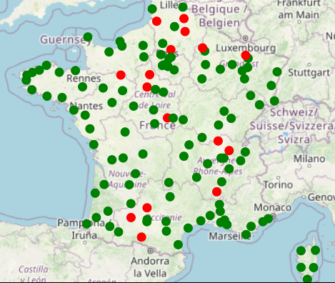

* <https://mesonet.agron.iastate.edu/sites/networks.php?network=BR__ASOS>

The Brazilian dataset has been collected since 1990. At that time, 70% of the airports were collecting data. We have this raw dataset with missing data (*br-data.rdata*) and a complete time series using interpolated data (*br-data-inter.rdata*). It contains 305379 hourly-based observations with 143 variables (the temperature of 143 airports), some of which are in the same city.

I have collected the French dataset since 2000. At that time, 87% of the airports were collecting data, but we can get 70% of the airport data since 1975. We have this raw dataset with missing data (*fr-data.rdata*) and a complete time series using interpolated data (*fr-data-inter.rdata*). It contains 212604 hourly-based observations with 128 variables (temperature of 128 airports), some of which are in the same city.

There are more attributes besides temperature:

* dew_point: Dew Point Temperature in Fahrenheit, typically 2 meters
* relative_humidity: Relative Humidity in %
* wind_direction: Wind Direction in degrees from *true* north
* wind_speed: Wind Speed in knots
* pressure: Pressure altimeter in inches
* mslp: Sea Level Pressure in millibar
* visibility: Visibility in miles
* apparent_temperature: apparent temperature.

The description of the available variables can be obtained at:

* <https://mesonet.agron.iastate.edu/request/download.phtml?network=BR__ASOS>
* <https://mesonet.agron.iastate.edu/request/download.phtml?network=FR__ASOS>
* In the US system, we can also collect rain conditions.

A multivariate time series dataset is available for each airport, both for the Brazilian and French systems.

* <https://github.com/cefet-rj-dal/dinizia-data/tree/main/br-airports>
* <https://github.com/cefet-rj-dal/dinizia-data/tree/main/fr-airports>

The datasets, raw data, and ETL process, are available at GitHub (<https://github.com/cefet-rj-dal/dinizia-data>)

Integrated dataset: <https://github.com/cefet-rj-dal/dinizia-data/tree/main/asos-airports>

Airport information: <https://github.com/cefet-rj-dal/dinizia-data/tree/main/airports>

Brazilian raw ASOS data: <https://github.com/cefet-rj-dal/dinizia-data/tree/main/br-asos>

French raw ASOS data: <https://github.com/cefet-rj-dal/dinizia-data/tree/main/br-asos>

ETL code: <https://github.com/cefet-rj-dal/dinizia-data/tree/main/br-asos>