Objective
The Chow-style structural break test estimates a linear model and finds breakpoints using F statistics. In this tutorial we:
- Load and visualize the same example change-point dataset used in the AMOC notebook
- Configure the Chow detector (hcp_chow)
- Inspect detections and evaluate against labels

Method at a glance
Chow tests: Chow tests for structural breaks in linear models using F-statistics over candidate breakpoints and returns estimated break locations. Harbinger wraps strucchange F-stats/breakpoints.

What you will do
- understand the purpose of the example and when the technique is useful
- follow the workflow from data loading to model fitting and detection
- inspect the evaluation outputs and the diagnostic plots produced by Harbinger

Prepare the Example
This setup anchors the notebook in the specific series used to examine hcp_chow. The semantic point is the one stated above: chow tests: Chow tests for structural breaks in linear models using F-statistics over candidate breakpoints and returns estimated break locations, so the raw signal needs to be visible before any fitting step hides that structure behind model output.
source(url("https://raw.githubusercontent.com/cefet-rj-dal/harbinger/master/examples/seed.R"))
# Install Harbinger (if needed)
#install.packages("harbinger")
# Load required packages
library(daltoolbox)
library(harbinger)
# Load example change-point datasets
data(examples_changepoints)
# Select the same dataset used in the AMOC example
dataset <- examples_changepoints$complex
head(dataset)
## serie event
## 1 0.3129618 FALSE
## 2 0.5944808 FALSE
## 3 0.8162731 FALSE
## 4 0.9560557 FALSE
## 5 0.9997847 FALSE
## 6 0.9430667 FALSE

Interpret the Result Visually
This first visual pass establishes what the method should react to in the raw series. Keep the method summary in mind here, because chow tests: Chow tests for structural breaks in linear models using F-statistics over candidate breakpoints and returns estimated break locations and the plot tells you whether that structure is clean, weak, local, repeated, or mixed with other effects.
# Plot the raw time series
har_plot(harbinger(), dataset$serie)
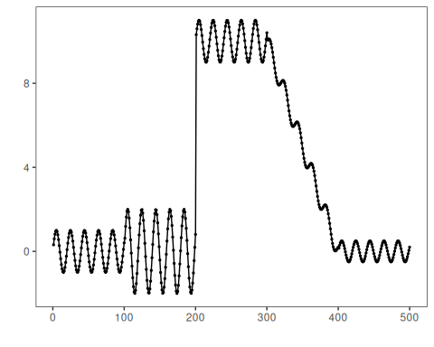

Configure the Method
The choices below turn the central modeling idea into concrete parameters. They matter because chow tests: Chow tests for structural breaks in linear models using F-statistics over candidate breakpoints and returns estimated break locations, so each argument controls how strongly the method will emphasize that pattern when it later produces change-point candidates.
# Configure the Chow detector
model <- hcp_chow()
# Fit the detector (no training required)
set_example_seed()
model <- fit(model, dataset$serie)

Run the Core Analysis
This is the moment where the notebook tests its central assumption on actual data. After applying hcp_chow, the important question is whether the resulting change-point candidates really correspond to the pattern implied by the method description above, rather than to arbitrary numerical variation.
# Run detection
detection <- detect(model, dataset$serie)
# Show detected change points
print(detection |> dplyr::filter(event == TRUE))
## idx event type
## 1 200 TRUE changepoint

Evaluate What Was Found
The evaluation asks whether the change-point candidates produced by hcp_chow match the labeled structure on this dataset. Read the scores as evidence about the method’s assumptions in practice, not as detached summary numbers.
# Evaluate detections against labels
evaluation <- evaluate(model, detection$event, dataset$event)
print(evaluation$confMatrix)
## event
## detection TRUE FALSE
## TRUE 1 0
## FALSE 3 496

Interpret the Result Visually
This visual check puts the model output back on top of the original signal. What matters now is whether the highlighted change-point candidates line up with the structure suggested by the method, which is the real semantic test of whether the example is teaching the right lesson.
# Plot detections vs. ground truth
har_plot(model, dataset$serie, detection, dataset$event)
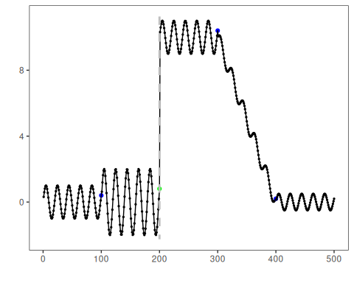

References
- Zeileis, A., Leisch, F., Kleiber, C., Hornik, K. (2002). strucchange: An R package for testing for structural change in linear regression models. Journal of Statistical Software, 7(2). doi:10.18637/jss.v007.i02

