Custom Transformation

Objective
The goal of this example is to show how to create a custom transformation that can be applied before the detection workflow starts.
The point of the example is to motivate why one may want to change the series before choosing a detector at all. In many event-detection tasks, the raw signal contains small impulsive spikes or local noise that make downstream interpretation harder.

Why this method matters
The median filter is a classic transformation for attenuating isolated spikes while preserving broader level changes and trend structure better than a simple mean smoother in some situations. That makes it a good teaching example when the reader needs intuition about preprocessing before detection.
This custom notebook matters because:
- it shows that customization in Harbinger is not limited to detectors;
- it introduces the idea that signal conditioning can improve interpretability;
- it gives a concrete example of a transformation that is easy to understand visually.

Method at a glance
The transformation applies stats::runmed() to the numeric series and then feeds the filtered output into a regular Harbinger detector. The custom part is only the signal transformation; the rest of the workflow stays unchanged.
The transformation implemented here is a median filter. It is useful for reducing isolated spikes before an anomaly detector is applied. The integration contract is small because a simple transformation only needs a constructor and a transform() method when no fitted state is required.

Prepare the Example
This setup anchors the notebook in the specific series used to examine 01-transformation-custom_transformation. The semantic point is the one stated above: the transformation applies stats::runmed() to the numeric series and then feeds the filtered output into a regular Harbinger detector, so the raw signal needs to be visible before any fitting step hides that structure behind model output.
source(url("https://raw.githubusercontent.com/cefet-rj-dal/harbinger/master/examples/seed.R"))
# installation
# install.packages(c("harbinger", "daltoolbox"))
library(daltoolbox)
library(harbinger)

Define the Support Structures
The code below defines the smallest Harbinger contract needed to express the idea behind this example. Read it in semantic terms: the goal is to encode that the transformation applies stats::runmed() to the numeric series and then feeds the filtered output into a regular Harbinger detector while still returning objects that Harbinger can plot and evaluate like any native method.
har_fil_median_custom <- function(k = 5) {
if (k %% 2 == 0) {
k <- k + 1
}
obj <- daltoolbox::dal_transform()
obj$k <- k
class(obj) <- append("har_fil_median_custom", class(obj))
obj
}
transform.har_fil_median_custom <- function(obj, data, ...) {
result <- stats::runmed(as.numeric(data), k = obj$k, endrule = "keep")
result[is.na(result)] <- as.numeric(data)[is.na(result)]
result
}
We first visualize the raw series, then apply the custom filter to attenuate local spikes.

Interpret the Result Visually
This first visual pass establishes what the method should react to in the raw series. Keep the method summary in mind here, because the transformation applies stats::runmed() to the numeric series and then feeds the filtered output into a regular Harbinger detector and the plot tells you whether that structure is clean, weak, local, repeated, or mixed with other effects.
data(examples_anomalies)
dataset <- examples_anomalies$simple
har_plot(harbinger(), dataset$serie, event = dataset$event)
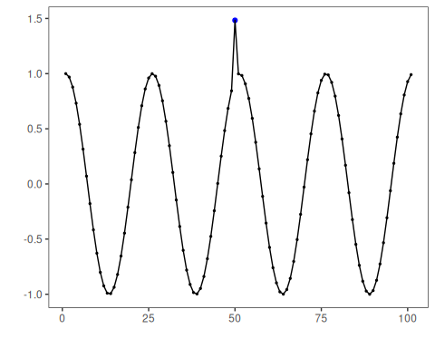

Run the Core Analysis
This is the moment where the notebook tests its central assumption on actual data. After applying 01-transformation-custom_transformation, the important question is whether the resulting transformed outputs really correspond to the pattern implied by the method description above, rather than to arbitrary numerical variation.
filter_custom <- har_fil_median_custom(k = 5)
serie_filtered <- transform(filter_custom, dataset$serie)
har_plot(harbinger(), serie_filtered, event = dataset$event)
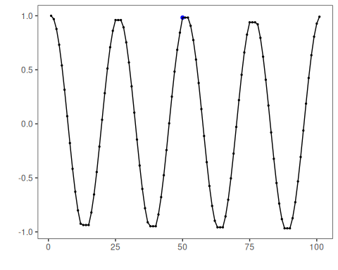
Once the transformation is defined, it can be inserted before a regular detector. Here we use hanr_arima() because it remains stable after smoothing and makes the downstream comparison easier to interpret.

Configure the Method
The choices below turn the central modeling idea into concrete parameters. They matter because the transformation applies stats::runmed() to the numeric series and then feeds the filtered output into a regular Harbinger detector, so each argument controls how strongly the method will emphasize that pattern when it later produces transformed outputs.
model <- hanr_arima()
set_example_seed()
model <- fit(model, as.numeric(serie_filtered))
detection <- detect(model, as.numeric(serie_filtered))
har_plot(model, as.numeric(serie_filtered), detection, dataset$event)
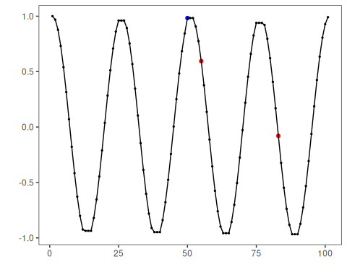
This example shows the usual role of a custom transformation in Harbinger: change the signal representation first, and then feed the transformed series into the downstream detection workflow.

References
- Tukey, J. W. (1977). Exploratory Data Analysis. Addison-Wesley.

