Objective
The goal of this notebook is to present a complete Harbinger workflow: loading an example dataset, configuring the method used in the notebook, running the analysis, and interpreting the resulting outputs and plots.

Method at a glance
This notebook tours common time-series anomaly patterns (point/isolated, contextual, collective/sequence, regime variance shifts) using Harbinger’s base pipeline. For each dataset, we fit a detector, run detection, and visualize predictions against ground truth. The goal is to illustrate how different patterns appear in residual magnitude and plots, and how Harbinger’s unified interface helps compare detectors consistently.

What you will do
- understand the purpose of the example and when the technique is useful
- follow the workflow from data loading to model fitting and detection
- inspect the evaluation outputs and the diagnostic plots produced by Harbinger

Prepare the Example
This setup anchors the notebook in the specific series used to examine harbinger(). The semantic point is the one stated above: this notebook tours common time-series anomaly patterns (point/isolated, contextual, collective/sequence, regime variance shifts) using Harbinger’s base pipeline, so the raw signal needs to be visible before any fitting step hides that structure behind model output.
source(url("https://raw.githubusercontent.com/cefet-rj-dal/harbinger/master/examples/seed.R"))
# Install Harbinger (if needed)
#install.packages("harbinger")
# Load required packages
library(daltoolbox)
library(harbinger)

Configure the Method
The choices below turn the central modeling idea into concrete parameters. They matter because this notebook tours common time-series anomaly patterns (point/isolated, contextual, collective/sequence, regime variance shifts) using Harbinger’s base pipeline, so each argument controls how strongly the method will emphasize that pattern when it later produces workflow outputs.
# Load example anomaly datasets and create a base object
data(examples_anomalies)
model <- harbinger()
# Simple anomalies: isolated spikes
dataset <- examples_anomalies$simple
set_example_seed()
model <- fit(model, dataset$serie)
detection <- detect(model, dataset$serie)
har_plot(model, dataset$serie, detection, dataset$event)
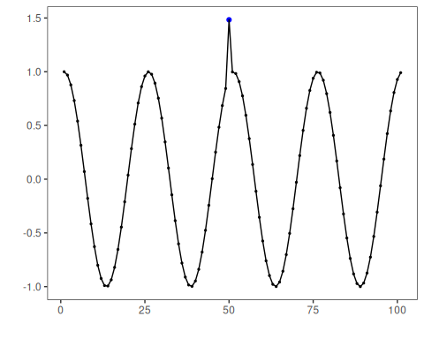
# Contextual anomalies: depend on local context
dataset <- examples_anomalies$contextual
set_example_seed()
model <- fit(model, dataset$serie)
detection <- detect(model, dataset$serie)
har_plot(model, dataset$serie, detection, dataset$event)
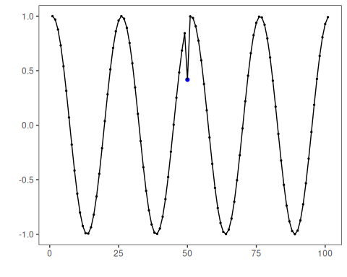
# Trend with anomalies
dataset <- examples_anomalies$trend
set_example_seed()
model <- fit(model, dataset$serie)
detection <- detect(model, dataset$serie)
har_plot(model, dataset$serie, detection, dataset$event)
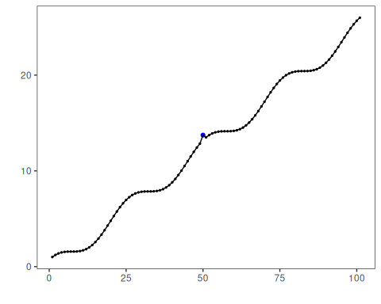
# Multiple anomalies
dataset <- examples_anomalies$multiple
set_example_seed()
model <- fit(model, dataset$serie)
detection <- detect(model, dataset$serie)
har_plot(model, dataset$serie, detection, dataset$event)
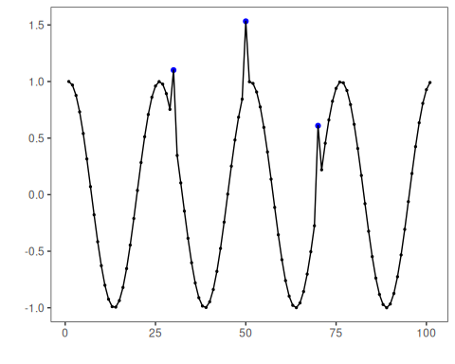
# Anomalous repeating sequences
dataset <- examples_anomalies$sequence
set_example_seed()
model <- fit(model, dataset$serie)
detection <- detect(model, dataset$serie)
har_plot(model, dataset$serie, detection, dataset$event)
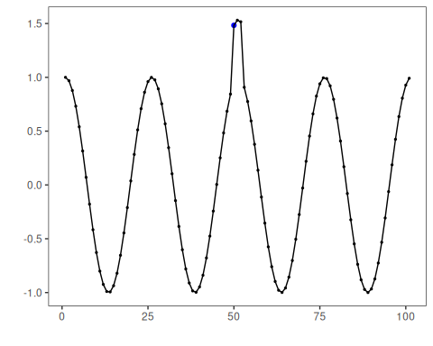
# Train/Test split
dataset <- examples_anomalies$tt
set_example_seed()
model <- fit(model, dataset$serie)
detection <- detect(model, dataset$serie)
har_plot(model, dataset$serie, detection, dataset$event)
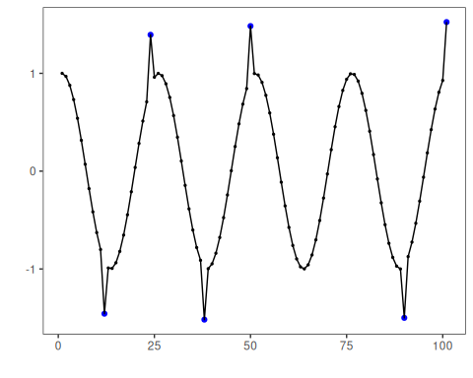
# Train/Test warped
dataset <- examples_anomalies$tt_warped
set_example_seed()
model <- fit(model, dataset$serie)
detection <- detect(model, dataset$serie)
har_plot(model, dataset$serie, detection, dataset$event)
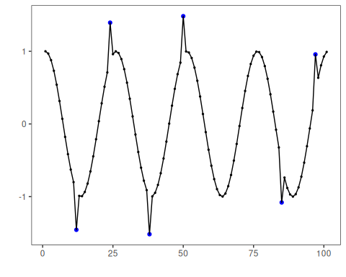
# Increasing amplitude over time
dataset <- examples_anomalies$increasing_amplitude
set_example_seed()
model <- fit(model, dataset$serie)
detection <- detect(model, dataset$serie)
har_plot(model, dataset$serie, detection, dataset$event)
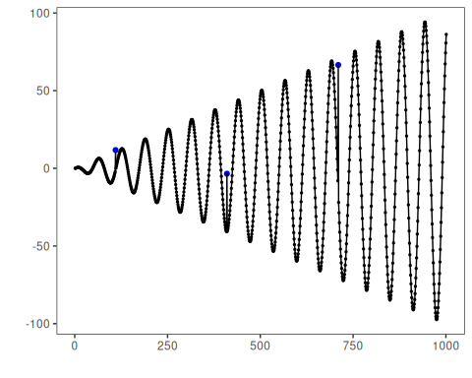
# Decreasing amplitude over time
dataset <- examples_anomalies$decreasing_amplitude
set_example_seed()
model <- fit(model, dataset$serie)
detection <- detect(model, dataset$serie)
har_plot(model, dataset$serie, detection, dataset$event)
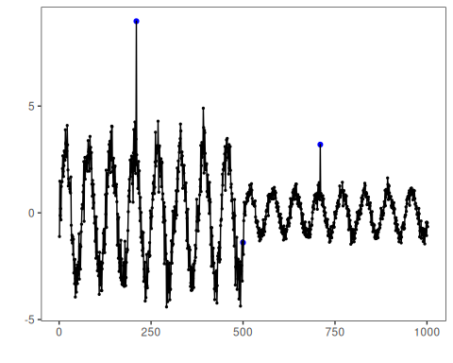
# Volatile variance
dataset <- examples_anomalies$volatile
set_example_seed()
model <- fit(model, dataset$serie)
detection <- detect(model, dataset$serie)
har_plot(model, dataset$serie, detection, dataset$event)
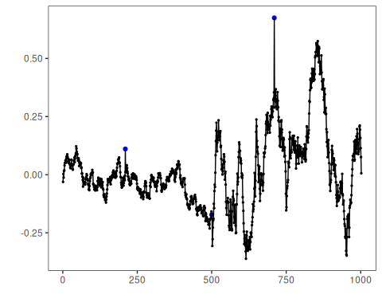

References
- Ogasawara, E., Salles, R., Porto, F., Pacitti, E. Event Detection in Time Series. Springer, 2025. doi:10.1007/978-3-031-75941-3
- Chandola, V., Banerjee, A., Kumar, V. (2009). Anomaly detection: A survey. ACM Computing Surveys, 41(3), 1-58.

