Objective
This notebook demonstrates trans_xsax(), an extended symbolic transformation for time series. The goal is to show how XSAX increases symbolic resolution relative to SAX by using a larger alphabet.

Method at a glance
XSAX follows the same general idea as SAX: normalize the series and discretize it into symbols. The difference is that XSAX uses a larger alphanumeric alphabet, which allows a finer symbolic partition of the values.

What you will do
- load an example motif series from Harbinger
- inspect the original numeric sequence
- configure an XSAX transformer
- transform the series into a richer symbolic encoding
- compare the numeric values with the symbolic codes

Prepare the Example
This setup anchors the notebook in the specific series used to examine 03-symbolic-trans_xsax. The semantic point is the one stated above: xSAX follows the same general idea as SAX: normalize the series and discretize it into symbols, so the raw signal needs to be visible before any fitting step hides that structure behind model output.
source(url("https://raw.githubusercontent.com/cefet-rj-dal/harbinger/master/examples/seed.R"))
# Install Harbinger (if needed)
#install.packages("harbinger")
# Load required packages
library(daltoolbox)
library(harbinger)
# Load example motif datasets
data(examples_motifs)
# Select a simple motif dataset
dataset <- examples_motifs$simple
head(dataset)
## serie event
## 1 1.0000000 FALSE
## 2 0.9939124 FALSE
## 3 0.9275826 FALSE
## 4 0.8066889 FALSE
## 5 0.6403023 FALSE
## 6 0.4403224 FALSE

Interpret the Result Visually
This first visual pass establishes what the method should react to in the raw series. Keep the method summary in mind here, because xSAX follows the same general idea as SAX: normalize the series and discretize it into symbols and the plot tells you whether that structure is clean, weak, local, repeated, or mixed with other effects.
# Plot the original time series
har_plot(harbinger(), dataset$serie, event = dataset$event)
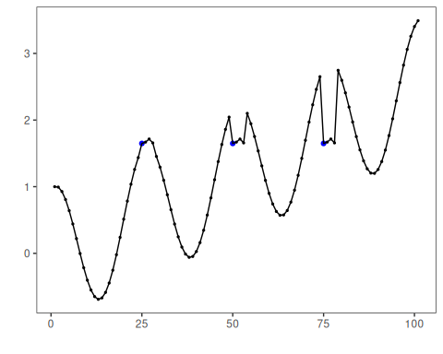

Configure the Method
The choices below turn the central modeling idea into concrete parameters. They matter because xSAX follows the same general idea as SAX: normalize the series and discretize it into symbols, so each argument controls how strongly the method will emphasize that pattern when it later produces transformed outputs.
# Configure the XSAX transformer
model <- trans_xsax(alpha = 16)
# Fit and transform the numeric series into an extended symbolic representation
set_example_seed()
model <- fit(model, dataset$serie)
xsax_series <- transform(model, dataset$serie)
# Inspect the first symbolic values
head(xsax_series, 20)
## [1] "6" "6" "6" "5" "4" "3" "2" "2" "1" "0" "0" "0" "0" "0" "0" "0" "1" "1" "2" "3"

Run the Core Analysis
This is the moment where the notebook tests its central assumption on actual data. After applying 03-symbolic-trans_xsax, the important question is whether the resulting transformed outputs really correspond to the pattern implied by the method description above, rather than to arbitrary numerical variation.
# Compare original values with XSAX symbols
comparison <- data.frame(
idx = seq_along(dataset$serie),
value = dataset$serie,
xsax = xsax_series
)
head(comparison, 20)
## idx value xsax
## 1 1 1.000000000 6
## 2 2 0.993912422 6
## 3 3 0.927582562 6
## 4 4 0.806688869 5
## 5 5 0.640302306 4
## 6 6 0.440322362 3
## 7 7 0.220737202 2
## 8 8 -0.003246056 2
## 9 9 -0.216146837 1
## 10 10 -0.403173623 0
## 11 11 -0.551143616 0
## 12 12 -0.649302379 0
## 13 13 -0.689992497 0
## 14 14 -0.669129676 0
## 15 15 -0.586456687 0
## 16 16 -0.445559357 0
## 17 17 -0.253643621 1
## 18 18 -0.021087490 1
## 19 19 0.239204201 2
## 20 20 0.512602153 3

References
- Ogasawara, E., Salles, R., Porto, F., Pacitti, E. Event Detection in Time Series. Springer, 2025. doi:10.1007/978-3-031-75941-3

