Objective
DTW-based discord discovery uses sequence windows (seq > 1) and flags sequences far from any centroid as discords.
Steps: - Load and visualize a dataset with repeating sequences - Configure and run hanct_dtw(seq > 1) - Inspect detections, evaluate, and plot results

Method at a glance
DTW-based discord anomaly detection: Dynamic Time Warping (DTW) clustering over subsequences; windows with large DTW distance to their nearest centroid are flagged as discords. Implementation wraps dtwclust and thresholds via harutils().

What you will do
- understand the purpose of the example and when the technique is useful
- follow the workflow from data loading to model fitting and detection
- inspect the evaluation outputs and the diagnostic plots produced by Harbinger

Prepare the Example
This setup anchors the notebook in the specific series used to examine hanct_dtw(seq > 1). The semantic point is the one stated above: dTW-based discord anomaly detection: Dynamic Time Warping (DTW) clustering over subsequences; windows with large DTW distance to their nearest centroid are flagged as discords, so the raw signal needs to be visible before any fitting step hides that structure behind model output.
# Install Harbinger (if needed)
#install.packages("harbinger")
# Load required packages
library(daltoolbox)
library(harbinger)
# Load example anomaly datasets
data(examples_anomalies)
# Select the sequence dataset
dataset <- examples_anomalies$sequence
head(dataset)
## serie event
## 1 1.0000000 FALSE
## 2 0.9689124 FALSE
## 3 0.8775826 FALSE
## 4 0.7316889 FALSE
## 5 0.5403023 FALSE
## 6 0.3153224 FALSE

Interpret the Result Visually
This first visual pass establishes what the method should react to in the raw series. Keep the method summary in mind here, because dTW-based discord anomaly detection: Dynamic Time Warping (DTW) clustering over subsequences; windows with large DTW distance to their nearest centroid are flagged as discords and the plot tells you whether that structure is clean, weak, local, repeated, or mixed with other effects.
# Plot the raw time series
har_plot(harbinger(), dataset$serie)
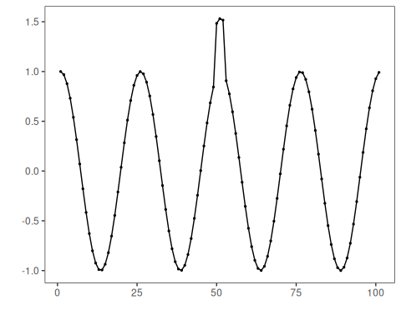

Configure the Method
The choices below turn the central modeling idea into concrete parameters. They matter because dTW-based discord anomaly detection: Dynamic Time Warping (DTW) clustering over subsequences; windows with large DTW distance to their nearest centroid are flagged as discords, so each argument controls how strongly the method will emphasize that pattern when it later produces cluster-based anomaly flags.
# Configure DTW-clustering for sequence discords (seq = 3)
model <- hanct_dtw(3)
# Fit the detector
model <- fit(model, dataset$serie)
## Found more than one class "dist" in cache; using the first, from namespace 'arules'
## Also defined by 'spam'
## Found more than one class "dist" in cache; using the first, from namespace 'arules'
## Also defined by 'spam'

Run the Core Analysis
This is the moment where the notebook tests its central assumption on actual data. After applying hanct_dtw(seq > 1), the important question is whether the resulting cluster-based anomaly flags really correspond to the pattern implied by the method description above, rather than to arbitrary numerical variation.
# Run detection
detection <- detect(model, dataset$serie)
# Show detected discord starts
print(detection |> dplyr::filter(event == TRUE))
## idx event type seq seqlen
## 1 52 TRUE discord 3 3

Evaluate What Was Found
The evaluation asks whether the cluster-based anomaly flags produced by hanct_dtw(seq > 1) match the labeled structure on this dataset. Read the scores as evidence about the method’s assumptions in practice, not as detached summary numbers.
# Evaluate detections against labels
evaluation <- evaluate(model, detection$event, dataset$event)
print(evaluation$confMatrix)
## event
## detection TRUE FALSE
## TRUE 0 1
## FALSE 1 99

Interpret the Result Visually
This visual check puts the model output back on top of the original signal. What matters now is whether the highlighted cluster-based anomaly flags line up with the structure suggested by the method, which is the real semantic test of whether the example is teaching the right lesson.
# Plot discords vs. ground truth
har_plot(model, dataset$serie, detection, dataset$event)
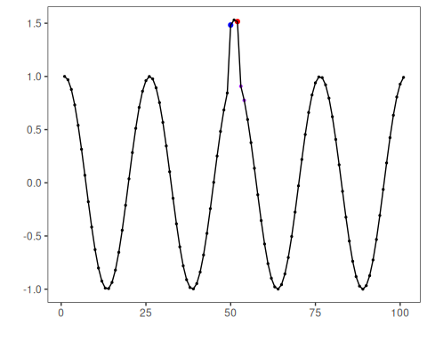
# Plot residual magnitude and decision thresholds
har_plot(model, attr(detection, "res"), detection, dataset$event, yline = attr(detection, "threshold"))
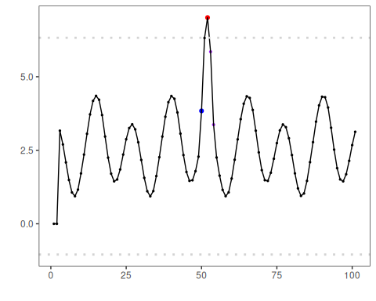

References
- Ogasawara, E., Salles, R., Porto, F., Pacitti, E. Event Detection in Time Series. Springer, 2025. doi:10.1007/978-3-031-75941-3

