Objective
This notebook demonstrates anomaly detection in a univariate time series using a Support Vector Machine regressor via harbinger’s hanr_ml + ts_svm. The model learns short-range dynamics to predict the next value; large residuals are flagged as anomalies using an adaptive threshold. The workflow is: load packages and data, visualize the series, define and fit the model, run detection, evaluate, and plot results (including residual scores).

Method at a glance
SVM regression anomaly detection: Model-deviation detection using ML regression: an SVM forecaster predicts the next value from a sliding window; large prediction errors are flagged as anomalies. Implemented via DALToolbox regressors and thresholded with harutils().

What you will do
- understand the purpose of the example and when the technique is useful
- follow the workflow from data loading to model fitting and detection
- inspect the evaluation outputs and the diagnostic plots produced by Harbinger

Prepare the Example
This setup anchors the notebook in the specific series used to examine hanr_ml + ts_svm. The semantic point is the one stated above: sVM regression anomaly detection: Model-deviation detection using ML regression: an SVM forecaster predicts the next value from a sliding window; large prediction errors are flagged as anomalies, so the raw signal needs to be visible before any fitting step hides that structure behind model output.
# Install Harbinger (only once, if needed)
#install.packages("harbinger")
# Load required packages
library(daltoolbox)
library(harbinger)
library(tspredit)
# Load example datasets bundled with harbinger
data(examples_anomalies)
# Select a simple synthetic time series with labeled anomalies
dataset <- examples_anomalies$simple
head(dataset)
## serie event
## 1 1.0000000 FALSE
## 2 0.9689124 FALSE
## 3 0.8775826 FALSE
## 4 0.7316889 FALSE
## 5 0.5403023 FALSE
## 6 0.3153224 FALSE

Interpret the Result Visually
This first visual pass establishes what the method should react to in the raw series. Keep the method summary in mind here, because sVM regression anomaly detection: Model-deviation detection using ML regression: an SVM forecaster predicts the next value from a sliding window; large prediction errors are flagged as anomalies and the plot tells you whether that structure is clean, weak, local, repeated, or mixed with other effects.
# Plot the time series
har_plot(harbinger(), dataset$serie)
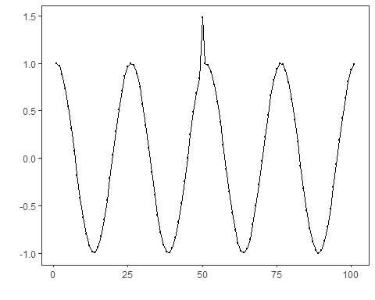

Configure the Method
The choices below turn the central modeling idea into concrete parameters. They matter because sVM regression anomaly detection: Model-deviation detection using ML regression: an SVM forecaster predicts the next value from a sliding window; large prediction errors are flagged as anomalies, so each argument controls how strongly the method will emphasize that pattern when it later produces anomaly flags.
# Define SVM-based regressor for anomaly detection (hanr_ml + ts_svm)
# - input_size=4 sets the window length used for prediction
# - kernel="radial" uses the RBF kernel; tune if needed
model <- hanr_ml(ts_svm(ts_norm_gminmax(), input_size=4, kernel = "radial"))
# Fit the model
model <- fit(model, dataset$serie)

Run the Core Analysis
This is the moment where the notebook tests its central assumption on actual data. After applying hanr_ml + ts_svm, the important question is whether the resulting anomaly flags really correspond to the pattern implied by the method description above, rather than to arbitrary numerical variation.
# Detect anomalies (compute residuals and events)
detection <- detect(model, dataset$serie)
# Show only timestamps flagged as events
print(detection |> dplyr::filter(event==TRUE))
## idx event type
## 1 50 TRUE anomaly

Evaluate What Was Found
The evaluation asks whether the anomaly flags produced by hanr_ml + ts_svm match the labeled structure on this dataset. Read the scores as evidence about the method’s assumptions in practice, not as detached summary numbers.
# Evaluate detections against ground-truth labels
evaluation <- evaluate(model, detection$event, dataset$event)
print(evaluation$confMatrix)
## event
## detection TRUE FALSE
## TRUE 1 0
## FALSE 0 100

Interpret the Result Visually
This visual check puts the model output back on top of the original signal. What matters now is whether the highlighted anomaly flags line up with the structure suggested by the method, which is the real semantic test of whether the example is teaching the right lesson.
# Plot detections over the series
har_plot(model, dataset$serie, detection, dataset$event)
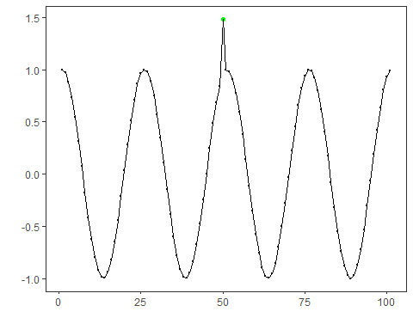
# Plot residual scores and threshold
har_plot(model, attr(detection, "res"), detection, dataset$event, yline = attr(detection, "threshold"))
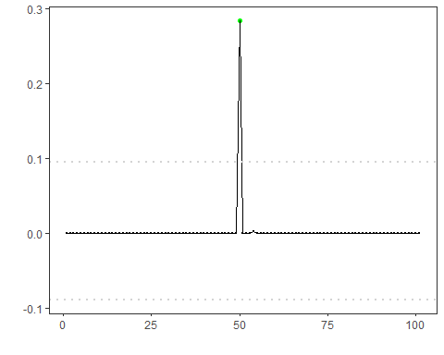

References
- Hyndman, R. J., Athanasopoulos, G. (2021). Forecasting: Principles and Practice. OTexts.

