Objective
The EMD-based detector (CEEMD variant) decomposes the series into intrinsic mode functions (IMFs) and uses high-frequency components to flag anomalies. In this tutorial we:
- Load and visualize a simple anomaly dataset
- Configure and run the EMD detector (hanr_emd)
- Inspect detections, evaluate, and plot residual magnitudes

Method at a glance
EMD regression anomaly detection: This detector uses Empirical Mode Decomposition (CEEMD) to extract intrinsic mode functions (IMFs) and isolates high-frequency components that capture abrupt deviations. Anomalies are flagged where these components show large magnitudes relative to baseline. Computation wraps hht::CEEMD and thresholds are applied via harutils().

What you will do
- understand the purpose of the example and when the technique is useful
- follow the workflow from data loading to model fitting and detection
- inspect the evaluation outputs and the diagnostic plots produced by Harbinger

Prepare the Example
This setup anchors the notebook in the specific series used to examine hanr_emd. The semantic point is the one stated above: eMD regression anomaly detection: This detector uses Empirical Mode Decomposition (CEEMD) to extract intrinsic mode functions (IMFs) and isolates high-frequency components that capture abrupt deviations, so the raw signal needs to be visible before any fitting step hides that structure behind model output.
# Install Harbinger (if needed)
#install.packages("harbinger")
# Load required packages
library(daltoolbox)
library(harbinger)
# Load example anomaly datasets
data(examples_anomalies)
# Select a simple anomaly dataset
dataset <- examples_anomalies$simple
head(dataset)
## serie event
## 1 1.0000000 FALSE
## 2 0.9689124 FALSE
## 3 0.8775826 FALSE
## 4 0.7316889 FALSE
## 5 0.5403023 FALSE
## 6 0.3153224 FALSE

Interpret the Result Visually
This first visual pass establishes what the method should react to in the raw series. Keep the method summary in mind here, because eMD regression anomaly detection: This detector uses Empirical Mode Decomposition (CEEMD) to extract intrinsic mode functions (IMFs) and isolates high-frequency components that capture abrupt deviations and the plot tells you whether that structure is clean, weak, local, repeated, or mixed with other effects.
# Plot the raw time series
har_plot(harbinger(), dataset$serie)
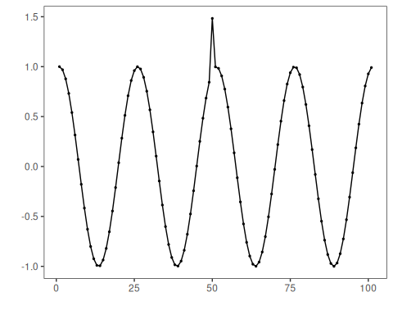

Configure the Method
The choices below turn the central modeling idea into concrete parameters. They matter because eMD regression anomaly detection: This detector uses Empirical Mode Decomposition (CEEMD) to extract intrinsic mode functions (IMFs) and isolates high-frequency components that capture abrupt deviations, so each argument controls how strongly the method will emphasize that pattern when it later produces anomaly flags.
# Configure the EMD-based detector
model <- hanr_emd()
# Fit the detector
model <- fit(model, dataset$serie)

Run the Core Analysis
This is the moment where the notebook tests its central assumption on actual data. After applying hanr_emd, the important question is whether the resulting anomaly flags really correspond to the pattern implied by the method description above, rather than to arbitrary numerical variation.
# Run detection
detection <- detect(model, dataset$serie)
# Show detected anomaly indices
print(detection |> dplyr::filter(event == TRUE))
## idx event type
## 1 50 TRUE anomaly

Evaluate What Was Found
The evaluation asks whether the anomaly flags produced by hanr_emd match the labeled structure on this dataset. Read the scores as evidence about the method’s assumptions in practice, not as detached summary numbers.
# Evaluate detections against labels
evaluation <- evaluate(model, detection$event, dataset$event)
print(evaluation$confMatrix)
## event
## detection TRUE FALSE
## TRUE 1 0
## FALSE 0 100

Interpret the Result Visually
This visual check puts the model output back on top of the original signal. What matters now is whether the highlighted anomaly flags line up with the structure suggested by the method, which is the real semantic test of whether the example is teaching the right lesson.
# Plot detections vs. ground truth
har_plot(model, dataset$serie, detection, dataset$event)
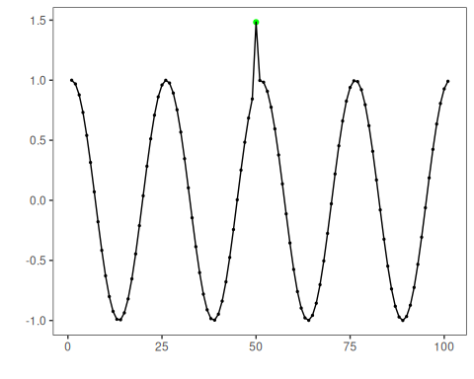
# Plot residual magnitude and decision thresholds
har_plot(model, attr(detection, "res"), detection, dataset$event, yline = attr(detection, "threshold"))
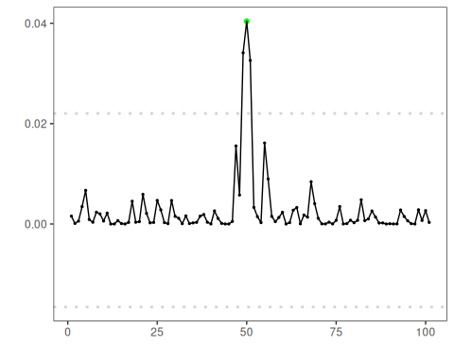

References
- Huang, N. E., et al. (1998). The empirical mode decomposition and the Hilbert spectrum for nonlinear and non-stationary time series analysis. Proceedings of the Royal Society A.

