Page-Hinkley with hcp_page_hinkley()

Objective
This notebook demonstrates Page-Hinkley change-point detection on a univariate time series. The detector monitors the cumulative deviation from the running mean and flags a changepoint when the score becomes too large.

Method at a glance
Page-Hinkley is a sequential test for persistent mean shifts. In Harbinger it is used as a univariate change-point detector for virtual drift in a single numeric series.

Prepare the Example
data(examples_changepoints)
dataset <- examples_changepoints$simple

Visualize the Raw Series
har_plot(harbinger(), dataset$serie)
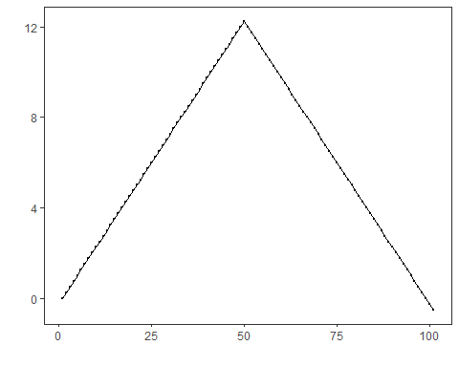

Configure the Method
model <- hcp_page_hinkley(min_instances = 30, delta = 0.005, threshold = 3, alpha = 0.999)
model <- fit(model, dataset$serie)

Run Detection
detection <- detect(model, dataset$serie)
print(detection[detection$event, ])
## idx event type
## 28 28 TRUE changepoint
## 57 57 TRUE changepoint

Evaluate the Result
evaluation <- evaluate(har_eval(), detection$event, dataset$event)
print(evaluation$confMatrix)
## event
## detection TRUE FALSE
## TRUE 0 2
## FALSE 1 98

Plot the Detections
har_plot(model, dataset$serie, detection, dataset$event)
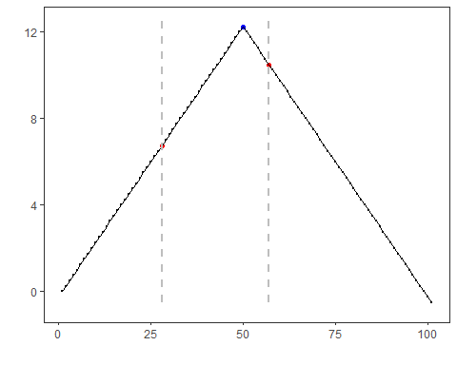

References
- Page ES (1954). Continuous Inspection Schemes. Biometrika, 41(1/2), 100-115.
- Raab C, Heusinger M, Schleif FM (2020). Reactive Soft Prototype Computing for Concept Drift Streams. Neurocomputing.

