KSWIN with hcp_kswin()

Objective
This notebook demonstrates KSWIN change-point detection on a univariate time series. The detector compares an early sample with the most recent observations inside a sliding window and flags a changepoint when the two distributions differ significantly.

Method at a glance
KSWIN is a window-based sequential detector for distributional change. In Harbinger it is restricted to one numeric series so that the output can be interpreted directly as virtual drift on the observed signal.

Prepare the Example
data(examples_changepoints)
dataset <- examples_changepoints$simple

Visualize the Raw Series
har_plot(harbinger(), dataset$serie)
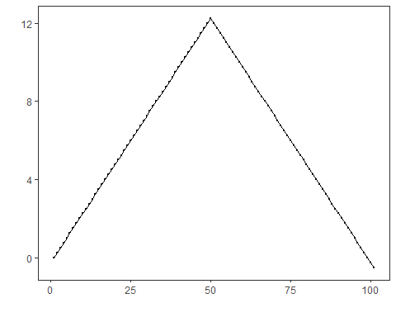

Configure the Method
model <- hcp_kswin(window_size = 100, stat_size = 30, alpha = 0.005)
model <- fit(model, dataset$serie)

Run Detection
detection <- detect(model, dataset$serie)
print(detection[detection$event, ])
## idx event type
## 99 99 TRUE changepoint
## 100 100 TRUE changepoint
## 101 101 TRUE changepoint

Evaluate the Result
evaluation <- evaluate(har_eval(), detection$event, dataset$event)
print(evaluation$confMatrix)
## event
## detection TRUE FALSE
## TRUE 0 3
## FALSE 1 97

Plot the Detections
har_plot(model, dataset$serie, detection, dataset$event)
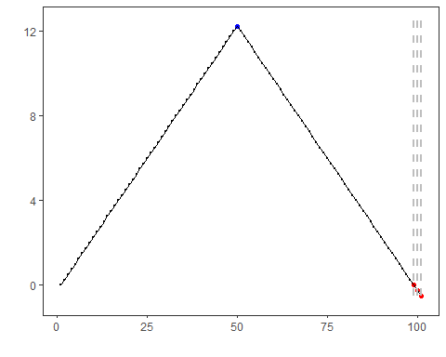

References
- Raab C, Heusinger M, Schleif FM (2020). Reactive Soft Prototype Computing for Concept Drift Streams. Neurocomputing.
- Bifet A, Gavaldà R (2007). Learning from time-changing data with adaptive windowing. SIAM International Conference on Data Mining.

