Joinpoint Regression++ with hcp_joinpoint()

Objective
This notebook demonstrates Joinpoint Regression++ for change-point detection on a univariate time series. The method fits connected linear segments and selects the number of breaks with information criteria, which makes it useful when the signal changes its trend in a structured way.

Method at a glance
hcp_joinpoint() searches for a piecewise linear representation of the series. Harbinger evaluates models with 0 to k_max joinpoints, computes BIC, BIC3 and WBIC, and keeps the model with the smallest WBIC score.
In this notebook the method is described as Joinpoint Regression++ to distinguish it from the original permutation-test workflow in the reference literature. This implementation uses dynamic programming for global segment optimization, so it does not rely on brute-force breakpoint enumeration.
This is a good fit for series where the main evidence of change is a shift in slope or trend level rather than an isolated spike.

Prepare the Example
data(examples_changepoints)
dataset <- examples_changepoints$simple

Visualize the Raw Series
har_plot(harbinger(), dataset$serie)
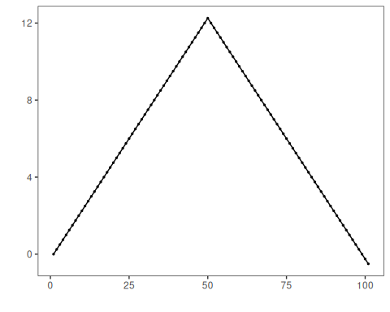

Configure the Method
model <- hcp_joinpoint(
min_between = 20,
min_end = 20,
k_max = 1,
log_transform = FALSE
)
model <- fit(model, dataset$serie)
model$model$comparison
## k RSS BIC BIC3 Weight WBIC
## 1 0 1.340223e+03 2.676859 2.676859 0.000000e+00 2.676859
## 2 1 1.333493e-27 -66.314339 -66.268645 2.220446e-16 -66.314339

Run Detection
detection <- detect(model, dataset$serie)
print(detection[detection$event, ])
## idx event type
## 51 51 TRUE changepoint

Evaluate the Result
evaluation <- evaluate(har_eval(), detection$event, dataset$event)
print(evaluation$confMatrix)
## event
## detection TRUE FALSE
## TRUE 0 1
## FALSE 1 99

Plot the Detections
har_plot(model, dataset$serie, detection, dataset$event)
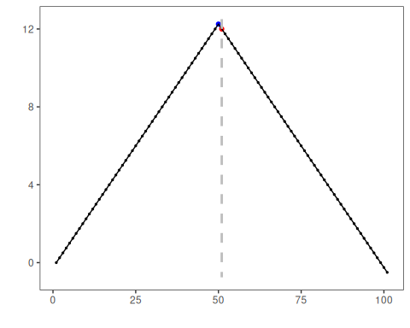

References
- Kim HJ, Fay MP, Feuer EJ, Midthune DN (2000). Permutation Tests for Joinpoint Regression with Applications to Cancer Rates. Statistics in Medicine, 19(3), 335-351.
- Kim HJ, Chen HS, Midthune D, Wheeler B, Buckman DW, Green D, Byrne J, Luo J, Feuer EJ (2023). Data-driven choice of a model selection method in joinpoint regression. Journal of Applied Statistics, 50(9), 1992-2013.
- National Cancer Institute. Joinpoint Trend Analysis Software. https://surveillance.cancer.gov/joinpoint/

