Objective
This notebook introduces the Numenta Anomaly Benchmark datasets exposed by Harbinger. For each NAB dataset object, it demonstrates how to load the full collection with loadfulldata(), count the available series, inspect the structure, and plot the first available signal with har_plot().

Method at a glance
The focus is on dataset inspection. NAB is often used as a benchmark family, so this notebook helps the reader understand the shape of each object before choosing a detection workflow. To avoid overly long figures, each plot uses at most the first 1000 observations of the first series.

What you will do
- load each NAB object with data() and loadfulldata()
- count how many series are available in the full dataset
- verify that the first series is univariate
- plot a short preview of the first signal and its labels

How to read this walkthrough
The code blocks below follow the same learning rhythm used throughout the collection: prepare the environment, choose the dataset, configure the method, run the analysis, and then inspect the result. Readers who are still learning time-series mining can use that order to understand not only what each command does, but also why it appears at that stage of the workflow.
As you go through the notebook, read the inline comments inside each chunk as the operational explanation and use the surrounding prose as the conceptual guide.

Walkthrough

Define the Support Structures
Before applying the workflow itself, we define the helper functions or custom objects that make the example possible. This is one of the most important didactic moments in extension-oriented notebooks because it shows the contract that Harbinger expects and where the reader can adapt the behavior later.
library(harbinger)
dataset_summary <- function(x) {
first_series <- x[[1]]
meta_cols <- c("idx", "event", "type", "seq", "seqlen")
signal_cols <- setdiff(names(first_series), meta_cols)
dataset_type <- if ("value" %in% names(first_series) || length(signal_cols) == 1) "univariate" else "multivariate"
plot_column <- if ("value" %in% names(first_series)) "value" else signal_cols[1]
list(
n_series = length(x),
dataset_type = dataset_type,
signal_cols = signal_cols,
plot_column = plot_column,
preview_size = min(1000, nrow(first_series)),
first_series = first_series
)
}
show_dataset <- function(x, name) {
info <- dataset_summary(x)
cat("Dataset:", name, "\n")
cat("Number of series:", info$n_series, "\n")
cat("Dataset type:", info$dataset_type, "\n")
cat("Signals in the first series:", paste(info$signal_cols, collapse = ", "), "\n")
cat("Column plotted with har_plot():", info$plot_column, "\n")
cat("Plot preview length:", info$preview_size, "observations\n")
invisible(info)
}
plot_dataset_preview <- function(info) {
preview <- info$first_series[seq_len(info$preview_size), , drop = FALSE]
har_plot(
harbinger(),
preview[[info$plot_column]],
event = preview$event
)
}

nab_artificialWithAnomaly
In this subsection, we load the relevant data object, confirm its structure, and prepare a concise preview so the reader can understand what kind of signal will be explored.
data(nab_artificialWithAnomaly)
nab_artificialWithAnomaly <- loadfulldata(nab_artificialWithAnomaly)
nab_artificial_info <- show_dataset(nab_artificialWithAnomaly, "nab_artificialWithAnomaly")
## Dataset: nab_artificialWithAnomaly
## Number of series: 5
## Dataset type: univariate
## Signals in the first series: value
## Column plotted with har_plot(): value
## Plot preview length: 1000 observations
plot_dataset_preview(nab_artificial_info)
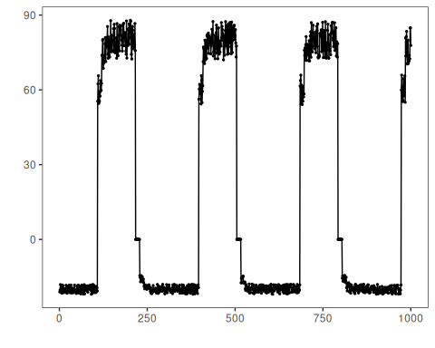

nab_realAdExchange
In this subsection, we load the relevant data object, confirm its structure, and prepare a concise preview so the reader can understand what kind of signal will be explored.
data(nab_realAdExchange)
nab_realAdExchange <- loadfulldata(nab_realAdExchange)
nab_adexchange_info <- show_dataset(nab_realAdExchange, "nab_realAdExchange")
## Dataset: nab_realAdExchange
## Number of series: 6
## Dataset type: univariate
## Signals in the first series: value
## Column plotted with har_plot(): value
## Plot preview length: 1000 observations
plot_dataset_preview(nab_adexchange_info)
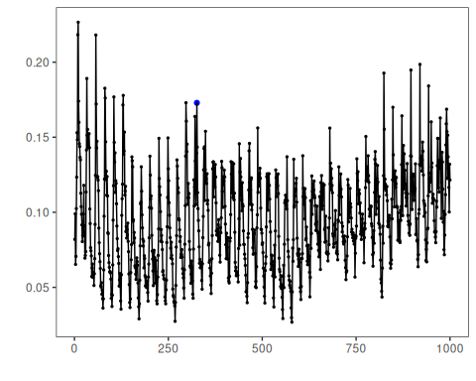

nab_realAWSCloudwatch
In this subsection, we load the relevant data object, confirm its structure, and prepare a concise preview so the reader can understand what kind of signal will be explored.
data(nab_realAWSCloudwatch)
nab_realAWSCloudwatch <- loadfulldata(nab_realAWSCloudwatch)
nab_aws_info <- show_dataset(nab_realAWSCloudwatch, "nab_realAWSCloudwatch")
## Dataset: nab_realAWSCloudwatch
## Number of series: 6
## Dataset type: univariate
## Signals in the first series: value
## Column plotted with har_plot(): value
## Plot preview length: 1000 observations
plot_dataset_preview(nab_aws_info)
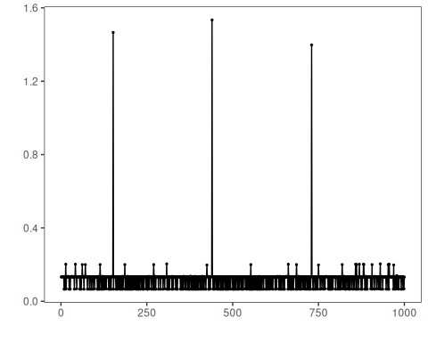

nab_realKnownCause
In this subsection, we load the relevant data object, confirm its structure, and prepare a concise preview so the reader can understand what kind of signal will be explored.
data(nab_realKnownCause)
nab_realKnownCause <- loadfulldata(nab_realKnownCause)
nab_known_info <- show_dataset(nab_realKnownCause, "nab_realKnownCause")
## Dataset: nab_realKnownCause
## Number of series: 7
## Dataset type: univariate
## Signals in the first series: value
## Column plotted with har_plot(): value
## Plot preview length: 1000 observations
plot_dataset_preview(nab_known_info)
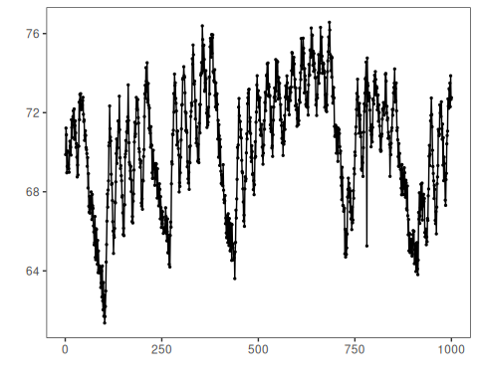

nab_realTraffic
In this subsection, we load the relevant data object, confirm its structure, and prepare a concise preview so the reader can understand what kind of signal will be explored.
data(nab_realTraffic)
nab_realTraffic <- loadfulldata(nab_realTraffic)
nab_traffic_info <- show_dataset(nab_realTraffic, "nab_realTraffic")
## Dataset: nab_realTraffic
## Number of series: 7
## Dataset type: univariate
## Signals in the first series: value
## Column plotted with har_plot(): value
## Plot preview length: 1000 observations
plot_dataset_preview(nab_traffic_info)
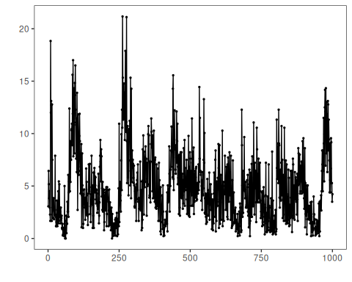

nab_realTweets
In this subsection, we load the relevant data object, confirm its structure, and prepare a concise preview so the reader can understand what kind of signal will be explored.
data(nab_realTweets)
nab_realTweets <- loadfulldata(nab_realTweets)
nab_tweets_info <- show_dataset(nab_realTweets, "nab_realTweets")
## Dataset: nab_realTweets
## Number of series: 10
## Dataset type: univariate
## Signals in the first series: value
## Column plotted with har_plot(): value
## Plot preview length: 1000 observations
plot_dataset_preview(nab_tweets_info)
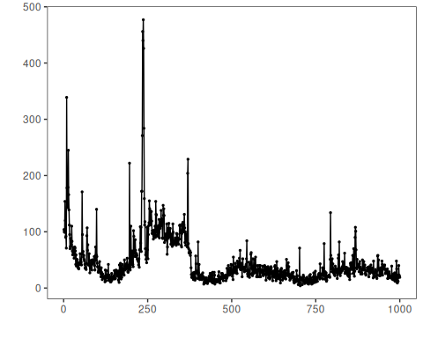

References
- Lavin, A., Ahmad, S. (2015). Evaluating real-time anomaly detection algorithms: the Numenta Anomaly Benchmark.
- Ogasawara, E., Salles, R., Porto, F., Pacitti, E. Event Detection in Time Series. Springer, 2025. doi:10.1007/978-3-031-75941-3

