Objective
This notebook demonstrates clustering-based anomaly detection using k-means via hanct_kmeans(k). The model clusters subsequences and flags anomalies based on distance to cluster centroids. Steps: load packages/data, visualize, define k-means model, fit, detect, evaluate, and plot series and residuals.

Method at a glance
k-means clustering anomaly detection: This approach applies k-means clustering to either points (seq = 1) or sliding-window subsequences (seq > 1). Observations (or windows) that lie far from their nearest centroid are flagged as anomalies or discords, respectively. The implementation wraps stats::kmeans for clustering and uses harutils() to summarize distances and set thresholds.

What you will do
- understand the purpose of the example and when the technique is useful
- follow the workflow from data loading to model fitting and detection
- inspect the evaluation outputs and the diagnostic plots produced by Harbinger

Prepare the Example
This setup anchors the notebook in the specific series used to examine hanct_kmeans(k). The semantic point is the one stated above: k-means clustering anomaly detection: This approach applies k-means clustering to either points (seq = 1) or sliding-window subsequences (seq > 1), so the raw signal needs to be visible before any fitting step hides that structure behind model output.
# Install Harbinger (only once, if needed)
#install.packages("harbinger")
# Load required packages
library(daltoolbox)
library(harbinger)
# Load example datasets bundled with harbinger
data(examples_anomalies)
# Select a simple synthetic time series with labeled anomalies
dataset <- examples_anomalies$simple
head(dataset)
## serie event
## 1 1.0000000 FALSE
## 2 0.9689124 FALSE
## 3 0.8775826 FALSE
## 4 0.7316889 FALSE
## 5 0.5403023 FALSE
## 6 0.3153224 FALSE

Interpret the Result Visually
This first visual pass establishes what the method should react to in the raw series. Keep the method summary in mind here, because k-means clustering anomaly detection: This approach applies k-means clustering to either points (seq = 1) or sliding-window subsequences (seq > 1) and the plot tells you whether that structure is clean, weak, local, repeated, or mixed with other effects.
# Plot the time series
har_plot(harbinger(), dataset$serie)
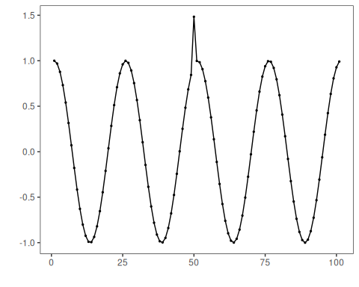

Configure the Method
The choices below turn the central modeling idea into concrete parameters. They matter because k-means clustering anomaly detection: This approach applies k-means clustering to either points (seq = 1) or sliding-window subsequences (seq > 1), so each argument controls how strongly the method will emphasize that pattern when it later produces cluster-based anomaly flags.
# Define k-means anomaly detector (k controls number of clusters)
model <- hanct_kmeans(1)
# Fit the model
model <- fit(model, dataset$serie)

Run the Core Analysis
This is the moment where the notebook tests its central assumption on actual data. After applying hanct_kmeans(k), the important question is whether the resulting cluster-based anomaly flags really correspond to the pattern implied by the method description above, rather than to arbitrary numerical variation.
# Detect anomalies using k-means distances
detection <- detect(model, dataset$serie)
# Show only timestamps flagged as events
print(detection |> dplyr::filter(event==TRUE))
## idx event type
## 1 50 TRUE anomaly

Evaluate What Was Found
The evaluation asks whether the cluster-based anomaly flags produced by hanct_kmeans(k) match the labeled structure on this dataset. Read the scores as evidence about the method’s assumptions in practice, not as detached summary numbers.
# Evaluate detections against ground-truth labels
evaluation <- evaluate(model, detection$event, dataset$event)
print(evaluation$confMatrix)
## event
## detection TRUE FALSE
## TRUE 1 0
## FALSE 0 100

Interpret the Result Visually
This visual check puts the model output back on top of the original signal. What matters now is whether the highlighted cluster-based anomaly flags line up with the structure suggested by the method, which is the real semantic test of whether the example is teaching the right lesson.
# Plot detections over the series
har_plot(model, dataset$serie, detection, dataset$event)
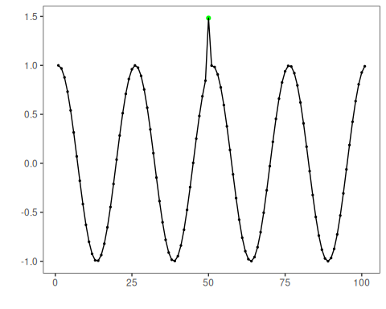
# Plot residual scores and threshold
har_plot(model, attr(detection, "res"), detection, dataset$event, yline = attr(detection, "threshold"))
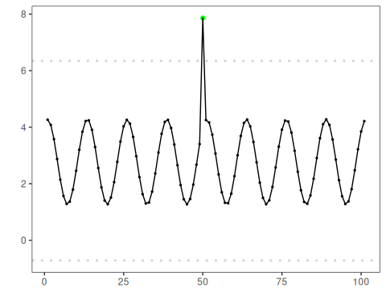

References
- Ogasawara, E., Salles, R., Porto, F., Pacitti, E. Event Detection in Time Series. 1st ed. Cham: Springer Nature Switzerland, 2025. doi:10.1007/978-3-031-75941-3

