Objective
DTW-based clustering detects anomalies by measuring distance to cluster centroids over sliding windows (seq=1 flags point anomalies).
Steps: - Load and visualize a simple anomaly dataset - Configure and run hanct_dtw(seq = 1) - Inspect detections, evaluate, and plot residual magnitudes and thresholds

Method at a glance
DTW-based clustering anomaly detector: This approach applies Dynamic Time Warping (DTW) within a clustering framework. For seq = 1, each observation is assigned to the nearest centroid under DTW; observations with large DTW distance from their closest centroid are flagged as point anomalies. For seq > 1, sliding-window subsequences are compared and large-distance windows are flagged as discords. The implementation wraps DTW-based clustering from dtwclust and uses harutils() for summarization and thresholding.

What you will do
- understand the purpose of the example and when the technique is useful
- follow the workflow from data loading to model fitting and detection
- inspect the evaluation outputs and the diagnostic plots produced by Harbinger

Prepare the Example
This setup anchors the notebook in the specific series used to examine hanct_dtw(seq = 1). The semantic point is the one stated above: dTW-based clustering anomaly detector: This approach applies Dynamic Time Warping (DTW) within a clustering framework, so the raw signal needs to be visible before any fitting step hides that structure behind model output.
# Install Harbinger (if needed)
#install.packages("harbinger")
# Load required packages
library(daltoolbox)
library(harbinger)
# Load example anomaly datasets
data(examples_anomalies)
# Select a simple anomaly dataset
dataset <- examples_anomalies$simple
head(dataset)
## serie event
## 1 1.0000000 FALSE
## 2 0.9689124 FALSE
## 3 0.8775826 FALSE
## 4 0.7316889 FALSE
## 5 0.5403023 FALSE
## 6 0.3153224 FALSE

Interpret the Result Visually
This first visual pass establishes what the method should react to in the raw series. Keep the method summary in mind here, because dTW-based clustering anomaly detector: This approach applies Dynamic Time Warping (DTW) within a clustering framework and the plot tells you whether that structure is clean, weak, local, repeated, or mixed with other effects.
# Plot the raw time series
har_plot(harbinger(), dataset$serie)
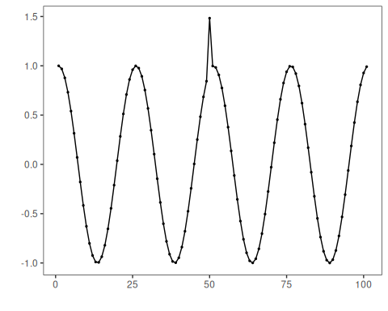

Configure the Method
The choices below turn the central modeling idea into concrete parameters. They matter because dTW-based clustering anomaly detector: This approach applies Dynamic Time Warping (DTW) within a clustering framework, so each argument controls how strongly the method will emphasize that pattern when it later produces cluster-based anomaly flags.
# Configure DTW-clustering for point anomalies (seq = 1)
model <- hanct_dtw(1)
# Fit the detector
model <- fit(model, dataset$serie)
## Found more than one class "dist" in cache; using the first, from namespace 'spam'
## Also defined by 'arules' 'dtwclust'

Run the Core Analysis
This is the moment where the notebook tests its central assumption on actual data. After applying hanct_dtw(seq = 1), the important question is whether the resulting cluster-based anomaly flags really correspond to the pattern implied by the method description above, rather than to arbitrary numerical variation.
# Run detection
detection <- detect(model, dataset$serie)
# Show detected anomaly indices
print(detection |> dplyr::filter(event == TRUE))
## idx event type
## 1 50 TRUE anomaly

Evaluate What Was Found
The evaluation asks whether the cluster-based anomaly flags produced by hanct_dtw(seq = 1) match the labeled structure on this dataset. Read the scores as evidence about the method’s assumptions in practice, not as detached summary numbers.
# Evaluate detections against labels
evaluation <- evaluate(model, detection$event, dataset$event)
print(evaluation$confMatrix)
## event
## detection TRUE FALSE
## TRUE 1 0
## FALSE 0 100

Interpret the Result Visually
This visual check puts the model output back on top of the original signal. What matters now is whether the highlighted cluster-based anomaly flags line up with the structure suggested by the method, which is the real semantic test of whether the example is teaching the right lesson.
# Plot detections vs. ground truth
har_plot(model, dataset$serie, detection, dataset$event)
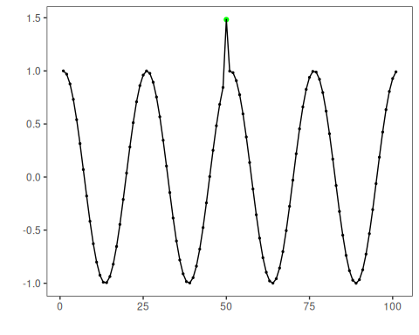
# Plot residual magnitude and decision thresholds
har_plot(model, attr(detection, "res"), detection, dataset$event, yline = attr(detection, "threshold"))
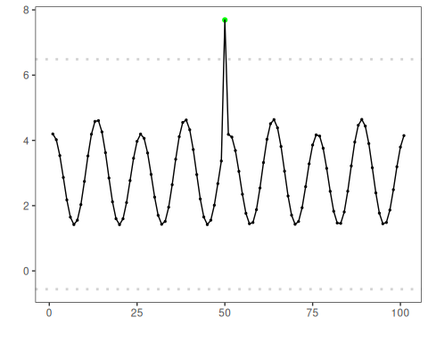

References
- Ogasawara, E., Salles, R., Porto, F., Pacitti, E. Event Detection in Time Series. 1st ed. Cham: Springer Nature Switzerland, 2025. doi:10.1007/978-3-031-75941-3

