Objective
This notebook demonstrates anomaly detection using a fuzzy-tolerant ensemble (har_ensemble(...) with time_tolerance). Multiple detectors (FBIAD, ARIMA, EMD) vote and detections within a time tolerance are merged. Steps: load packages/data, visualize, define ensemble and tolerance, fit, detect, evaluate, and plot.

Method at a glance
Ensemble Fuzzy anomaly detection: Ensemble voting with temporal fuzzification merges detections within a tolerance window into a single event before voting, reducing duplicate triggers and aligning with ground-truth granularity.

What you will do
- understand the purpose of the example and when the technique is useful
- follow the workflow from data loading to model fitting and detection
- inspect the evaluation outputs and the diagnostic plots produced by Harbinger

Prepare the Example
This setup anchors the notebook in the specific series used to examine 71-ensemble-hanr_ensemble_fuzzy. The semantic point is the one stated above: ensemble Fuzzy anomaly detection: Ensemble voting with temporal fuzzification merges detections within a tolerance window into a single event before voting, reducing duplicate triggers and aligning with ground-truth granularity, so the raw signal needs to be visible before any fitting step hides that structure behind model output.
# Install Harbinger (only once, if needed)
#install.packages("harbinger")
# Load required packages
library(daltoolbox)
library(harbinger)
# Load example datasets bundled with harbinger
data(examples_anomalies)
# Select a simple synthetic time series with labeled anomalies
dataset <- examples_anomalies$simple
head(dataset)
## serie event
## 1 1.0000000 FALSE
## 2 0.9689124 FALSE
## 3 0.8775826 FALSE
## 4 0.7316889 FALSE
## 5 0.5403023 FALSE
## 6 0.3153224 FALSE

Interpret the Result Visually
This first visual pass establishes what the method should react to in the raw series. Keep the method summary in mind here, because ensemble Fuzzy anomaly detection: Ensemble voting with temporal fuzzification merges detections within a tolerance window into a single event before voting, reducing duplicate triggers and aligning with ground-truth granularity and the plot tells you whether that structure is clean, weak, local, repeated, or mixed with other effects.
# Plot the time series
har_plot(harbinger(), dataset$serie)
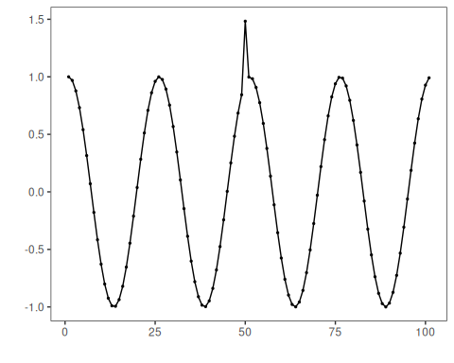

Configure the Method
The choices below turn the central modeling idea into concrete parameters. They matter because ensemble Fuzzy anomaly detection: Ensemble voting with temporal fuzzification merges detections within a tolerance window into a single event before voting, reducing duplicate triggers and aligning with ground-truth granularity, so each argument controls how strongly the method will emphasize that pattern when it later produces ensemble anomaly flags.
# Define the ensemble and set time tolerance for fuzzy matching
model <- har_ensemble(hanr_fbiad(), hanr_arima(), hanr_emd())
model$time_tolerance <- 10
# Fit the model
model <- fit(model, dataset$serie)

Run the Core Analysis
This is the moment where the notebook tests its central assumption on actual data. After applying 71-ensemble-hanr_ensemble_fuzzy, the important question is whether the resulting ensemble anomaly flags really correspond to the pattern implied by the method description above, rather than to arbitrary numerical variation.
# Detect anomalies via ensemble voting with tolerance
detection <- detect(model, dataset$serie)
# Show only timestamps flagged as events
print(detection |> dplyr::filter(event==TRUE))
## idx event type
## 1 50 TRUE anomaly

Evaluate What Was Found
The evaluation asks whether the ensemble anomaly flags produced by 71-ensemble-hanr_ensemble_fuzzy match the labeled structure on this dataset. Read the scores as evidence about the method’s assumptions in practice, not as detached summary numbers.
# Evaluate detections against ground-truth labels
evaluation <- evaluate(model, detection$event, dataset$event)
print(evaluation$confMatrix)
## event
## detection TRUE FALSE
## TRUE 1 0
## FALSE 0 100

Interpret the Result Visually
This visual check puts the model output back on top of the original signal. What matters now is whether the highlighted ensemble anomaly flags line up with the structure suggested by the method, which is the real semantic test of whether the example is teaching the right lesson.
# Plot detections over the series
har_plot(model, dataset$serie, detection, dataset$event)
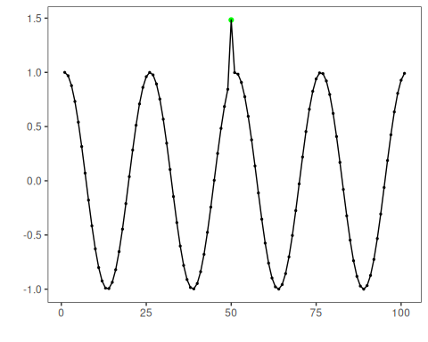
# Plot residual scores and threshold
har_plot(model, attr(detection, "res"), detection, dataset$event, yline = attr(detection, "threshold"))
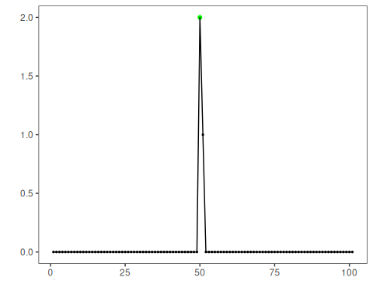

References
- Ogasawara, E., Salles, R., Porto, F., Pacitti, E. Event Detection in Time Series. Springer, 2025. doi:10.1007/978-3-031-75941-3

