Objective
The PCA-based detector flags large reconstruction errors when projecting multivariate data onto principal components. In this tutorial we:
- Load a multivariate example and create synthetic event labels
- Fit the PCA detector on two dimensions
- Visualize detections over different series and inspect residual magnitudes

Method at a glance
PCA-based regression anomaly detection: Projects multivariate observations onto principal components and reconstructs data; large reconstruction errors indicate anomalies. Data are standardized, PCA is fitted, and reconstruction errors are thresholded.

What you will do
- understand the purpose of the example and when the technique is useful
- follow the workflow from data loading to model fitting and detection
- inspect the evaluation outputs and the diagnostic plots produced by Harbinger

Prepare the Example
This setup anchors the notebook in the specific series used to examine 90-multivariate-hmu_pca. The semantic point is the one stated above: pCA-based regression anomaly detection: Projects multivariate observations onto principal components and reconstructs data; large reconstruction errors indicate anomalies, so the raw signal needs to be visible before any fitting step hides that structure behind model output.
# Install Harbinger (if needed)
#install.packages("harbinger")
# Load required packages
library(daltoolbox)
library(harbinger)
library(ggplot2)
# Load a multivariate example and define event labels (for demo)
data("examples_harbinger")
dataset <- examples_harbinger$multidimensional
dataset$event <- FALSE
dataset$event[c(101,128,167)] <- TRUE

Run the Core Analysis
This is the moment where the notebook tests its central assumption on actual data. After applying 90-multivariate-hmu_pca, the important question is whether the resulting multivariate anomaly flags really correspond to the pattern implied by the method description above, rather than to arbitrary numerical variation.
head(dataset)
## serie x event
## 1 -0.6264538 0.40940184 FALSE
## 2 -0.8356286 1.58658843 FALSE
## 3 1.5952808 -0.33090780 FALSE
## 4 0.3295078 -2.28523554 FALSE
## 5 -0.8204684 2.49766159 FALSE
## 6 0.5757814 -0.01339952 FALSE

Interpret the Result Visually
This visual check puts the model output back on top of the original signal. What matters now is whether the highlighted multivariate anomaly flags line up with the structure suggested by the method, which is the real semantic test of whether the example is teaching the right lesson.
# Plot the target series
har_plot(harbinger(), dataset$serie)
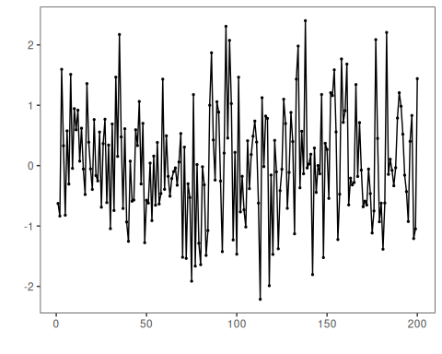
# Plot the second dimension
har_plot(harbinger(), dataset$x)
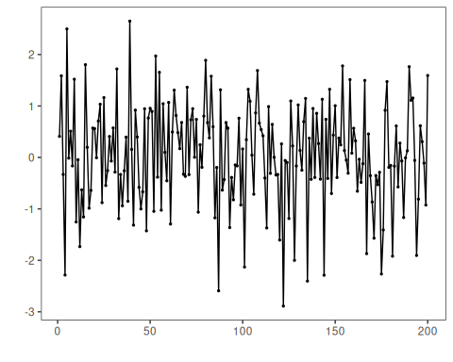

Configure the Method
The choices below turn the central modeling idea into concrete parameters. They matter because pCA-based regression anomaly detection: Projects multivariate observations onto principal components and reconstructs data; large reconstruction errors indicate anomalies, so each argument controls how strongly the method will emphasize that pattern when it later produces multivariate anomaly flags.
# Fit the PCA detector on the first two columns and run detection
model <- fit(hmu_pca(), dataset[,1:2])
detection <- detect(model, dataset[,1:2])

Interpret the Result Visually
This visual check puts the model output back on top of the original signal. What matters now is whether the highlighted multivariate anomaly flags line up with the structure suggested by the method, which is the real semantic test of whether the example is teaching the right lesson.
# Plot detections on the target series
grf <- har_plot(model, dataset$serie, detection, dataset$event)
grf <- grf + ylab("serie")
# Plot detections on the second dimension
grf <- har_plot(model, dataset$x, detection, dataset$event)
grf <- grf + ylab("x")
# Plot residual magnitude and decision thresholds
har_plot(model, attr(detection, "res"), detection, dataset$event, yline = attr(detection, "threshold"))
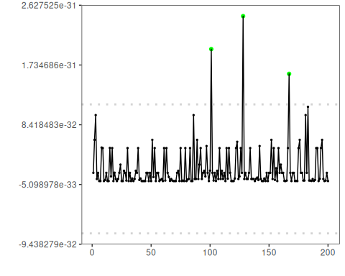

References
- Jolliffe, I. T. (2002). Principal Component Analysis. Springer.

