Objective
This notebook demonstrates anomaly detection with an adversarial autoencoder (han_autoencoder(..., autoenc_adv_ed, ...)). The model learns a robust latent representation; anomalies yield higher reconstruction error. Steps: load packages/data, visualize, define the architecture/epochs, fit, detect, evaluate, and plot.

Method at a glance
Adversarial Autoencoder (encode-decode): An adversarial autoencoder (AAE) augments a standard encoder–decoder with an adversarial objective on the latent code. The encoder maps each input window into a latent vector and the decoder attempts to reconstruct the original window. In parallel, a discriminator is trained to distinguish latent samples produced by the encoder from samples drawn from a chosen prior distribution (e.g., Gaussian). The encoder is trained to fool the discriminator, aligning the aggregated posterior of the latent space with the prior. This regularization encourages the model to represent normal time-series patterns on a compact manifold and to reconstruct them well. Windows that deviate from this learned manifold (anomalies) typically yield larger reconstruction errors. In this example, windows are scored by reconstruction error and events are flagged when the score exceeds a learned threshold.

What you will do
- understand the purpose of the example and when the technique is useful
- follow the workflow from data loading to model fitting and detection
- inspect the evaluation outputs and the diagnostic plots produced by Harbinger

Walkthrough
# Install Harbinger (only once, if needed)
#install.packages("harbinger")
# Load required packages
library(daltoolbox)
library(daltoolboxdp)
library(harbinger)
# Load example datasets bundled with harbinger
data(examples_anomalies)
# Select a simple synthetic time series with labeled anomalies
dataset <- examples_anomalies$simple
head(dataset)
## serie event
## 1 1.0000000 FALSE
## 2 0.9689124 FALSE
## 3 0.8775826 FALSE
## 4 0.7316889 FALSE
## 5 0.5403023 FALSE
## 6 0.3153224 FALSE
# Plot the time series
har_plot(harbinger(), dataset$serie)
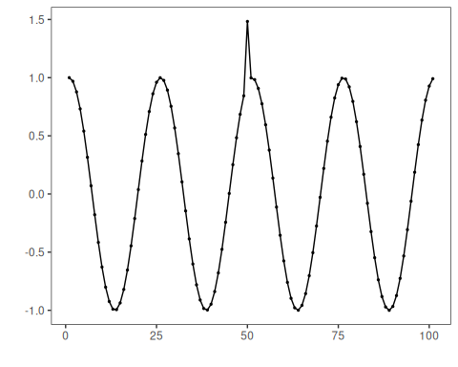
# Define adversarial autoencoder-based detector (autoenc_adv_ed)
model <- han_autoencoder(3, 2, autoenc_adv_ed, num_epochs = 1500)
# Fit the model
model <- fit(model, dataset$serie)
# Detect anomalies (reconstruction error -> events)
detection <- detect(model, dataset$serie)
# Show only timestamps flagged as events
print(detection |> dplyr::filter(event==TRUE))
## idx event type
## 1 19 TRUE anomaly
## 2 44 TRUE anomaly
## 3 69 TRUE anomaly
# Evaluate detections against ground-truth labels
evaluation <- evaluate(model, detection$event, dataset$event)
print(evaluation$confMatrix)
## event
## detection TRUE FALSE
## TRUE 0 3
## FALSE 1 97
# Plot detections over the series
har_plot(model, dataset$serie, detection, dataset$event)
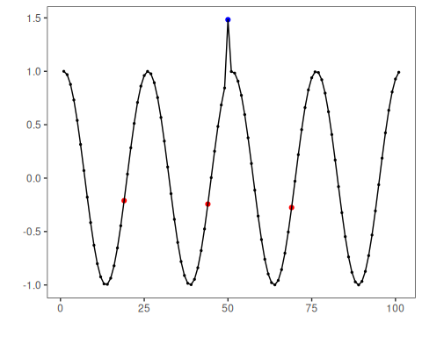
# Plot residual scores and threshold
har_plot(model, attr(detection, "res"), detection, dataset$event, yline = attr(detection, "threshold"))
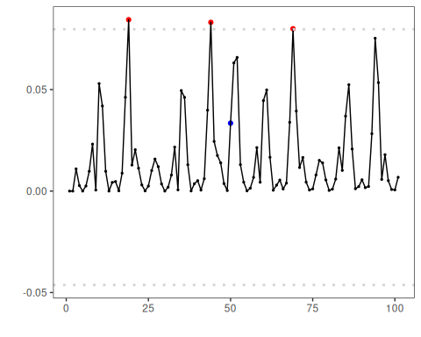

References
- Makhzani, A., Shlens, J., Jaitly, N., Goodfellow, I., & Frey, B. (2016). Adversarial Autoencoders. arXiv:1511.05644.
- Chalapathy, R., & Chawla, S. (2019). Deep Learning for Anomaly Detection: A Survey. arXiv:1901.03407.

