Objective
This notebook demonstrates anomaly detection with a stacked autoencoder (han_autoencoder(..., autoenc_stacked_ed, ...)). Stacking deepens the encoder/decoder to capture richer structure; anomalies have higher reconstruction error. Steps: load packages/data, visualize, define layers/epochs, fit, detect, evaluate, and plot.

Method at a glance
Stacked autoencoder (encode-decode): A stacked autoencoder deepens encoder/decoder layers to capture richer nonlinear structure; large reconstruction error flags anomalies. Detection thresholds use harutils().

What you will do
- understand the purpose of the example and when the technique is useful
- follow the workflow from data loading to model fitting and detection
- inspect the evaluation outputs and the diagnostic plots produced by Harbinger

Walkthrough
# Load required packages
library(daltoolbox)
library(harbinger)
library(daltoolboxdp)
# Load example datasets bundled with harbinger
data(examples_anomalies)
# Select a simple synthetic time series with labeled anomalies
dataset <- examples_anomalies$simple
head(dataset)
## serie event
## 1 1.0000000 FALSE
## 2 0.9689124 FALSE
## 3 0.8775826 FALSE
## 4 0.7316889 FALSE
## 5 0.5403023 FALSE
## 6 0.3153224 FALSE
# Plot the time series
har_plot(harbinger(), dataset$serie)
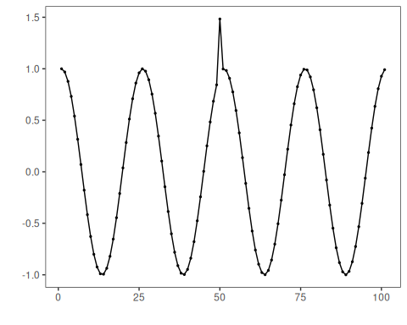
# Define stacked autoencoder-based detector (autoenc_stacked_ed)
model <- han_autoencoder(3, 2, autoenc_stacked_ed, num_epochs = 1500)
# Fit the model
model <- fit(model, dataset$serie)
# Detect anomalies (reconstruction error -> events)
detection <- detect(model, dataset$serie)
# Show only timestamps flagged as events
print(detection |> dplyr::filter(event==TRUE))
## [1] idx event type
## <0 rows> (or 0-length row.names)
# Evaluate detections against ground-truth labels
evaluation <- evaluate(model, detection$event, dataset$event)
print(evaluation$confMatrix)
## event
## detection TRUE FALSE
## TRUE 0 0
## FALSE 1 100
# Plot detections over the series
har_plot(model, dataset$serie, detection, dataset$event)
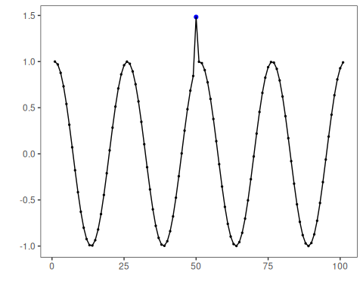
# Plot residual scores and threshold
har_plot(model, attr(detection, "res"), detection, dataset$event, yline = attr(detection, "threshold"))
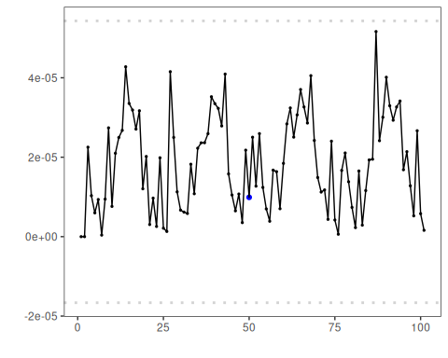

References
- Sakurada, M., Yairi, T. (2014). Anomaly Detection Using Autoencoders with Nonlinear Dimensionality Reduction. MLSDA 2014.

