Objective
This Rmd shows supervised anomaly classification using hanc_ml with a Multi-Layer Perceptron (cla_mlp). It uses labeled events, a simple train/test split, and min–max normalization. Steps: load packages/data, visualize, preprocess, define and fit the classifier, detect, evaluate, and plot results.

Method at a glance
MLP classification anomaly detector: Supervised anomaly detection with a neural network classifier (MLP) trained on labeled events; predicted probabilities above a threshold are flagged.

What you will do
- understand the purpose of the example and when the technique is useful
- follow the workflow from data loading to model fitting and detection
- inspect the evaluation outputs and the diagnostic plots produced by Harbinger

Walkthrough
# Install Harbinger (only once, if needed)
#install.packages("harbinger")
# Load required packages
library(daltoolbox)
library(harbinger)
# Load example datasets bundled with harbinger
data(examples_anomalies)
# Use the "tt" time series (labeled)
dataset <- examples_anomalies$tt
head(dataset)
## serie event
## 1 1.0000000 FALSE
## 2 0.9689124 FALSE
## 3 0.8775826 FALSE
## 4 0.7316889 FALSE
## 5 0.5403023 FALSE
## 6 0.3153224 FALSE
# Plot the time series
har_plot(harbinger(), dataset$serie)
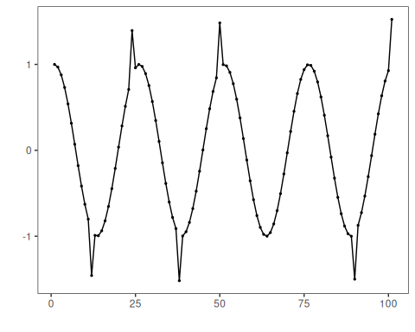
# Data preprocessing: split and scale
train <- dataset[1:80,]
test <- dataset[-(1:80),]
norm <- minmax()
norm <- fit(norm, train)
train_n <- transform(norm, train)
summary(train_n)
## serie event
## Min. :0.0000 Mode :logical
## 1st Qu.:0.2859 FALSE:76
## Median :0.5348 TRUE :4
## Mean :0.5221
## 3rd Qu.:0.7587
## Max. :1.0000
# Define MLP classifier for events (hanc_ml + cla_mlp)
model <- hanc_ml(cla_mlp("event", c("FALSE", "TRUE"), size=3, decay=0.03))
# Fit the model on training data
model <- fit(model, train_n)
detection <- detect(model, train_n)
print(detection |> dplyr::filter(event==TRUE))
## [1] idx event type
## <0 rows> (or 0-length row.names)
# Evaluate training performance
evaluation <- evaluate(model, detection$event, as.logical(train_n$event))
print(evaluation$confMatrix)
## event
## detection TRUE FALSE
## TRUE 0 0
## FALSE 4 76
# Plot training detections
har_plot(model, train_n$serie, detection, as.logical(train_n$event))
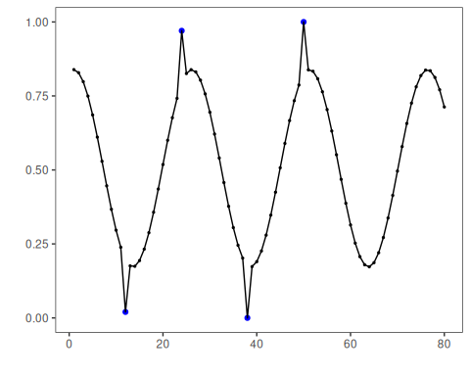
# Prepare test data (apply same scaler)
test_n <- transform(norm, test)
# Detect and evaluate on test data
detection <- detect(model, test_n)
print(detection |> dplyr::filter(event==TRUE))
## [1] idx event type
## <0 rows> (or 0-length row.names)
evaluation <- evaluate(model, detection$event, as.logical(test_n$event))
print(evaluation$confMatrix)
## event
## detection TRUE FALSE
## TRUE 0 0
## FALSE 2 19
# Plot test detections
har_plot(model, test_n$serie, detection, as.logical(test_n$event))
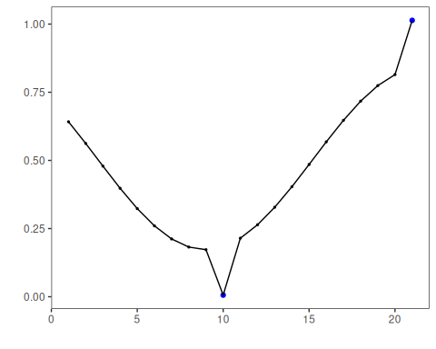
# Plot residual scores and threshold
har_plot(model, attr(detection, "res"), detection, test_n$event, yline = attr(detection, "threshold"))
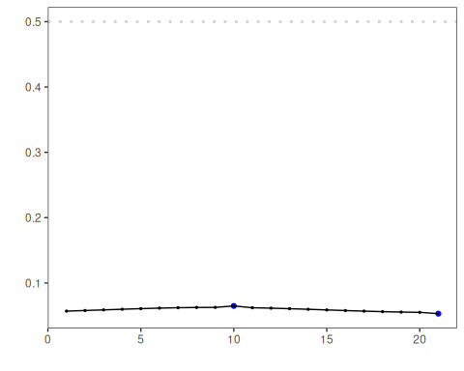

References
- Bishop, C. M. (2006). Pattern Recognition and Machine Learning. Springer.
- Hyndman, R. J., Athanasopoulos, G. (2021). Forecasting: Principles and Practice. OTexts.

