Objective
The ARIMA-based anomaly detector fits an ARIMA model to the time series and flags large residuals as anomalies. In this walkthrough we will:
- Load a synthetic anomaly dataset and visualize it
- Configure and run the ARIMA detector (hanr_arima)
- Inspect detections, evaluate against ground truth, and plot residuals and thresholds

Method at a glance
ARIMA regression anomaly detection: This detector fits an ARIMA(p, d, q) model to the series and uses large standardized residuals as anomaly evidence. After estimating the model, residual magnitudes are summarized via a distance function and thresholded using outlier heuristics provided by harutils().

What you will do
- understand the purpose of the example and when the technique is useful
- follow the workflow from data loading to model fitting and detection
- inspect the evaluation outputs and the diagnostic plots produced by Harbinger

Walkthrough
# Install Harbinger (if needed)
#install.packages("harbinger")
# Load required packages
library(daltoolbox)
library(harbinger)
# Load example anomaly datasets
data(examples_anomalies)
# Select a simple anomaly dataset
dataset <- examples_anomalies$simple
head(dataset)
## serie event
## 1 1.0000000 FALSE
## 2 0.9689124 FALSE
## 3 0.8775826 FALSE
## 4 0.7316889 FALSE
## 5 0.5403023 FALSE
## 6 0.3153224 FALSE
# Plot the raw time series
har_plot(harbinger(), dataset$serie)
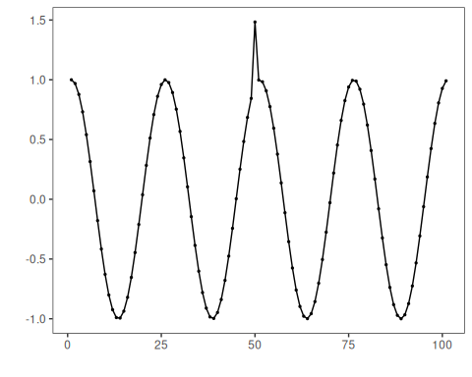
# Configure ARIMA-based anomaly detector
model <- hanr_arima()
# Fit the detector (estimates ARIMA order and caches parameters)
model <- fit(model, dataset$serie)
# Run detection to compute residual magnitudes and flags
detection <- detect(model, dataset$serie)
# Show detected anomaly indices
print(detection |> dplyr::filter(event == TRUE))
## idx event type
## 1 50 TRUE anomaly
# Evaluate detections against labeled events
evaluation <- evaluate(model, detection$event, dataset$event)
print(evaluation$confMatrix)
## event
## detection TRUE FALSE
## TRUE 1 0
## FALSE 0 100
# Plot detections vs. ground truth
har_plot(model, dataset$serie, detection, dataset$event)
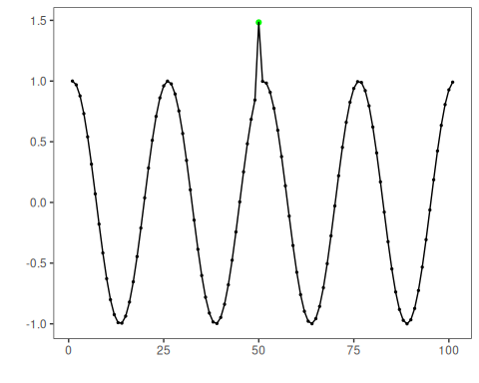
# Plot the residual magnitude and the decision thresholds
har_plot(model, attr(detection, "res"), detection, dataset$event, yline = attr(detection, "threshold"))
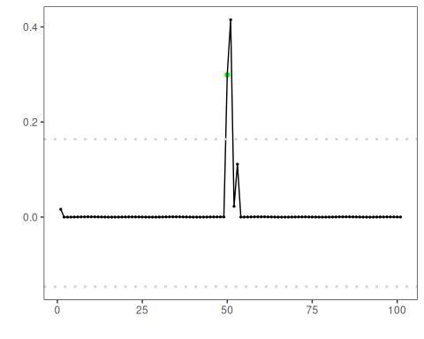

References
- Box, G. E. P., Jenkins, G. M., Reinsel, G. C., Ljung, G. M. (2015). Time Series Analysis: Forecasting and Control. Wiley.

