Objective
FBIAD (Forward and Backward Inertial Anomaly Detector) compares deviations from sliding-window means computed forward and backward in time, then merges evidence. In this tutorial we:
- Load and visualize a simple anomaly dataset
- Configure and run the FBIAD detector (hanr_fbiad)
- Inspect detections, evaluate, and plot residual magnitudes

Method at a glance
FBIAD regression anomaly detection: Forward and Backward Inertial Anomaly Detector compares each point against forward and backward inertia, flagging observations that break both temporal tendencies. Scores are summarized and thresholded using harutils().

What you will do
- understand the purpose of the example and when the technique is useful
- follow the workflow from data loading to model fitting and detection
- inspect the evaluation outputs and the diagnostic plots produced by Harbinger

Walkthrough
# Install Harbinger (if needed)
#install.packages("harbinger")
# Load required packages
library(daltoolbox)
library(harbinger)
# Load example anomaly datasets
data(examples_anomalies)
# Select a simple anomaly dataset
dataset <- examples_anomalies$simple
head(dataset)
## serie event
## 1 1.0000000 FALSE
## 2 0.9689124 FALSE
## 3 0.8775826 FALSE
## 4 0.7316889 FALSE
## 5 0.5403023 FALSE
## 6 0.3153224 FALSE
# Plot the raw time series
har_plot(harbinger(), dataset$serie)
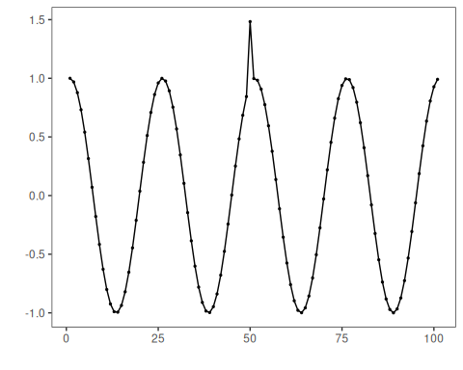
# Configure the FBIAD detector
model <- hanr_fbiad()
# Fit the detector
model <- fit(model, dataset$serie)
# Run detection
detection <- detect(model, dataset$serie)
# Show detected anomaly indices
print(detection |> dplyr::filter(event == TRUE))
## idx event type
## 1 50 TRUE anomaly
# Evaluate detections against labels
evaluation <- evaluate(model, detection$event, dataset$event)
print(evaluation$confMatrix)
## event
## detection TRUE FALSE
## TRUE 1 0
## FALSE 0 100
# Plot detections vs. ground truth
har_plot(model, dataset$serie, detection, dataset$event)
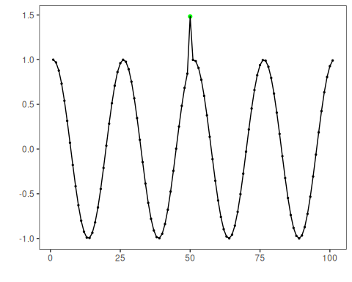
# Plot residual magnitude and decision thresholds
har_plot(model, attr(detection, "res"), detection, dataset$event, yline = attr(detection, "threshold"))
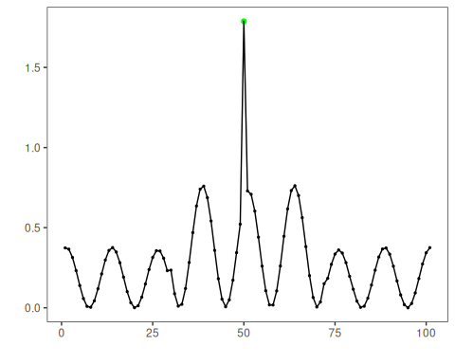

References
- Lima, J., et al. Forward and Backward Inertial Anomaly Detector: A Novel Time Series Event Detection Method. IJCNN, 2022. doi:10.1109/IJCNN55064.2022.9892088

