Objective
The FFT-based detector applies a high-pass filter in the frequency domain and flags large deviations between the original and filtered signal.
Steps: - Load and visualize a sample anomaly dataset - Configure and run the FFT detector (hanr_fft) - Inspect detections, evaluate, and plot residuals with thresholds

Method at a glance
FFT regression anomaly detector: This detector applies high-pass filtering via the discrete Fourier transform. The spectrum is computed with the FFT, a cutoff is selected from the power spectrum to suppress low-frequency components, and the inverse FFT reconstructs a high-pass signal. Residual magnitudes are then summarized and thresholded using harutils().

What you will do
- understand the purpose of the example and when the technique is useful
- follow the workflow from data loading to model fitting and detection
- inspect the evaluation outputs and the diagnostic plots produced by Harbinger

Walkthrough
# Install Harbinger (if needed)
#install.packages("harbinger")
# Load required packages
library(daltoolbox)
library(harbinger)
# Load example anomaly datasets
data(examples_anomalies)
# Select a simple anomaly dataset
dataset <- examples_anomalies$simple
head(dataset)
## serie event
## 1 1.0000000 FALSE
## 2 0.9689124 FALSE
## 3 0.8775826 FALSE
## 4 0.7316889 FALSE
## 5 0.5403023 FALSE
## 6 0.3153224 FALSE
# Plot the raw time series
har_plot(harbinger(), dataset$serie)
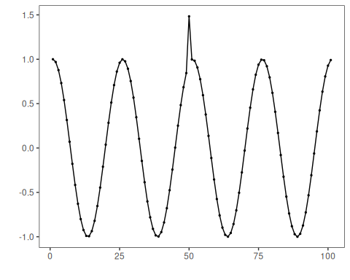
# Configure the FFT-based detector
model <- hanr_fft()
# Fit the detector (no training required, tracks parameters)
model <- fit(model, dataset$serie)
# Run detection to compute residual magnitudes and flags
detection <- detect(model, dataset$serie)
# Show detected anomaly indices
print(detection |> dplyr::filter(event == TRUE))
## idx event type
## 1 50 TRUE anomaly
# Evaluate detections against labeled events
evaluation <- evaluate(model, detection$event, dataset$event)
print(evaluation$confMatrix)
## event
## detection TRUE FALSE
## TRUE 1 0
## FALSE 0 100
# Plot detections vs. ground truth
har_plot(model, dataset$serie, detection, dataset$event)
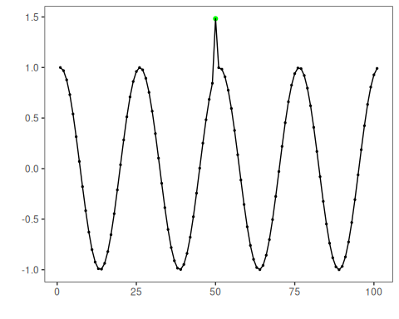
# Plot residual magnitude and decision thresholds
har_plot(model, attr(detection, "res"), detection, dataset$event, yline = attr(detection, "threshold"))
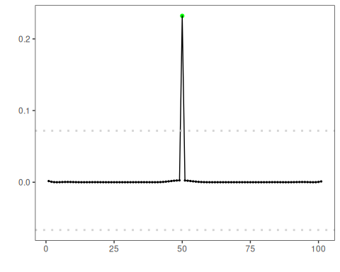

References
- Sobrinho, E. P., Souza, J., Lima, J., Giusti, L., Bezerra, E., Coutinho, R., Baroni, L., Pacitti, E., Porto, F., Belloze, K., Ogasawara, E. Fine-Tuning Detection Criteria for Enhancing Anomaly Detection in Time Series. In: Simpósio Brasileiro de Banco de Dados (SBBD). SBC, 29 Sep. 2025. doi:10.5753/sbbd.2025.247063

