Objective
This notebook demonstrates a hybrid residual-based anomaly detector combining FFT preprocessing, AMOC (At Most One Change) modeling, and CUSUM scoring via hanr_fft_amoc_cusum(). The pipeline models dominant frequencies, captures a single change, and accumulates deviations to flag anomalies. Steps: load packages/data, visualize, define and fit, detect, evaluate, and plot.

Method at a glance
FFT AMOC CUSUM regression anomaly detection: This hybrid detector computes the FFT and transforms the power spectrum with CUSUM to emphasize gradual spectral shifts. AMOC selects a single changepoint that serves as a frequency cutoff. Components below the cutoff are removed, the inverse FFT reconstructs a high-pass signal, and residual magnitudes are thresholded via harutils().

What you will do
- understand the purpose of the example and when the technique is useful
- follow the workflow from data loading to model fitting and detection
- inspect the evaluation outputs and the diagnostic plots produced by Harbinger

Walkthrough
# Install Harbinger (only once, if needed)
#install.packages("harbinger")
# Load required packages
library(daltoolbox)
library(harbinger)
# Load example datasets bundled with harbinger
data(examples_anomalies)
# Select a simple synthetic time series with labeled anomalies
dataset <- examples_anomalies$simple
head(dataset)
## serie event
## 1 1.0000000 FALSE
## 2 0.9689124 FALSE
## 3 0.8775826 FALSE
## 4 0.7316889 FALSE
## 5 0.5403023 FALSE
## 6 0.3153224 FALSE
# Plot the time series
har_plot(harbinger(), dataset$serie)
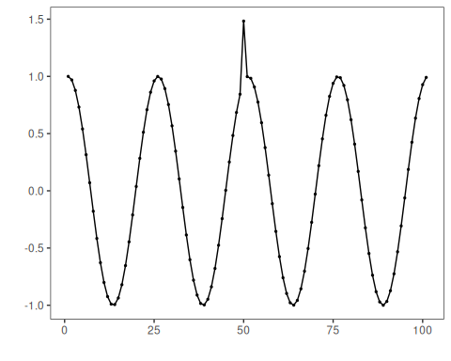
# Define FFT + AMOC + CUSUM detector
model <- hanr_fft_amoc_cusum()
# Fit the model
model <- fit(model, dataset$serie)
# Detect anomalies
detection <- detect(model, dataset$serie)
# Show only timestamps flagged as events
print(detection |> dplyr::filter(event==TRUE))
## idx event type
## 1 50 TRUE anomaly
# Evaluate detections against ground-truth labels
evaluation <- evaluate(model, detection$event, dataset$event)
print(evaluation$confMatrix)
## event
## detection TRUE FALSE
## TRUE 1 0
## FALSE 0 100
# Plot detections over the series
har_plot(model, dataset$serie, detection, dataset$event)
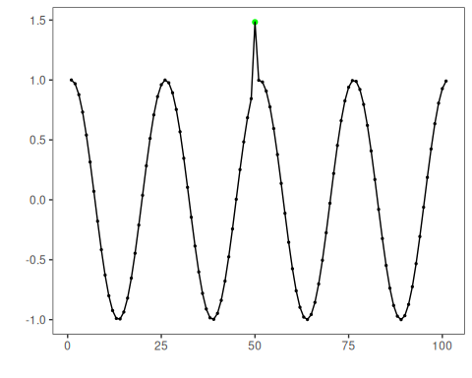
# Plot residual scores and threshold
har_plot(model, attr(detection, "res"), detection, dataset$event, yline = attr(detection, "threshold"))
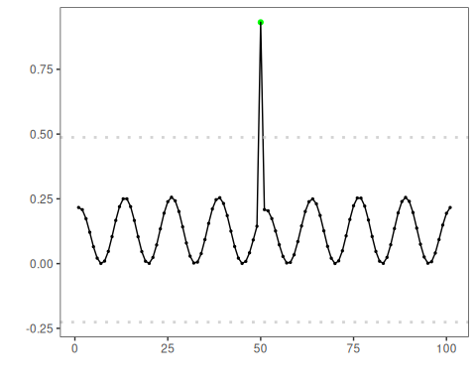

References
- Sobrinho, E. P., et al. Fine-Tuning Detection Criteria for Enhancing Anomaly Detection in Time Series. SBBD, 2025. doi:10.5753/sbbd.2025.247063

